**Project Report**

|  |  |
| --- | --- |
| Project Title | Design, Develop, Implement, Test & Document Used Car Sales Portal Website |
| Qualification Name (NICF) | Advanced Certificate in Software Applications (Development and Process) |
| Product Name | ABC Cars Pte Ltd Portal |
| Module Name (NICF) | Application Development & Process |

|  |  |  |  |
| --- | --- | --- | --- |
| Student name | | Assessor name | |
| Chathushi Jayarathna | | MS. Aravider Kaur | |
| Date issued | Completion date | | Submitted on |
| 30/11/2022 | 18/01/2023 | | 20/01/2023 |
|  | |  | |
| Project Title | Design, Develop, Implement, Test & Document Used Car Sales Portal Website | | |

|  |
| --- |
| Learner declaration |
| I certify that the work submitted for this assignment is my own and research sources are fully acknowledged.  Student signature: **Chathushi**  Date: 20/01/2023 |

Table of Contents

**1)** **Project Background** 7

**2)** **Project Objective** 8

**3)** **Project Requirement Specification** 11

**3.1** **Project Scope** 11

**3.2** **Functional Requirement** 11

**4)** **Business Process** 12

**4.1** **Explain the Business Processes the Software is supporting.** 12

4.1.1 Document 2 business processes 12

4.2 Document 2 Module functionality 16

4.2.1 UI Screenshots 16

**4.3** **Functionality of post cars and search cars** 23

**5)** **Project Plan** 23

**5.1** **Software Development Methodology to be used for developing a system** 23

**5.1.1** **Advantages and Disadvantages of Spiral Model** 25

5.2 List various tasks to be done during various phase 25

5.3 Project plan with dates and timelines 27

**6)** **Testing Concepts** 29

**6.1** **Risk-based testing concepts and requirements** 29

6.1.1 Stages involved in RBT Model 29

6.2 Eight characteristics of Software Product Quality. 33

6.3 Type of risk and its impact 36

**7)** **Test Planning** 38

**7.1** **The test phases of security testing with its prioritization** 38

**7.1.1** **Risk-Based Test Strategy in ABC Car Sale website.** 38

**7.2** **Among test strategies, how to carry out security testing.** 39

**7.3** **Test phases in security testing** 40

7.4 Detailed test plan with test cases based on quantitative risk analysis 41

**7.4.1** **Quantitative risk analysis** 41

7.5 Develop a test risk matrix for the given specification 42

7.6 Create a test risk matrix with the evaluation of the impact 45

7.7 Develop a test risk matrix for the given specification 45

**8)** **Test Strategy** 48

**8.1** **Suitable RBT cycle content and priorities further test cycles** 48

**8.2** **Communicate the details of the strategy and test planning to the key stakeholders with proper justifications** 49

**9)** **Testing Results** 55

9.1 Execute the risk-based test plan and log the test results 55

9.1.1 UAT Testing 55

**9.1.2** **Unit Testing** 73

**9.1.3** **Functional Testing – Performance Testing** 75

**9.1.4** **Functional Testing - Compatibility Testing** 79

**9.1.5** **Usability Testing** 92

**9.1.6** **Portability Testing** 102

**9.1.7** **Security Testing** 107

**9.2** **Provide a detailed log of test results** 111

**9.3** Modify the risk-based test procedure with the reasons 114

Table of Figures

Figure 1:Screenshot of Landing page 16

Figure 2:Screenshot of Registration Page (1) 17

Figure 3:Screenshot of Registration Page (2) 17

Figure 4:Screenshot of login page 18

Figure 5:Screenshot of user profile page 18

Figure 6:Screenshot of Post Car form 19

Figure 7:Screenshot of posted car list 19

Figure 8:Screenshot of all posted cars page 20

Figure 9:Screenshot of car details 20

Figure 10:Screenshot of search cars 21

Figure 11:Screenshot of home page 22

Figure 12:Screenshot of cars page 22

Figure 13:Spiral Model 24

Figure 14:Risk Plan Diagram 30

Figure 15:Lesson learned Diagram 33

Figure 16:Types of security Testing 38

Figure 17:Test phases in security testing 41

Figure 18:RBT Cycle Design 48

Figure 19:Types of Stakeholders 51

Figure 20:Evidence: Fig: TS001 – TC001 56

Figure 21:Evidence: Fig: TS001 – TC002 (1) 57

Figure 22:Evidence: Fig: TS001 – TCOO2 (2) 58

Figure 23:Evidence: Fig: TS002 – TC001 (1) 59

Figure 24:Evidence: Fig: TS002 – TC001 (2) 60

Figure 25:Evidence: Fig: TS002 – TC002 (1) 61

Figure 26:Evidence: Fig: TS002 – TC002 (2) 61

Figure 27: Evidence: Fig: TS003 -TC001 63

Figure 28:Fig: TS003 – TC002 (1) 64

Figure 29:Fig: TS003 – TC002 (2) 65

Figure 30:Fig: TS003 – TC003 (1) – Post car (User) 66

Figure 31:Evidence: Fig: TS003 – TC003 (2) – Car Bid (User) 67

Figure 32:Fig: TS003 – TC003 (3) – Test Drive Appointments (User) 67

Figure 33:Fig: TS003 – TC003 (4) – Admin Dashboard 68

Figure 34:Fig: TS003 – TC003 (5) – Car Mangement 68

Figure 35:Evidence: Fig: TS004 – TC001 70

Figure 36:Evidence: Fig: TS004 – TC001 (1) 70

Figure 37:Evidence: Fig: TS004 – TC002(1) 72

Figure 38:Evidence: Fig: TS004 – TC002(2) 72

Figure 39:Evidence: Fig: TS004 – TC002(3) 73

Figure 40:Evidence: Fig: TS006 – TC001 (1) 77

Figure 41:Evidence: Fig: TS006 – TC001 (1) 77

Figure 42:Evidence: Fig: TS006 – TC001 (2) 78

Figure 43:Evidence: Fig: TS006 – TC001 (3) 78

Figure 44:Evidance: Fig: CBTS001 – CBT01 - Google Chrome 80

Figure 45:Evidance: Fig: CBTS001 – CBT01 - Google Chrome 80

Figure 46:Evidance: Fig: CBTS001 – CBT01 – Microsoft Edge 82

Figure 47:Evidance: Fig: CBTS001 – CBT01 – Microsoft Edge 82

Figure 48:Evidance: Fig: CBTS002 – CBT01 – Google Chrome 84

Figure 49:Evidance: Fig: CBTS002 – CBT01 – Google Chrome 84

Figure 50:Evidance: Fig: CBTS002 – CBT01 – Microsoft Edge 85

Figure 51:Evidance: Fig: CBTS002 – CBT01 – Microsoft Edge 85

Figure 52:Evidance: Fig: CBTS003 – CBT01 – Google Chrome 87

Figure 53:Evidance: Fig: CBTS003 – CBT01 – Google Chrome 87

Figure 54:Evidance: Fig: CBTS003 - CBT02 – Microsoft Edge 88

Figure 55:Evidance: Fig: CBTS003 - CBT02 – Microsoft Edge 88

Figure 56:Evidence: Fig: CBTS004 – CBT01 – Google Chrome 90

Figure 57:Evidence: Fig: CBTS004 – CBT01 – Google Chrome 90

Figure 58:Evidence: Fig: CBTS004 – CBT02 – Microsoft Edge 91

Figure 59:Evidence: Fig: CBTS004 – CBT02 – Microsoft Edge 91

Figure 60:Evidence: Fig: TS008 – TC001 93

Figure 61:Evidence: Fig: TS008 – TC001 93

Figure 62:Evidence: Fig: TS008 – TC001 95

Figure 63:Evidence: Fig: TS009-TC001 97

Figure 64:Evidence: Fig: TS010 – TC001 99

Figure 65:Evidence: Fig:TS011 – TC001 101

Figure 66:Evidence: Fig:TS012 – TC001 – Phone Mode 103

Figure 67:Evidence: Fig: TS013 – TC001 – Tablet Mode 105

Figure 68:Evidence: Fig: TS014 – TC001 – Laptop Mode 107

Figure 69:Evidence: Fig: TS015 – TC002 109

Figure 70:Before Fix - Interface 114

Figure 71:Before Fix - Source Code 115

Figure 72:After Fixed - Interface 115

Figure 73:After Fixed - Source Code 116

Figure 74:Screenshot of Home Page 121

Figure 75:Screenshot of About Us Page 122

Figure 76:Screenshot of Contact Us Page 123

Figure 77:Screenshot of Login Page 124

Figure 78:Screenshot of Register Account Page 124

Figure 79:Screenshot of register Profile Page 125

Figure 80: Screenshot of Car View Page 125

Figure 81:Screenshot of car details view page 126

Figure 82:Screenshot of User Profile 126

Figure 83:Screenshot of Post Car Page 126

Figure 84:Screenshot of User Edit Profile 126

Figure 85:User Posted Car List Page 126

Figure 86:Screenshot of User Test Drive Car Page 126

Figure 87:Screenshot of Car Bidding Page 126

Figure 88:Screenshot of Edit Posted Car Details 126

Figure 89:Screenshot of Admin Dashboard 126

Figure 90:Screenshot of Admin Dashboard 126

Figure 91:Screenshot of Car Mangement Page 126

Figure 92:Screenshot of Registration Thank You Page 126

1. **Project Background**

ABC cars Pte Ltd' has been engaged as a website developer for the improvement. Creates a car sales portal for used cars. For that it creates users who can register on the portal. this is, assisting portal users look for cars the usage of the registration page, make, model, and many others. abilities required for planning, implementation, testing and documentation are also studied underneath this task. There, the website for a used car sales portal has been designed greater effectively using Spring Framework, MySQL server, Spring safety and test. It additionally allows users to view car information after registration and charge range. This portal lets in users to log inside and out on every occasion they want. Used car sales portal has categories as users and admin. There separate duties are assigned below them. inside the portal,

users can register on the portal, get right of entry to the portal, post a car for sale with image upload, close an existing car sale, replace their profile after logging in, e book an appointment for a take a look at force in addition to post a put up. except, the admin has any other job right here. Registering at the portal, logging into the portal, viewing the listing of registered users, marking a user as an administrator, allowing and disabling a car post, updating their profile, approving or rejecting user appointments whilst bidding and making sales transactions are only some.

1. **Project Objective**

* The grant objective of this project is considered to be development of skills required for project planning, implementation, testing and documentation.
* For that, using Spring Framework, spring security, MySQL server and test, the website has been created for a used car sales portal.
* Identify and analyse business processes
* Creating a business process session.
* Create the project plan document.
* Create test concepts.
* Create test planning phase. 8. View and understand and complete all tests, assignments, e-content related to the module

2.1 Tools and Platforms used

* 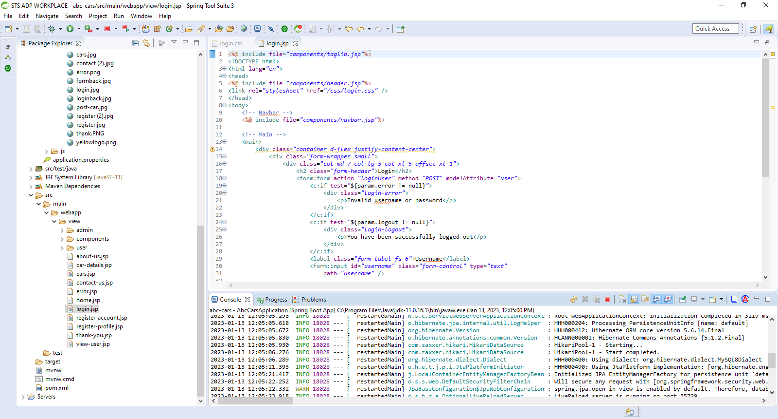Spring Tool Suite – To implement the project

Figure 1:Screenshot of STS Workplace

* 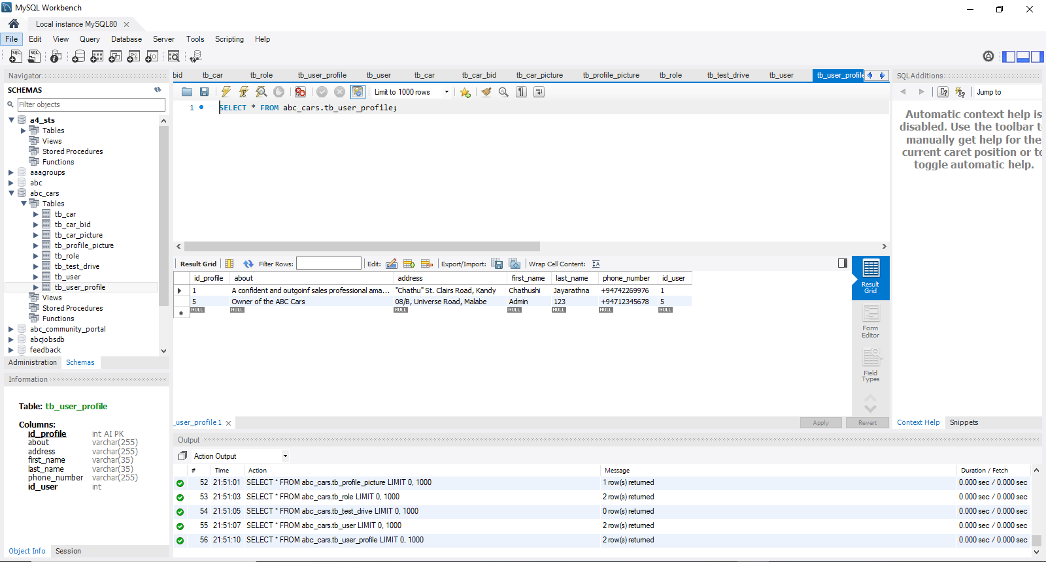MySQL Workbench – T connect database

Figure 2:Screenshot of MySQL Workbench

* 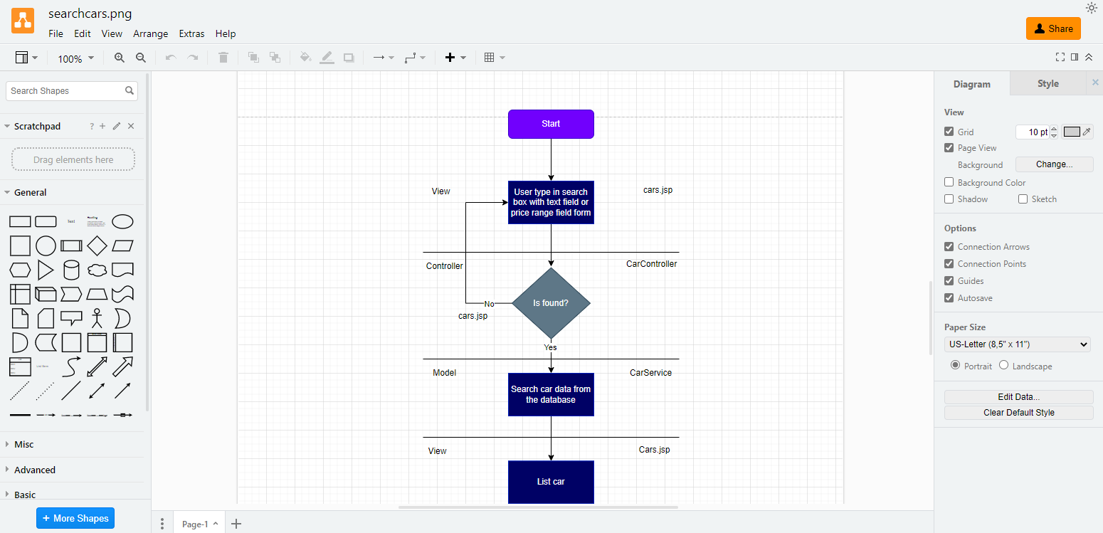Diagram.net – To create flow charts

Figure 3:Screenshot of Diagram.Net

* 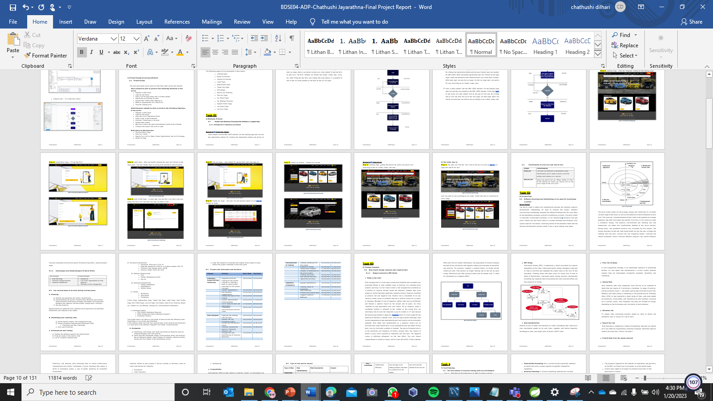MS Word – To create Project Report

Figure 4:Screenshot of MS Words

* **MS PowerPoint – To create Project Presentation**

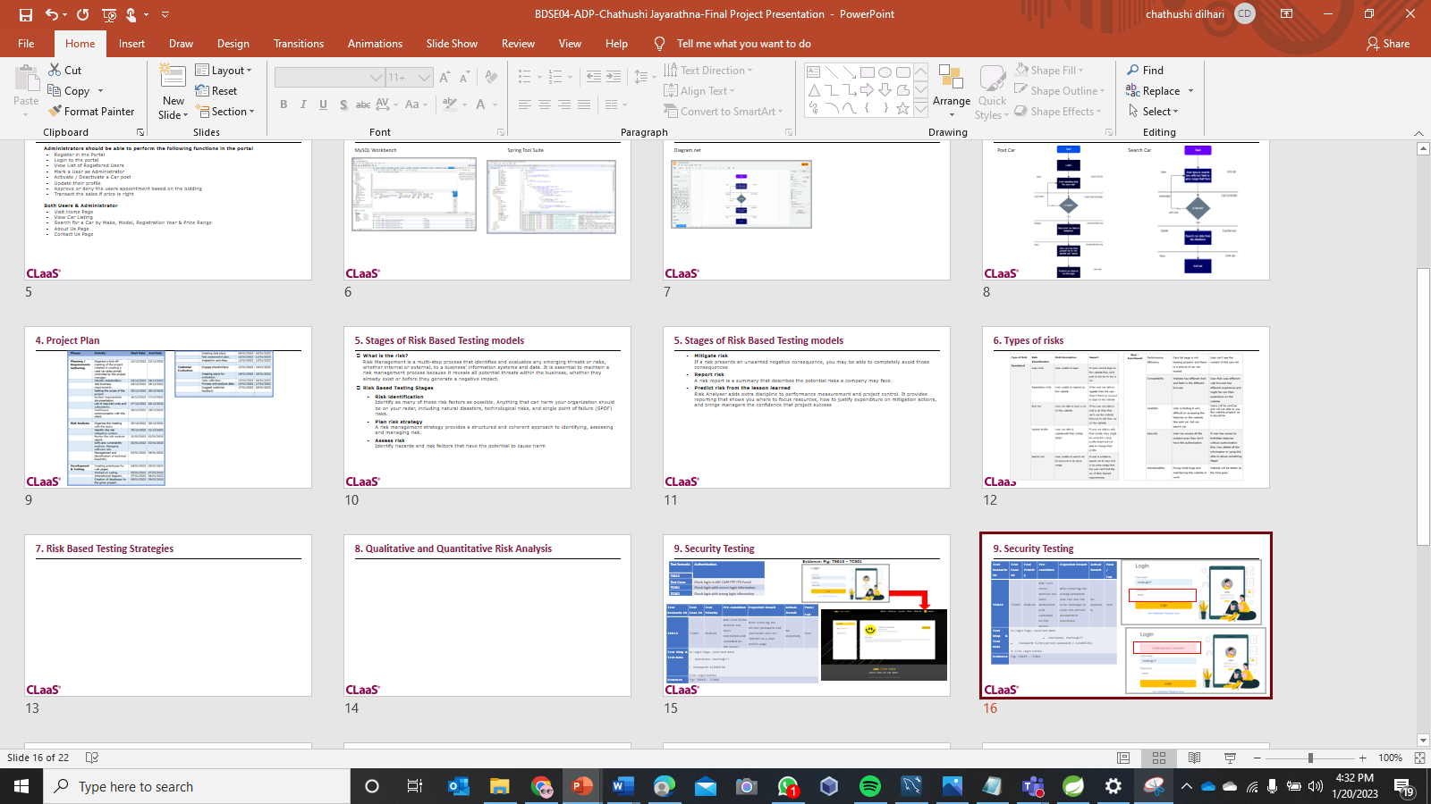

Figure 5:Screenshot of MS PowerPoint

1. **Project Requirement Specification**
   1. **Project Scope**

The web application has 2 types of roles that could access the website

Users should be able to perform the following functions in the portal

* Register in the Portal
* Login to the Portal
* Post a Car for Sale along with a Picture upload
* Deactivate an Existing car sale
* Update their Profile after logging in.
* Book an appointment for a test drive
* Post the bidding price

Administrators should be able to perform the following functions in the portal

* Register in the Portal
* Login to the portal
* View the List of Registered Users
* Mark a User as Administrator
* Activate / Deactivate a Car post
* Update their profile
* Approve or deny the users appointment based on the bidding
* Transact the sales if the price is right

Both Users & Administrator

* Visit the Home Page
* View Car Listing
* Search for a Car by Make, Model, Registration Year & Price Range
* About Us Page
* Contact Us Page
  1. **Functional Requirement**

The following pages will be developed in the project.

* Landing Page.
* About Us Section.
* Contact Us Section
* Login Page.
* Registration Page.
* Thank You Page.
* Homepage.
* Search Car Function.
* Post Car Page.
* Car Detail Page.
* Car Bidding Function.
* Update Profile Page.
* List Users Page.
* List Cars Page.

**Task 01**

1. **Business Process**
   1. **Explain the Business Processes the Software is supporting.**
      1. Document 2 business processes

**Scenario 1 : Post Car (User)**

Users should visit the ABC CARS website. On the landing page user can see the registration button. By clicking the registration button and giving all details user can register for ABC CARS. After successful registration user will redirect to the login page. Using the Login form user can access their account. After login user can post a car list the using “My posted car” menu. By clicking my posted car user can go to the post on the car page. In the post car page, there is an option to post cars. User should fill out the form to post cars. The form includes car details like model, make, year, price, etc. After filling out the form and clicking the post button, it is possible to see all the car posts posted by the user on the car list page

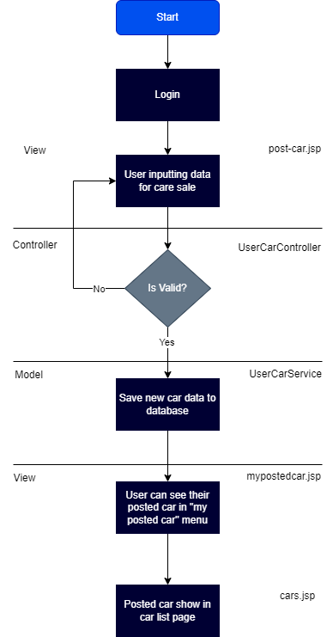

**Scenario 2 : Search Car**

There are 2 ways to search cars. 1st one is users should visit the ABC CARS website. On the landing page user can see the registration button. By clicking the registration button and giving all details user can register for ABC CARS. After successful registration user will redirect to the login page. Using the username and password users can access their account. After login user can see the car page. On the car page user can search for cars according to car model, make, year.

2nd one is users should visit the ABC CARS website. On the landing page user can see the cars posted on the ABC CARS website. If the user want to see every cars user should click on the see all cars link. By clicking see all cars link user will go to the cars page. On that page users can see all cars and user can search cars according to car model, make, year

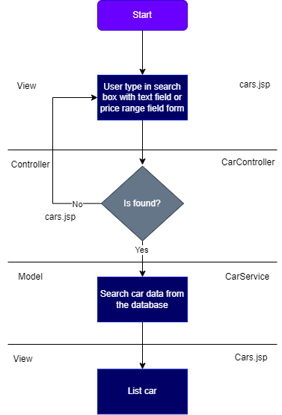

* 1. Document 2 Module functionality
     1. UI Screenshots

Scenario 1: Post car

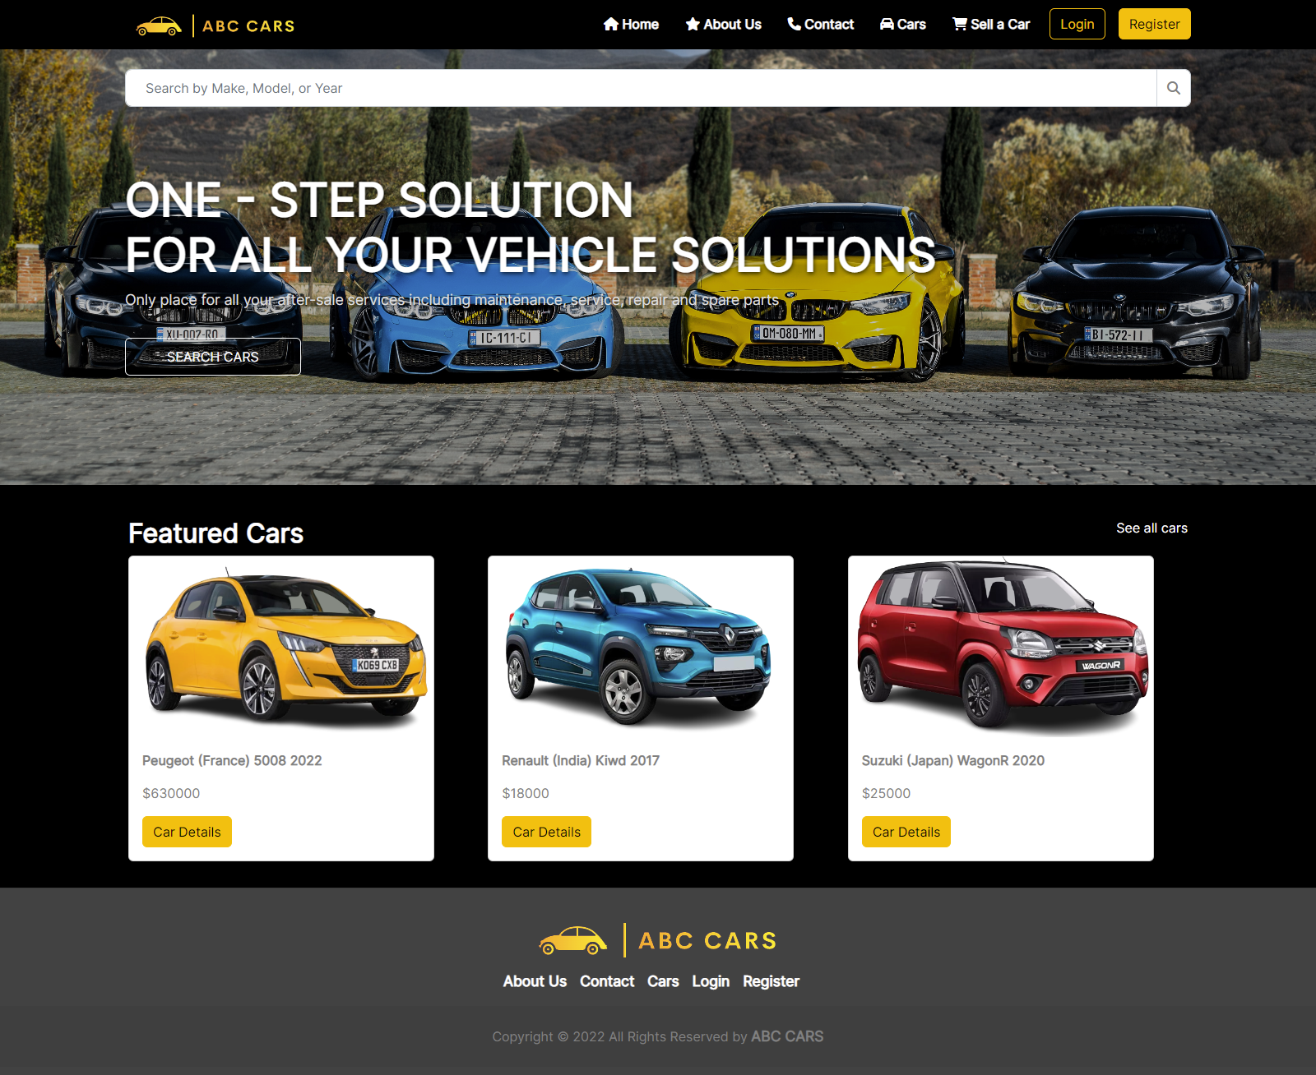Step 1: Landing Page - Click the “Register” button on the landing page

Figure 6:Screenshot of Landing page

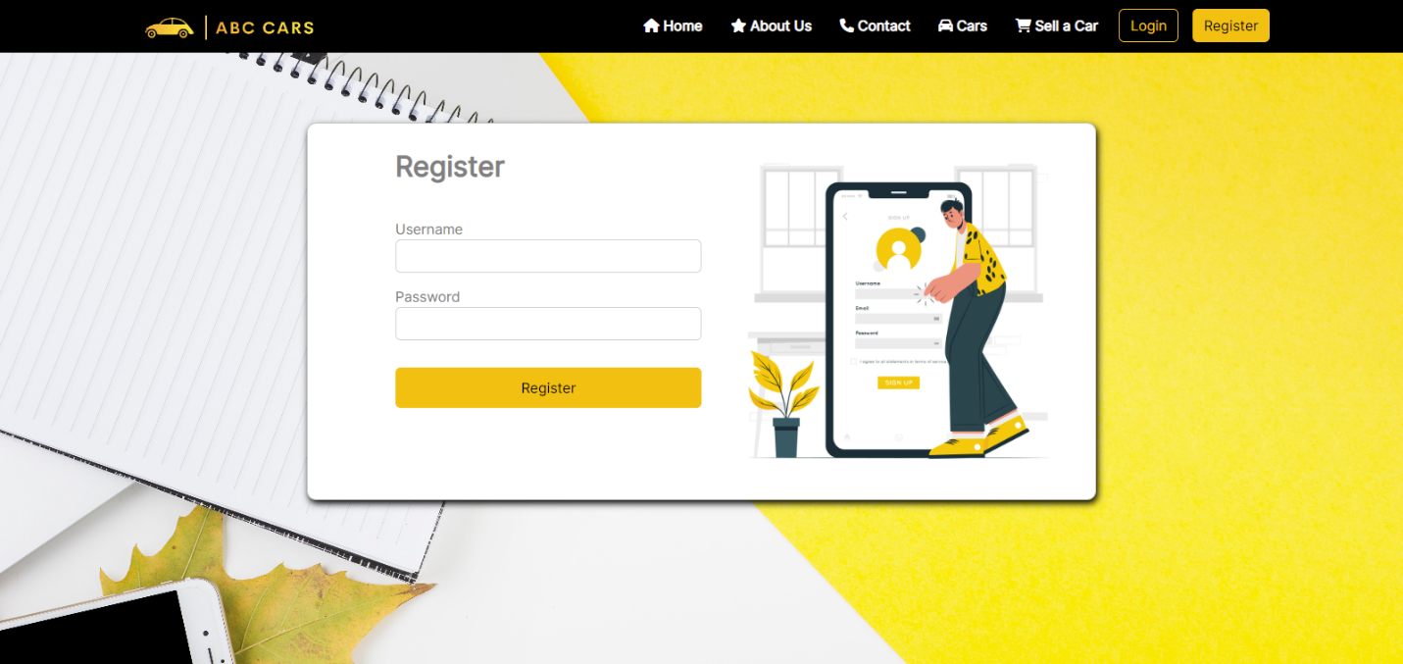Step 2: Registration Page – Fill out the form.

Figure 7:Screenshot of Registration Page (1)

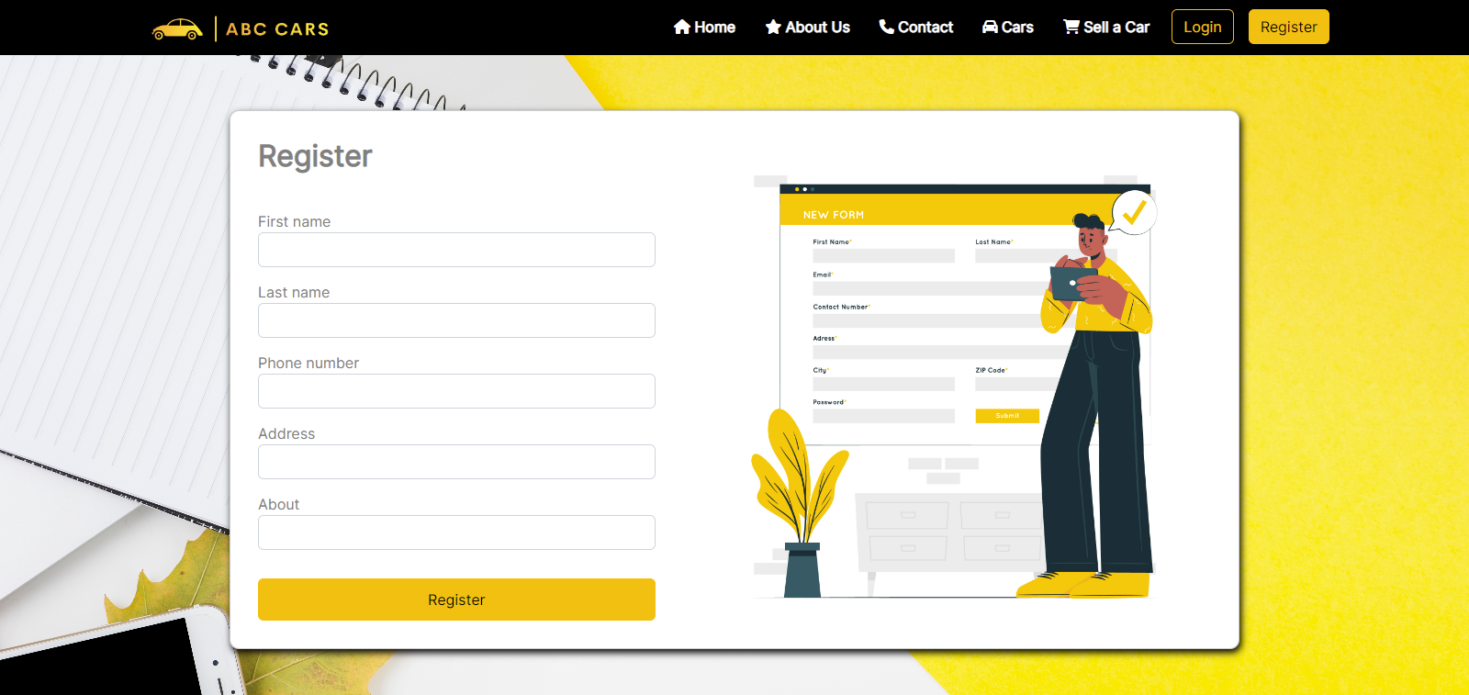

Figure 8:Screenshot of Registration Page (2)

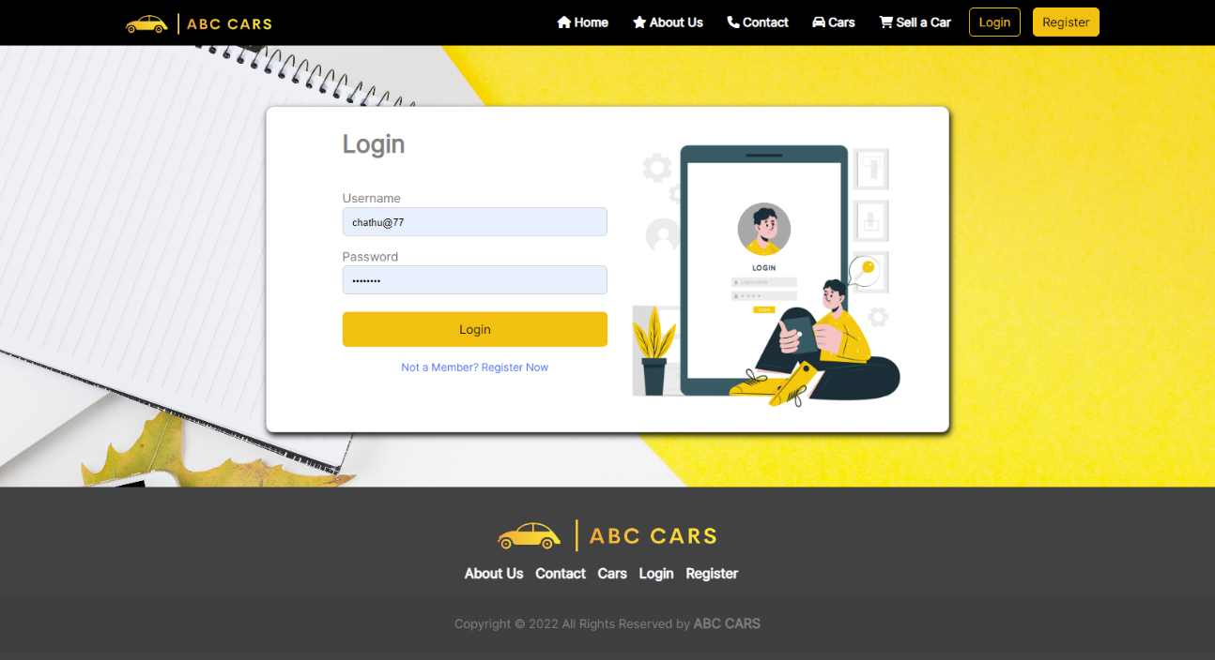**Step 3:** Login Page – After successful registration, user will redirect to the login page. The user should login by giving their username and password

Figure 9:Screenshot of login page

**Step 4:** User Profile Page – In here user can see Sell a Car link in nav bar. Using this Sell a Car link user can post car detail to sell

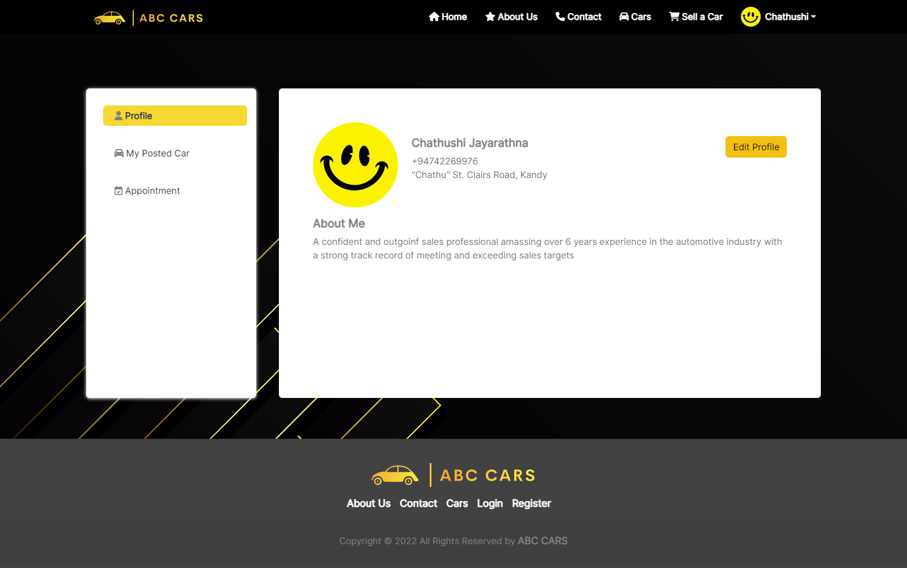

Figure 10:Screenshot of user profile page

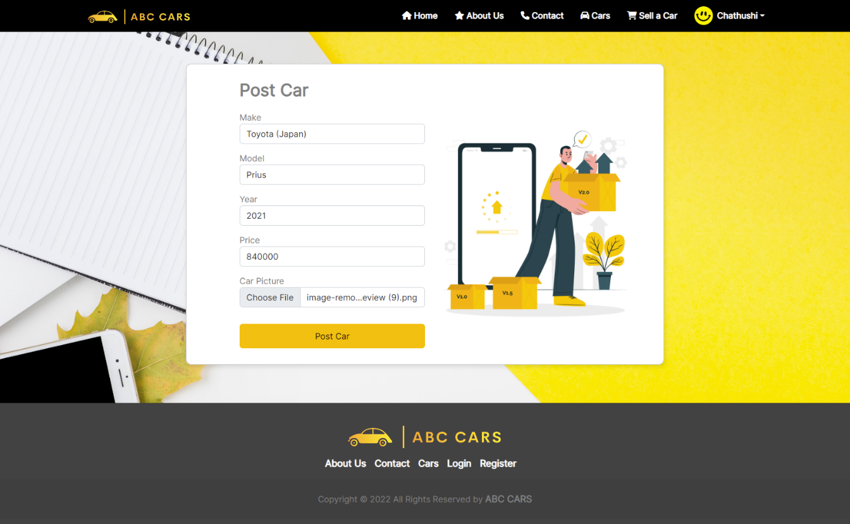**Step 5:** Post car page – User should fill out the form and click post car

Figure 11:Screenshot of Post Car form

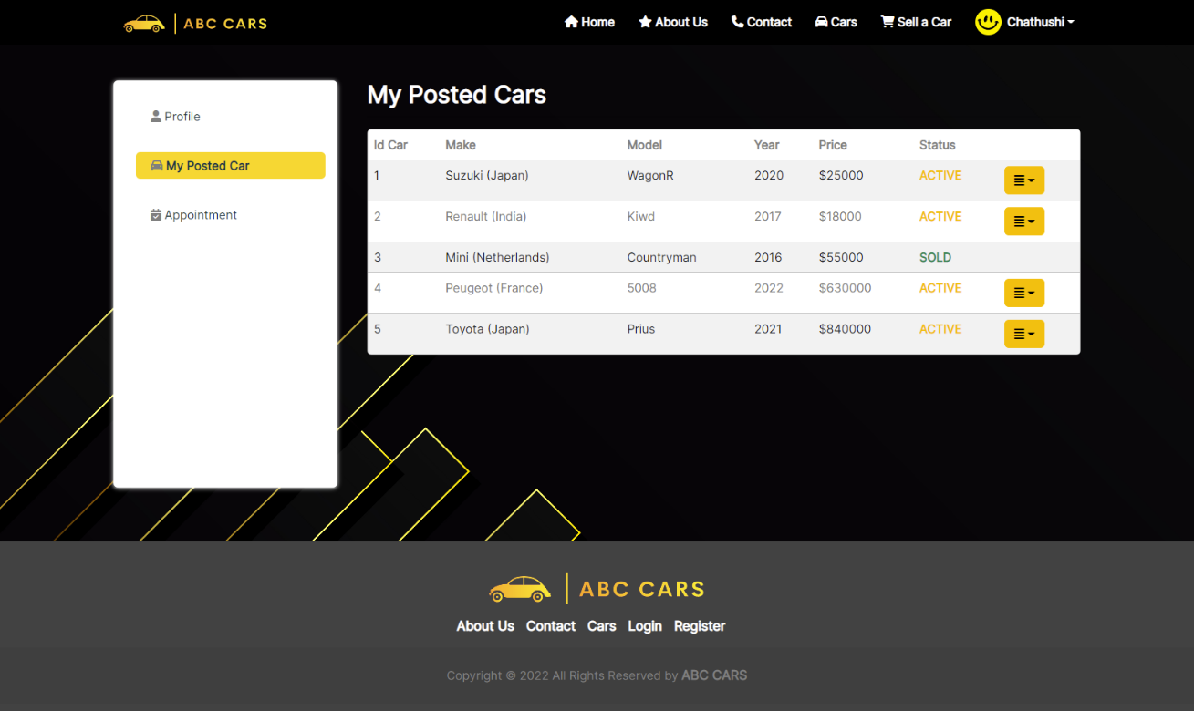**Step 6:** Posted Car page – The user can see he/she posted car list the on posted car page

Figure 12:Screenshot of posted car list

**Step 7:** Posted car Details – Posted cars review

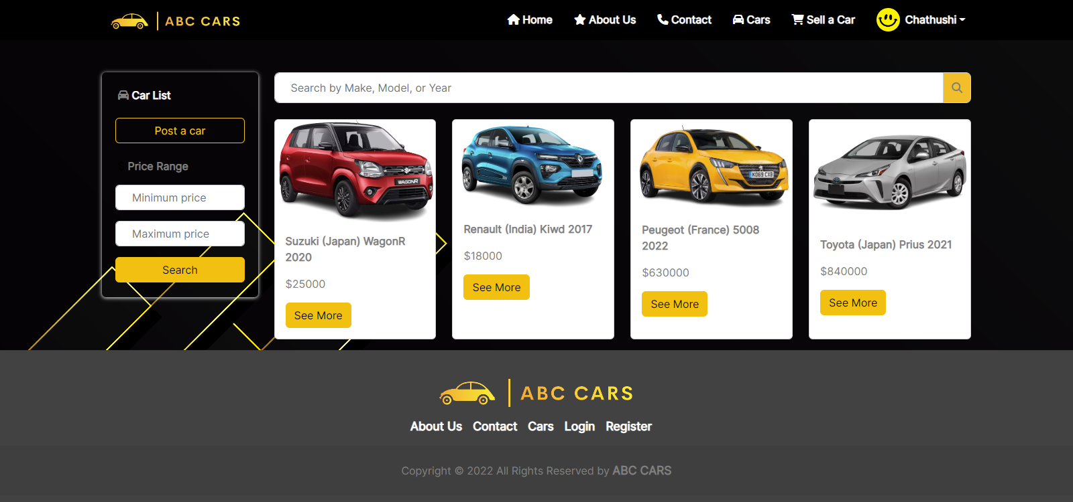

Figure 13:Screenshot of all posted cars page

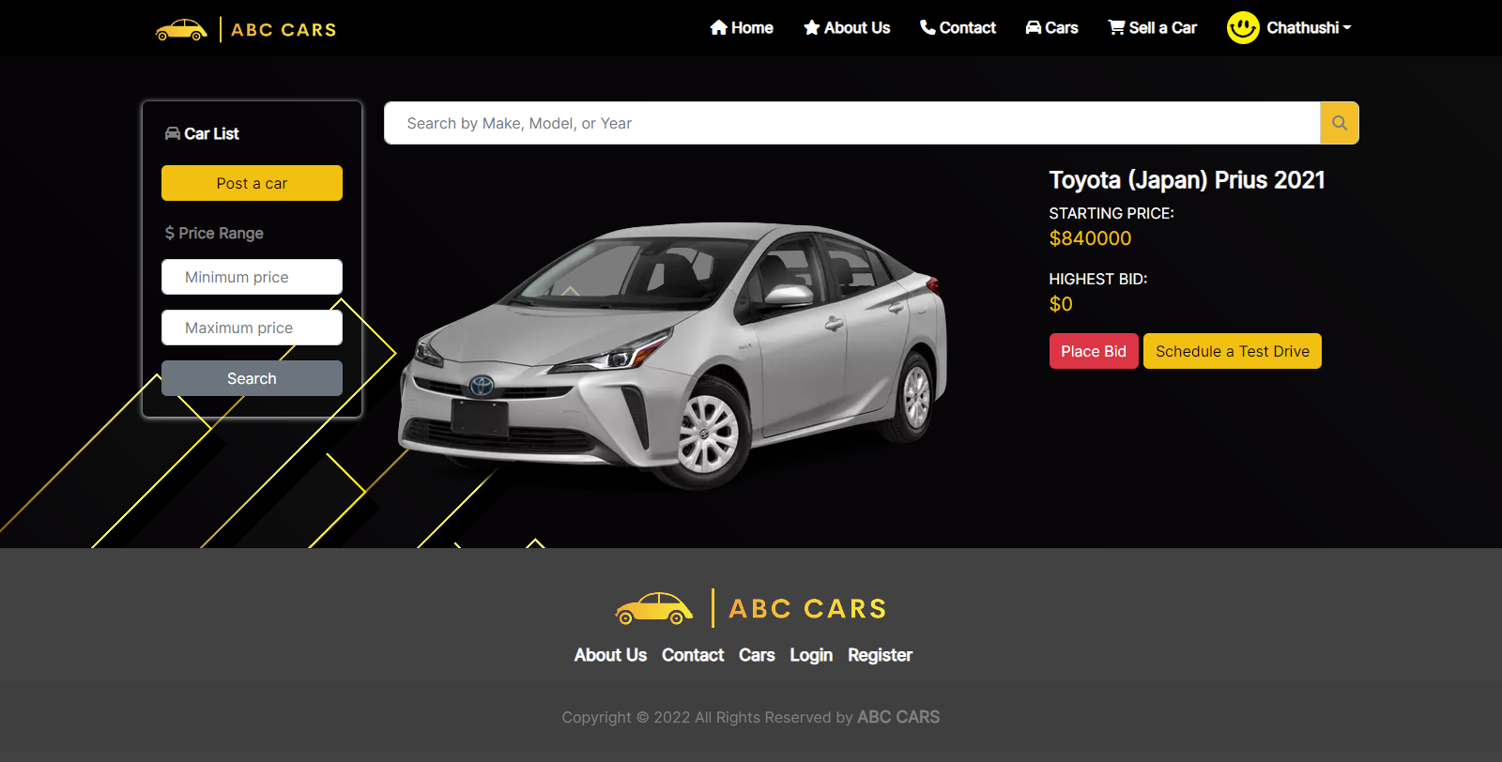

Figure 14:Screenshot of car details

**Scenario 2 : Search car**

**Step 1:** Landing Page –Using the search bar users can search cars according to the car model, make, and year

Figure 15:Screenshot of search cars

**Or the other way is,**

**Step 1:** The user can click the “cars” link on the nav bar and go the to car page and search for cars

Figure 16:Screenshot of home page

User can search cars according to car make, model and year or according to price range



Figure 17:Screenshot of cars page

* 1. **Functionality of post cars and search cars**

|  |  |
| --- | --- |
| Pages | Functionality |
| Post Car | The post-car function is considered a user Functionality and is used to post a price for selling and bidding on a vehicle. |
| Search Car | Users can search cars by “Make, Model, or Year” of the desired car users can search cars by the price range of the car’s price |

**Task 02**

1. **Project Plan**
   1. **Software Development Methodology to be used for developing a system**

**Spiral Model**

The spiral model is taken into consideration because the software program development methodology for used to increase the system. software improvement methodology beneath the software development life cycle refers to the dependent processes involved in working on a project. The spiral model is important in structured processes. it's far considered a excessive risk safe place. clearly put, the Spiral model is a system development existence cycle system used for risk control, combining factors of the waterfall model with the iterative development process model. It has a spiral shaped loop shape

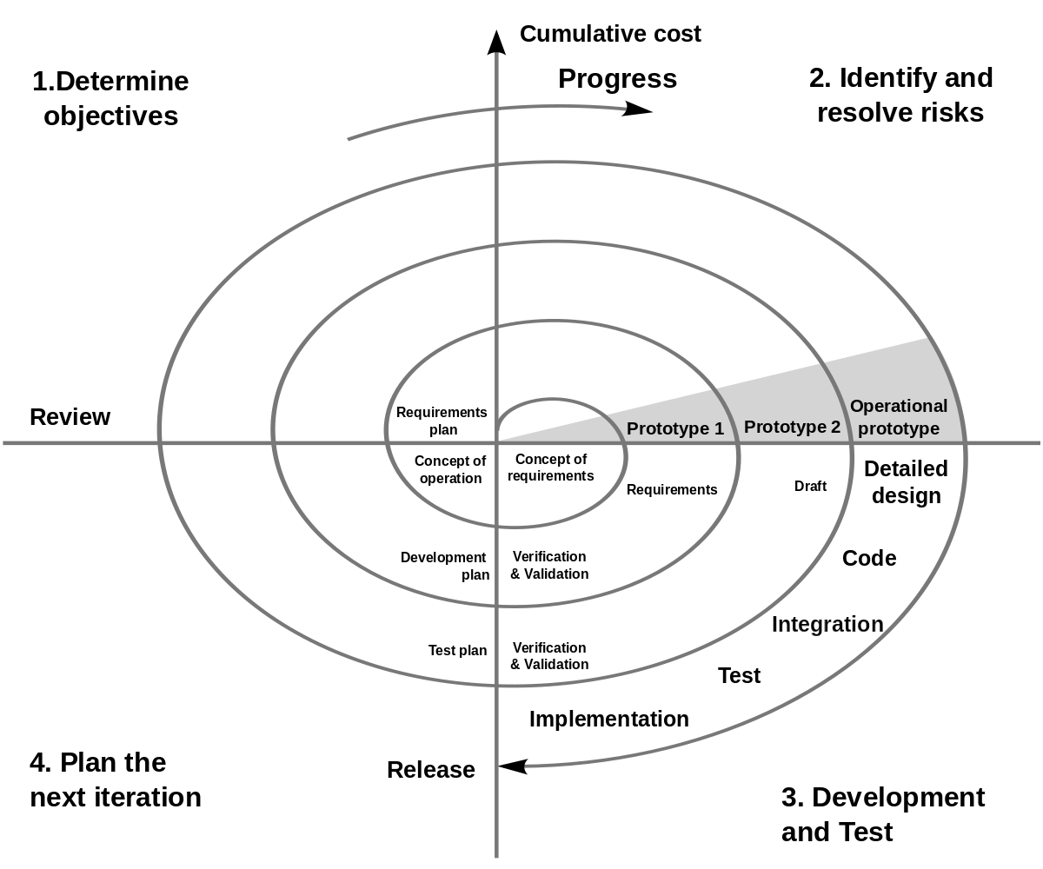

Figure 18:Spiral Model

The spiral model allows for the gradual release and refinement of a product via each stage of the spiral, as well as the potential to build prototypes at each level. The maximum important feature of the model is the potential to manage unknown risks after the project has started. From this, it's far viable to create a prototype. design, risk analysis, improvement and checking out, and assessment, are taken into consideration because of the spiral process. Among them, risk evaluation become very important for this project. The project develops carried-out code based totally on the risk plan. arrange the meeting with the team, discover the risk mitigation system, overview the chance evaluation record, examine software program risk, control software risk and manipulate and become aware of technical feasibility, chance analysis tasks

* + 1. **Advantages and Disadvantages of Spiral Model**

|  |  |
| --- | --- |
| Advantages | Disadvantages |
| * Risk Handling * Flexible in Requirements * Customer Satisfaction | * Expensive * Too much dependable on Risk Analysis * Difficulty in time management |

* 1. List various tasks to be done during various phase
     + - 1. **Planning**

1. Identify and gathered the system requirements
2. Understanding the system requirements (Business and System Requirements Specification) through continuous communication between the customer and the system analyst team members
3. Set the objective

Requirements are gathered from customers and objectives are identified, Elaborated, and analyse at the outset

* + - * 1. **Identifying and resolving risks**

1. Document the project risk management plan
2. Prepare Software Requirement Document (SRS)

* Functional and Non-Functional

1. Use Case Document
   * + - 1. **Development and Testing**
   1. Testing the software against the requirements
   2. Fixed all issues in the source code
   3. List of Technical requirements
      * 1. Hardware Requirement

* Processor: Minimum 2 GHz, i5
* Ethernet connection (LAN) or a wireless adapter (WI-FI)
* Minimum free storage space: 20GB
* Memory (RAM); Minimum 4GB
  + - 1. Software Requirement
* STS
* MySQL Workbench 8.0.30
* JDK 11
  + - 1. Database Requirement
* MySQL Workbench
* PhpMyAdmin
* MySQL Server
  + 1. Create,
* Wireframe
* Storyboard
* Prototypes

(Home Page, Registration Page, Thank You Page, Login Page, User Profile Page, Edit Profile Page, List Car Page, Car Details, Search Car Function, About Us, Contact Us, Car Bidding, Posting Car, Administrator Dashboard)

* + 1. Database Design
* ERD (Entity Relational Diagram)
* EERD (Enhanced Entity Relational Diagram)
* Relational Schema

The project team may select a pilot group of users to test the software’s user-friendliness or to provide user feedback

If the software does not meet the requirements in the requirement document it is sent back to the software engineers for further implementation

1. **Evaluation**
2. Identifying, estimating, and observing technical feasibility such as schedule slippage and cost overrun
3. starts with the conceptual design in the baseline spiral and involves the architectural design, logical design of modules, physical product design and final design in the subsequent spirals
4. allow the customer to evaluate the output of the project to data before the project continues to the next spiral
   1. Project plan with dates and timelines

|  |  |  |  |
| --- | --- | --- | --- |
| Phases | Activity | Start Date | End Date |
|  |  |  |  |
| Planning /  Requirements Gathering. | Organize a kick-off meeting of the project (related to creating a used car sales portal) controlled by the project manager. | 22/12/2022 | 23/12/2022 |
|  | Identify stakeholders. | 23/12/2022 | 24/12/2022 |
|  | Add business requirements. | 24/12/2022 | 25/12/2022 |
|  | Setting the scope of the project. | 25/12/2022 | 26/12/2022 |
|  | System requirements documentation. | 26/12/2022 | 27/12/2022 |
|  | List of required units and subsystems. | 27/12/2022 | 28/12/2022 |
|  | Continuous communication with the client. | 28/12/2022 | 29/12/2022 |
|  |  |  |  |
| Risk Analysis. | Organize the meeting with the team. | 29/12/2022 | 30/12/2022 |
|  | Identify the risk mitigation system. | 30/12/2022 | 31/12/2022 |
|  | Review the risk analysis report. | 31/01/2023 | 02/01/2023 |
|  | Software vulnerability analysis. Managing software risk. | 02/01/2023 | 03/01/2023 |
|  | Management and identification of technical feasibility. | 03/01/2023 | 04/01/2023 |
|  |  |  |  |
| Development & Testing. | Creating prototypes for web pages. | 04/01/2023 | 05/01/2023 |
|  | Worked on coding. | 05/01/2023 | 07/01/2023 |
|  | Interactional diagram. | 07/01/2023 | 08/01/2023 |
|  | Creation of databases for the given project. | 08/01/2023 | 09/01/2023 |
|  | Creating test plans. | 09/01/2023 | 10/01/2023 |
|  | Risk assessment plan. | 10/01/2023 | 12/01/2023 |
|  | Inspection activities. | 12/01/2023 | 13/01/2023 |
|  |  |  |  |
| Customer Evaluation | Engage shareholders. | 13/01/2023 | 14/01/2023 |
|  | Creating plans for evaluation. | 14/01/2023 | 15/01/2023 |
|  | Data collection. | 15/01/2023 | 16/01/2023 |
|  | Process and analyse data. | 16/01/2023 | 17/01/2023 |
|  | Suggest customer feedback. | 17/01/2023 | 18/01/2023 |
|  |  |  |  |

**Task 03**

1. **Testing Concepts**
   1. **Risk-based testing concepts and requirements** 
      1. Stages involved in RBT Model

* What is the risk?

Risk management is a multi-step process that identifies and evaluates any emerging threats or risks, whether inner or external, to a business facts systems and data. It's far crucial to hold a risk management procedure as it exhibits all capacity threats inside the business, whether they exist already or earlier than they generate a negative impact. Risks are classified as positive risk and negative risk. Positive risk is considered to be any scenario, event, event or situation that has a positive impact on a project or business. Because it's not all negative, taking risks may be worthwhile and feature a positive impact on the project and its goals. Its miles classified as new opportunity and cost impact. As an instance, when a marketing product is released to the market at the wrong time via individuals who do now not recognize a way to market it, it'll now not get the advertising benefits it deserves. However while it's miles issued for the duration of festivals or unique times, you may get properly blessings. Risk can be diagnosed and new opportunities and cost impacts can be accurately adjusted. Also taken into consideration as a negative impact are all activities that could reason harm to an organization and the extent of that harm may be minimized, avoided or reduced. The point of interest here is at the possibility and frequency of failure. Among them, the chance of failure is once more classified as frequency and first-rate. The negative impact is definitely influenced via the cost effect. The cost impact consequences in economic losses, lack of client self-belief, critical business effect and time to market. Additionally, the opportunity of failure increases because of the complexity that regularly takes place because of possibility and severity. For example, consider a scenario where my phone variety would not work. One become no longer running due to the fact he gave wrong information and after giving accurate info he worked well. It could be considered as a negative effect.

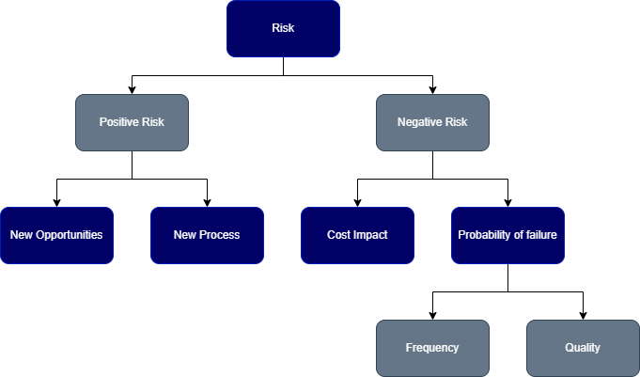

Figure 19:Risk Plan Diagram

* **RBT Stage**

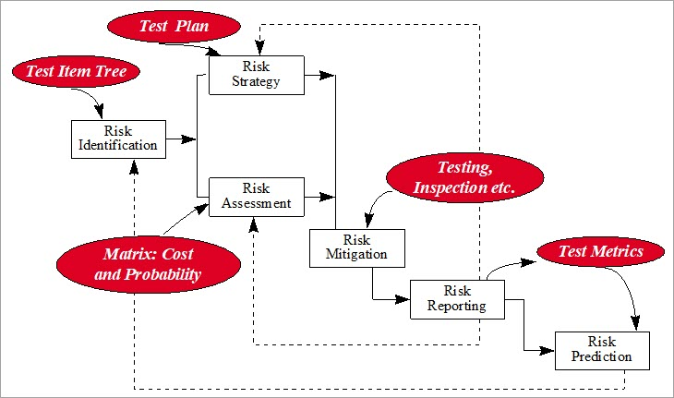Risk-based testing (RBT) is essentially a check completed for projects depending on the risks. Risk-based totally testing strategies make use of risks to prioritize and highlight the proper tests at the time of test execution. Thinking about that there won't be ample time to test all kinds of functionality, risk-based totally testing specially concentrates on testing the capability that incorporates the most important effect and the possibility of failure.

* **Risk Identification**

Identify as lots of those risk elements as viable. Something that could harm your corporation should be on your radar, together with herbal disasters, technological risks, and single point of failure (SPOF) risks.

* Plan risk strategy

A risk management strategy is an established approach to addressing threats. it's also taken into consideration a cyclical system wherein present risks are continuously recognized, assessed, controlled, and monitored.

* Assess Risk

Once potential risks were diagnosed, each risk has to be assessed to determine the chance of it becoming a challenge, its stage of severity, and the probable impact — this allows audit groups prioritize to each risk. Whether your audit group is conducting a risk assessment for Sarbanes Oxley (SOX) or that specialize in other styles of risks, your tests should be systematic, documented, and, depending on your business, reviewed as a minimum yearly. How frequently risk tests are finished will range, depending on the dimensions and complexity of each business

* Minimize risk

To reduce risks, everything possible should be done to reduce the probability and, or impact of a risk to zero.

* Report the risk

Risk reporting is considered a method of identifying risks that are related to or may affect an organization's business processes. Identified risks are usually compiled into a formal risk report.

* Predict Risk from the lesson learned

Predictive, risk Analyzer adds additional field to overall performance measurement and project manipulate. It gives reporting that shows in which to awareness assets, a way to justify spending on mitigation movements.

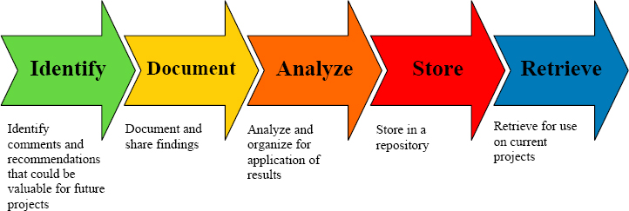

Figure 20:Lesson learned Diagram

* 1. Eight characteristics of Software Product Quality.

The product quality model classifies products best into eight characteristics. specifically, functional suitability, reliability, performance efficiency, usability, safety, compatibility, maintainability and portability.

* Functional Suitability

Functional Suitability refers to how well a product or machine is able to offer features that meet the stated and implied needs.

* Functional Completeness
* Functional Correctness
* Useful Appropriateness
* Reliability

Reliability refers to how nicely a system, product, or element performs precise functions below special conditions.

maturity: Refers to how properly a device, product, or element is able to meet your desires for reliability.

* Availability
* Fault Tolerance
* Recoverability
* Performance efficiency

Performance efficiency refers back to the performance related to the number of sources used.

* Time behavior
* Resource utilization
* Capacity
* Usability

Usability refers to how well a product or system may be used to gain distinct goals efficiently, efficiently, and satisfactorily.

* Appropriateness Recognizability
* Learnability
* Operability
* user mistakes safety
* consumer Interface Aesthetics
* Accessibility
* Safety

Security refers to how nicely a product or system protects data and information from security vulnerabilities.

* Confidentiality
* Integrity
* Non-repudiation
* responsibility
* Authenticity
* Compatibility

Compatibility refers to how properly a product, system, or component can change records in addition to carry out its required functions whilst sharing the same hardware or software program environment.

* Co-lifestyles
* Interoperability
* Maintainability

Maintainability refers to how well a product or system can be changed to enhance, correct, or adapt to adjustments inside the environment in addition to necessities.

* Modularity
* Reusability
* Analyzability
* Modifiability
* Testability
* Portability

Portability refers to how properly a system, product, or aspect can be transferred from one surrounding to any other.

* Adaptability
* Install ability
* Replaceability
  1. Type of risk and its impact

|  |  |  |  |
| --- | --- | --- | --- |
| * + Type of Risk | * + Risk Identification | * + Risk Description | * + Impact |
| Functional | * + Login Risk | * + User unable to login | * + If users cannot login to the website they can’t post or bid car to buy a car |
| * + Registration Risk | * + User unable to register to the website | * + If the user not able to register then the user doesn’t have an account to login to the website |
| * + Post Car | * + User not able to post a car on the website | * + If the user not able to post a car then they can’t use the website features to sell their car on the website |
| * + Update Profile | * + User not able to update/edit their profile detail | * + If user not able to edit their profile, they might be using the wrong profile detail and not able to change their profile |
| * + Search Car | * + User unable to search car by keyword or by price range | * + If user is unable to search car by keyword or by price range then the user can’t find the car of their desired requirements |
| Non – Functional | * + Performance Efficiency | * + Cars list page is not loading properly and there is a picture of car not loaded | * + User can’t see the content of the cars list |
| * + Compatibility | * + Website has different look and feels in the different browser | * + User that uses different web browser has different experience and might be ruin their experience on the website |
| * + Usability | * + User is finding it very difficult on accessing the features on the website like post car, bid car, search car | Users will be confuse and will not able to use the website properly as it should be |
| * + Security | * + User can access all the content even they don’t have the authorization | * + If user has access to forbidden features without authorization they may delete all the information or using the data to abuse something illegal |
| * + Maintainablity | * + Fixing small bugs and maintaining the website to work | * + Website will be better as the time goes |

**Task 4**

1. **Test Planning**
   1. **The test phases of security testing with its prioritization**
      1. **Risk-Based Test Strategy in ABC Car Sale website.**
   2. **What is Security Testing ?**

Security testing is a sort of software program testing that uncovers vulnerabilities, threats, risks in a software program software and prevents malicious assaults from intruders. The purpose of security tests is to identify all feasible loopholes and weaknesses of the software program system which might bring about a lack of statistics, sales, reputation at the palms of the personnel or outsiders of the corporation.

* 1. 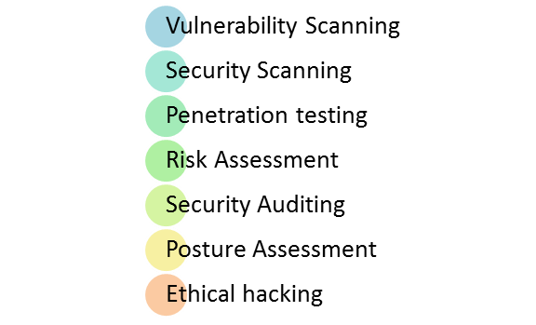**Types of Security Testing**

Figure 21:Types of security Testing

* **Vulnerability Scanning:** this is carried out thru automatic software to experiment with a system against recognized vulnerability signatures.
* **Security Scanning:** It involves identifying network and machine weaknesses, and later offers solutions for decreasing these risks. This scanning can be done for both manual and automated scanning.
* **Penetration testing:** This form of testing simulates an attack from a malicious hacker. This trying out includes the evaluation of a selected gadget to test for capacity vulnerabilities to an outside hacking try.
* **Risk assessment:** This testing involves analysis of security risks observed inside the company. Risks are categorized as Low, Medium, and excessive. This checking out recommends controls and measures to reduce the risk.
* **Security Auditing:** This is an inner inspection of packages and operating systems for safety flaws. An audit also can be executed via line-by-line inspection of code
* **Ethical hacking:** It’s hacking a company software program system. In contrast to malicious hackers, who thieve for their own gains, the cause is to expose safety flaws inside the device.
* **Posture assessment:** This combines security scanning, moral Hacking, and risk assessments to reveal a usual safety posture of a business enterprise.
  1. **Among test strategies, how to carry out security testing.**

The ABC cars project’s security testing method,

* The security checking out technique for the car Portal project is completed via Spring Boot security.
* In Most of the testing strategies, vulnerability evaluation is used within the Safety testing procedure.
* The password supplied for the duration of registration and get entry to the ABC car Project has to be stored in an encrypted shape.
* Invalid users ought to no longer be allowed to get entry to the application or system.
* For the software, cookies and session time should be checked.
* The browser's returned button has to not work on financial websites.
* other pages cannot be accessed without a login.
* Everybody concerned must set expectations and only display applicable Pages to users and administrators.
* Provides material for project managers and program managers to
* Develop and put into effect their own plans.
  1. **Test phases in security testing**

Security testing is carried out after the software implementation phase or after deployment. Also, if its miles are postponed, the value will increase. Consequently, security testing is involved in the early stages of the SDLC life cycle. SDLC levels are numerous safety system stages. That is necessities, design, coding and unit testing, integration testing, system testing, implementation, and support.

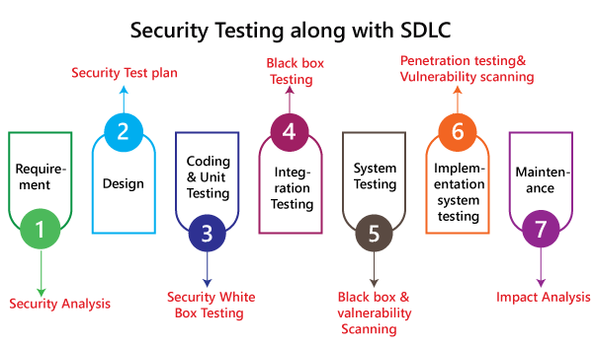

Figure 22:Test phases in security testing

* 1. Detailed test plan with test cases based on quantitative risk analysis
     1. **Quantitative risk analysis**
* Functional Testing - UAT Test (5 cases).
* Compatibility - Cross Browser Testing.
* Performance - Load Testing / Stress Testing.
* Usabillity - Prototyping.
* Security - Security Testing / Spring Security.
* SQL Injection
* Logging
* Authentication and Authorization
* Portability - Multi Platforms.
* Reliability - Usability
* Maintainability - Dependency Injections / JUnit Testing
  1. Develop a test risk matrix for the given specification

|  |  |  |  |  |  |  |  |
| --- | --- | --- | --- | --- | --- | --- | --- |
| Risk No | Test Scenario ID | Test Scenario | Test Objective | Test Priority | Risk | Technique | Expected Result |
| 1 | TS001 | Ensure that users are able to register in the car portal. | Whether or not the user can register using data input like username, password, first name, last name, phone number, contact number | High | Whether or not the user can register using data input like username, password, first name, last name, phone number, contact number | Functional Testing | After submitting the registration data, the user is taken to a page the page will display the user's successfully saved information and a login link. |
| 2 | TS002 | Ensure that users are able to login to the car portal. | Whether the user can log in with the credentials or not |  | Users will not be able to login to ABC Cars Portal | Functional Testing | After registration, the user can successfully log in to the home page |
| 3 | TS003 | Ensure that users are able to post the car on the car portal. | Whether the user can post the car. | Medium | Users will not be able to post cars on the ABC Car portal. | Functional Testing | Users can post the car successfully |
| 4 | TS004 | Ensure that the data is entered into the database | Whether the data database can be added | Medium | Users will not be able to add data to the database. | Functional Testing | After submitting the registration data, the user's successfully saved information will be displayed in the database. |
| 5 | TS005 | Ensure that the registration details are valid. | Is it possible to enter user details and check the validity? | Medium | Users cannot use valid data. | Functional Testing | After submitting valid registration data, the user's successfully saved details will be displayed |
| 6 | TS006 | Ensure that the home page loads at the expected time | Whether the home page can be loaded at the expected time. | High | Users cannot load the home page. | Non-Functional Testing | When the user runs the car portal successfully, the user can successfully login to the home page |
| 7 | TS007 | Ensure that the Spring Boot security code can be authenticated and authorized. | Whether the Spring Boot security code can be authenticated and authorized | Low | Spring Boot security code cannot be authenticated and authorized | Technical Testing | After the Spring Boot security code is verified and authorized, the code can be run with security |
| 8 | TS008 | Make sure the home page has a different look and feel in different browsers. | Whether the home page looks and feels different in different browsers | Low | The home page does not look and feel different to different browsers. | Non-Functional Testing | Setting the home page to look different in different browsers. |
| 9 | TS009 | Ensure that parts of the Spring Boot code are running. | Whether it is possible to ensure that parts of the Spring Boot code are running? | Low | Spring boot code could not work. | Non-Functional Testing | Spring boot code can be run when errors occur again to make it work |

* 1. Create a test risk matrix with the evaluation of the impact

**How Risk Evaluation is conducted.**

In general, to carry out an evaluation, it's miles vital to pick out risks. everyday working conditions, as well as maintenance, shutdowns, power outages, and emergencies, are affected. This consists of identifying risks, determining who can be harmed and how, assessing risks and determining control measures, reporting your findings, and identifying risks. The assessment is reviewed.

* 1. Develop a test risk matrix for the given specification

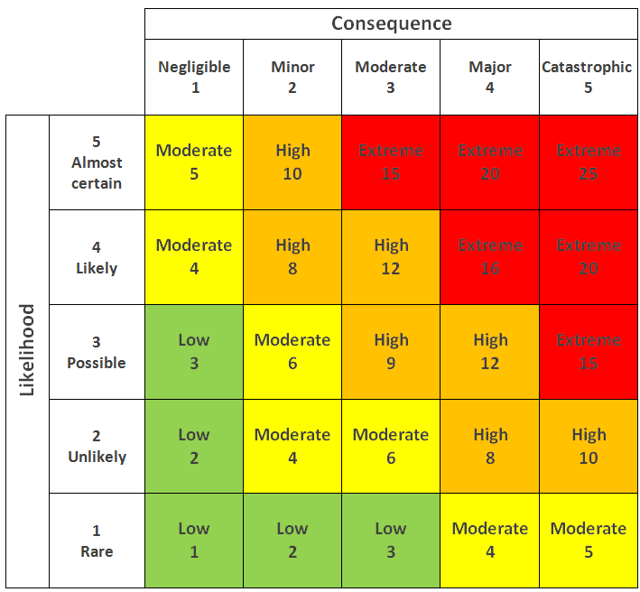

|  |  |  |  |  |  |  |
| --- | --- | --- | --- | --- | --- | --- |
| Risk ID | Risk | Likelihood  (1-5) | Impact  (1 – 5) | Type of  Testing | Risk  Rating | Risk Level |
| 1 | Data not getting into the database | 3 | 4 | Functional Testing | 12 | High |
| 2 | Empty fields are getting into the database | 5 | 4 | Functional Testing | 20 | Extreme |
| 3 | The name fields are taking numbers with the characters | 2 | 3 | Functional Testing | 6 | Moderate |
| 4 | Website navigation links not working properly instead going to the wrong pages | 2 | 2 | Functional Testing | 4 | Moderate |
| 5 | The button is not working when user is trying to submit | 1 | 5 | Functional Testing | 5 | Moderate |
| 6 | Check if the website is not working properly in the google chrome | 2 | 4 | Compatibility Testing | 8 | High |
| 7 | Check if the website is not working properly in safari | 3 | 2 | Compatibility Testing | 6 | Moderate |
| 8 | Check if the website is not working properly in the Microsoft Edge | 2 | 1 | Compatibility Testing | 2 | Low |
| 9 | Pages get loaded in less time or not under 5-sec pages should get a load | 4 | 3 | Performance Testing | 12 | High |
| 10 | Check whether the user finds it easy to run the website | 2 | 2 | Usability Testing | 4 | Moderate |
| 11 | Maintaining the code and adding features and updating the website is comparatively easy | 3 | 3 | Maintainability t Testing | 9 | High |
| 12 | authentication authorization working properly or not in the website | 3 | 2 | Security Testing | 6 | Moderate |
| 13 | the website is able to run on different screen size and different device without compromising feature, design and function. | 4 | 4 | Portability Testing | 16 | Extreme |

**Task 5**

1. **Test Strategy**
   1. **Suitable RBT cycle content and priorities further test cycles**

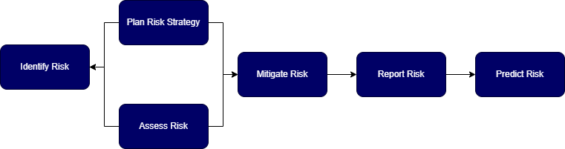Based on ABC Car Sale website, below are design and explanation of suitable risk base test cycle

Figure 23:RBT Cycle Design

* 1. **Identify Risk**

Even as identifying risks in ABC car Portal, it specializes in workshops, checklists, interviews, Delphi method, purpose and effect diagrams, instructions discovered from preceding tasks, root reason analysis, domain specialists and subject matter. All participants involved inside the car Portal challenge help pick out risks.

* 1. **Plan Risk Strategy**

Right here, strategic risk control is the technique of identifying, quantifying and mitigating any risks that have an effect on or are inherent to ABC car's business strategy, strategic targets and strategy implementation.

* 1. **Assess Risk**

Risk assessment is a time period used to describe the whole system or technique that you do. This is to identify risks and risk elements which could cause damage to car portals. Here, evaluation and assessment of chance is likewise vital.

* 1. **Mitigate Risk**

Right here, risk mitigation is a method to prepare for and mitigate the consequences of threats that the car portal enterprise faces. Compared to risk reduction, risk mitigation is critical to reduce the terrible outcomes of threats and disasters on commercial enterprise continuity.

* 1. **Report Risk**

Risk reporting here is a way of figuring out risks that can relate to or affect ABC Car PVT Ltd. enterprise strategies. Diagnosed risks are typically compiled right into a formal risk document, which is exceeded over to an employer's senior control or to diverse control groups throughout the employer.

* 1. **Predict Risk**

Prediction is an crucial a part of any test. Prediction supports the improvement of vital questioning talents via requiring students to draw on their previous know-how and experience in addition to observations to expect what would possibly appear.

* 1. **Communicate the details of the strategy and test planning to the key stakeholders with proper justifications**

1. Justification of selected test methods based on project-quantified risk

|  |  |
| --- | --- |
| Type of Testing | Main Purposes |
| Functionality | The purpose of the test is to ensure that the features based on project requirements are working as intended. |
| Performance | To ensure the performance of the webpages are consistent with the project requirement below 3 seconds. |
| Compatibility | The goal of it to ensure that the website works properly within multiple browsers. |
| Usability | The main purpose is to ensure that the website interfaces are able to be understood and can be accessed by most visitors. |
| Security | The main purpose of the test is to identify any potential threats from the external party that would access the website and create exploitation to the website. |
| Portability | The goal is to ensure that the website could be accessed using multiple different devices. |
| Maintainability | The main purpose is to determine how suitable the project is for maintenance in difficulty wise. |

1. Communicate the details of the strategy and test planning to the key stakeholders with proper justifications

* Stakeholders Identification of ABC Cars Pte Ltd
* Determine for Communication Tool
* Interview Stakeholders
* Gather Together

**What is a Stakeholder?**

A stakeholder is someone, group, or organization with a vested interest, or stake, in the decision-making and activities of a commercial enterprise, enterprise, or undertaking. Stakeholders can be individuals of the organization they have a stake in, or they could haven't any legit affiliation. Stakeholders will have an immediate or indirect effect on the activities or tasks of an organization. Their help is frequently required for business and project achievement.

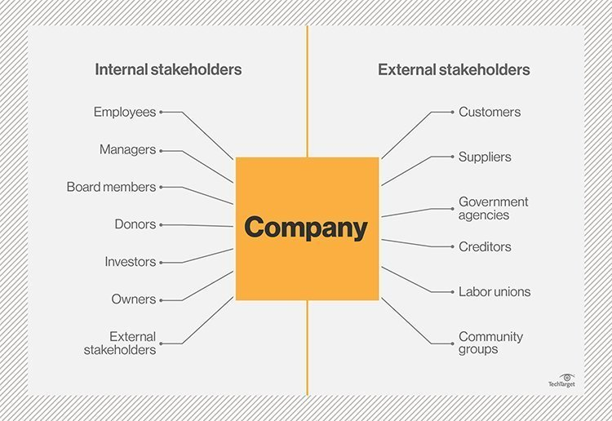

Figure 24:Types of Stakeholders

**Why communicate with key stakeholders is important?**

Risks need to be truly communicated before, for the duration of and after a assignment to ensure stakeholder expectancies and opinions are confirmed. Also, project managers need to engage stakeholders in project conversations, involve key humans, and use the right gear to permit effective communication. Speaking risks to stakeholders. It is also vital to interaction the team, consider the stakeholder state of affairs, use technology, report and use alerts.

Additionally, by way of communicating effectively, permitting them to research and alternate how they are enabled, a better understanding of a purchaser's or stakeholders' targets and average desires can be acquired. Moreover, stakeholders are very important because they offer support and comments on your projects and business enterprise. Also, they boom the wide variety of human beings taking part in my task and appearance after the first-class interests of the challenge corporation.

* + - 1. **Identify and evaluate our ABC Cars Pte Ltd key stakeholders**

Create a list of all project stakeholders, each inner and external, and include Customers, Investors, Company leaders, Creditors, Employees, Department Managers, Business owners, Regional or national communities, Potential customers, Suppliers, Distributors, Shareholders and etc and others who have got an interest in the project or its results. within the case of one individual group, the names of the stakeholders should be delivered, and in the case of an individual, the names of the stakeholders have to also be added. Then observe the identity or vicinity of the touch and provide touch records of the stakeholders such as e-mail and phone number. eventually, the undertaking engages stakeholders

* + - 1. **Determine available communication tools.**

various communique tools are used for external and internal communication. those tools consist of mail, e-mail, telephone, cell phones, smartphones, computers, video, and internet conferencing tools, social networks, as well as online collaboration and productivity platforms. communication equipment can be utilized by the team in interacting with the stakeholders before they are recognized, earlier than engaging with them. They must be privy to the subsequent for every medium of conversation

* Internal Preferences - Your organization in all likelihood has a few strategies which can be preferred, whether or not due to ease of use, extensive availability, or truly way of life.
* Geographical Limitations - Notice whether positive channels are only practical inside a sure geographic radius or location or whether or not they'll be prohibited in a few areas.
* Frequency Limitations - Some communique strategies make extra feel for month-to-month updates than each day.
* Internal Cost
* Stakeholder Costs
* Additional Notes
  + - 1. **Interview Stakeholders.**

You want as plenty information as possible about your stakeholders, mainly key stakeholders.

where possible, get this information from non-public conferences, but some facts may be garnered via oblique manner if necessary.

**Your purpose right here is to determine,**

* The aim of every stakeholder
* Their desired communication frequency
* Any extra issues they've
* Preferred or available verbal exchange channels
  + - 1. **Assign communication channels.**

Frequency communique, primarily based on their availability and possibilities, the maximum stakeholder must have one or more communication channels assigned to them, based totally on preference,

Boundaries, and charges as cited in the step. it's far very essential to have the very last variations of those assignments with the stakeholders, especially to deal with many situations throughout the interview. With the complexity of commonplace colloquial language, communication consciousness has shifted broadly speaking to accumulating records thru a single channel. this is, phrases, face, body, voice, verbal content material, and verbal style are considered channels of conversation.

* + - 1. **Building Plan/Dimensions.**

Development teams can fill out the pdf without delay on paper or use excel or google stakeholder communication template. Design metrics specify the idea on which a design is evaluated for a given hassle for the advantage of the designer. Given different design metrics the equal preliminary and aim conditions might also yield completely one-of-a-kind most efficient designs.

* Stakeholder/person
* Title/role
* Communication type
* Communication channel
* Frequency of communication
* Stakeholder goal
* Stakeholder project interest rating (1-10)
* Contact details
* Notes

**Task 6**

1. **Testing Results**
   1. Execute the risk-based test plan and log the test results
      1. UAT Testing

* **Registration**

|  |  |
| --- | --- |
| Test Scenario | Registration |
| TS001 |
| Test Cases | Registration in ABC Cars Sales Portal Website |
| TC001 | Validating data that is input into registration form |
| TC002 | After user submitting correct data it should load a thank you page |

|  |  |  |  |  |  |  |  |
| --- | --- | --- | --- | --- | --- | --- | --- |
| Tet Scenario ID | Test Case ID | | Test Priority | Pre-conditions | Expected Result | Actual Result | Final Result |
| TS001 | TC001 | | High | ABC Cars Sale Portal Website hosted on server | All field is needed except “about” subject if the user input clean statistics It ought to throw an error | As expected | Pass |
| Test Data | | Firstname = “______”  Lastname = “______”  Phone number = +94742269976  Address = Test2  About = Test2 | | | | | |
| Evidance | | Fig: TS001 – TC001 | | | | | |

**Evidence: Fig: TS001 – TC001** 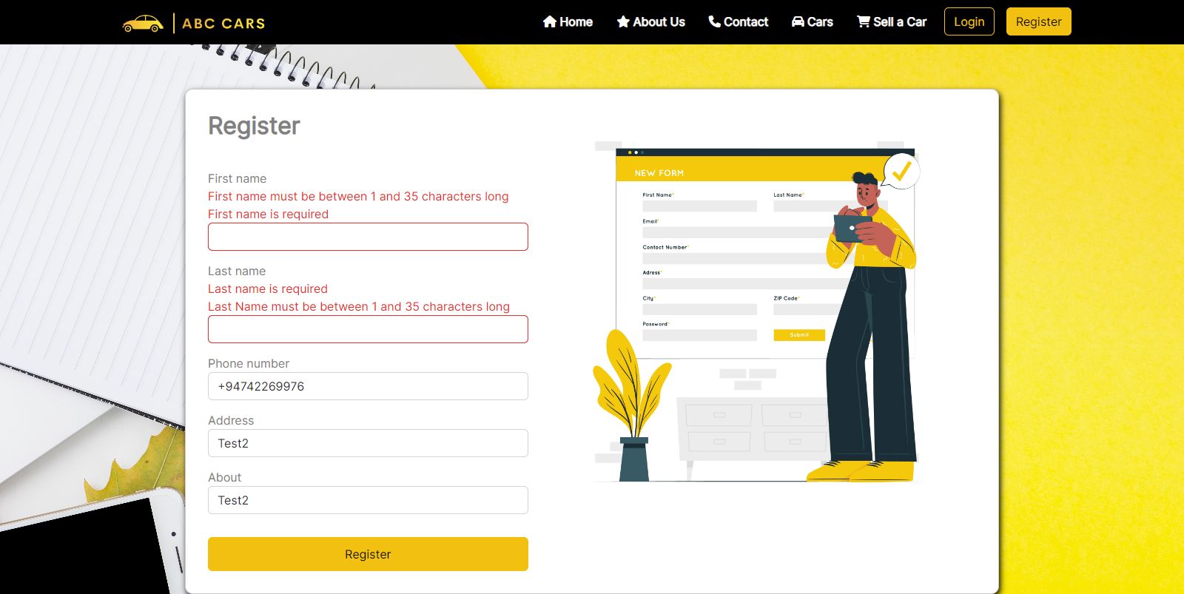

Figure 25:Evidence: Fig: TS001 – TC001

|  |  |  |  |  |  |  |  |
| --- | --- | --- | --- | --- | --- | --- | --- |
| Test Scenario ID | Test Case ID | | Test Priority | Pre-conditions | Expected Result | Actual Result | Final Result |
| TS001 | TC002 | | High | ABC Cars Sale Portal Website hosted on a server | Load thank you page after a successful registration | As expected | Pass |
| Test Data | | Username= chathu@77  Password = 12345678  Firstname = Chathushi  Lastname = Jayarathna  Phone number = +94742269976  Address = “Chathu” St. Clairs Road, Kandy  About = A confident and outgoing sales professional amassing over 6 years experience in the automotive industry with a strong track record of meeting and exceeding sales targets | | | | | |
| Evidance | | Fig: TS001 – TC002 (1)  Fig: TS001 – TCOO2 (2) | | | | | |

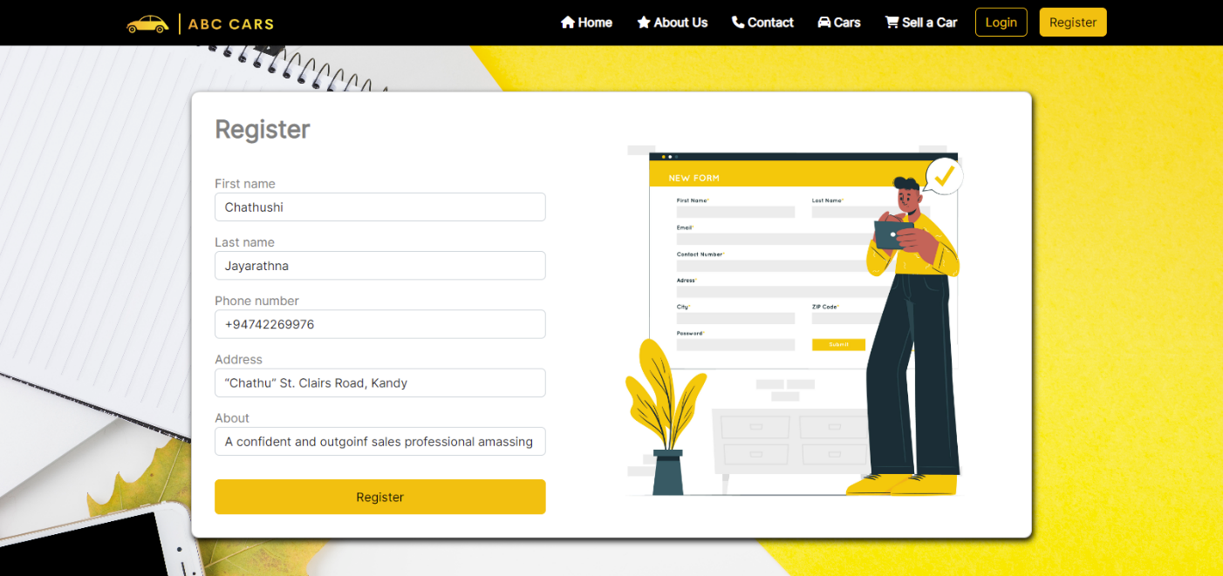**Evidence: Fig: TS001 – TC002 (1)**

Figure 26:Evidence: Fig: TS001 – TC002 (1)

**Evidence: Fig: TS001 – TCOO2 (2)**

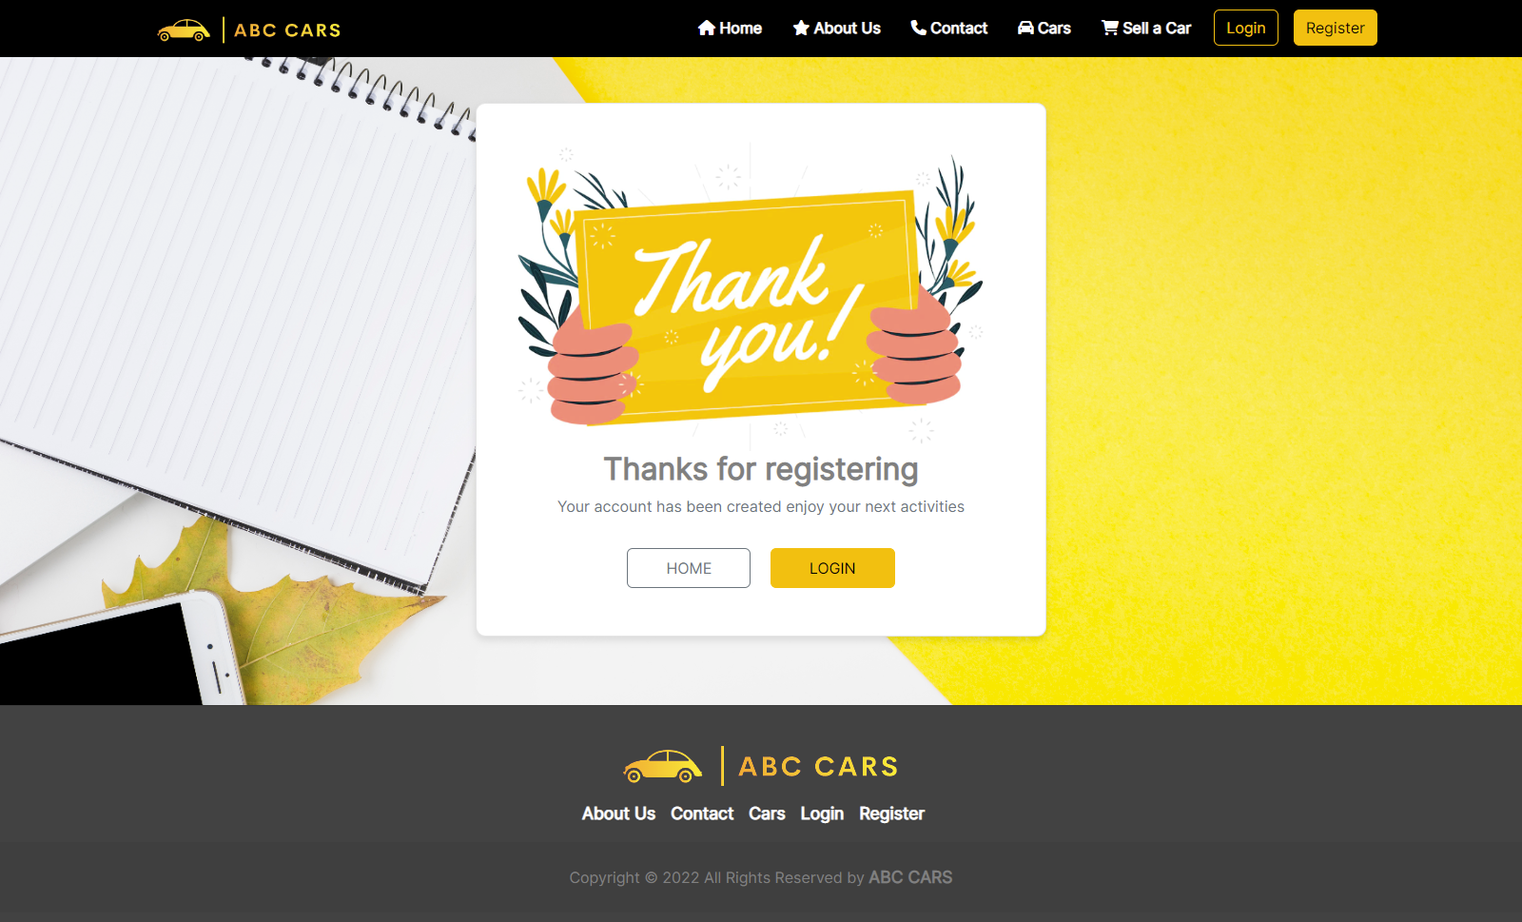

Figure 27:Evidence: Fig: TS001 – TCOO2 (2)

* **Search**

|  |  |
| --- | --- |
| Test Scenario | Search Car |
| TS002 |
| Test Cases | Search Car by keyword or price range |
| TC001 | Search car by keyword (Make, Model, or Year) |
| TC002 | Search car by price range (Maximum price & Minimum Price) |

|  |  |  |  |  |  |  |  |
| --- | --- | --- | --- | --- | --- | --- | --- |
| Test Scenario ID | Test Case ID | | Test Priority | Pre-conditions | Expected Result | Actual Result | Final Result |
| TS002 | TC001 | | Medium | ABC Cars Sale Portal Website hosted on a server | When the car name is searched among the relevant care registration data, it displays the relavant information og the given car details on the search result page | As expected | Pass |
| Test Data | | Model : Peugeot | | | | | |
| Evidance | | Fig: TS002 – TC001 (1)  Fig: TS002 – TC001 (2) | | | | | |

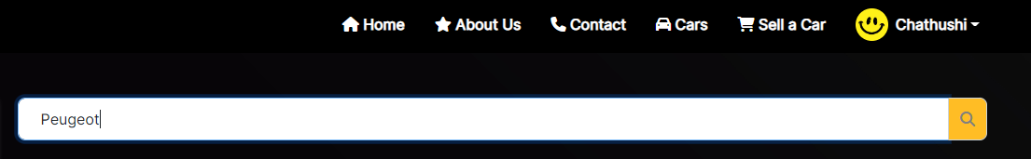**Evidence: Fig: TS002 – TC001 (1)**

Figure 28:Evidence: Fig: TS002 – TC001 (1)

**Evidence: Fig: TS002 – TC001 (2)**

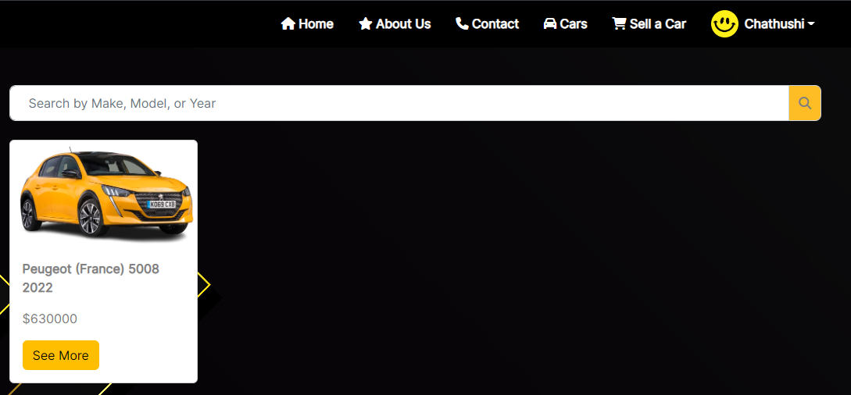

Figure 29:Evidence: Fig: TS002 – TC001 (2)

|  |  |  |  |  |  |  |  |
| --- | --- | --- | --- | --- | --- | --- | --- |
| Test Scenario ID | Test Case ID | | Test Priority | Pre-conditions | Expected Result | Actual Result | Final Result |
| TS002 | TC002 | | Medium | ABC Cars Sale Portal Website hosted on a server | Error message (car not found) will be displayed after submitting details of unregistered vehciles | As expected | Fail |
| Test Data | | Model: Peugeot | | | | | |
| Evidence | | Fig: TS002 – TC002 (1)  Fig: TS002 – TC002 (2) | | | | | |

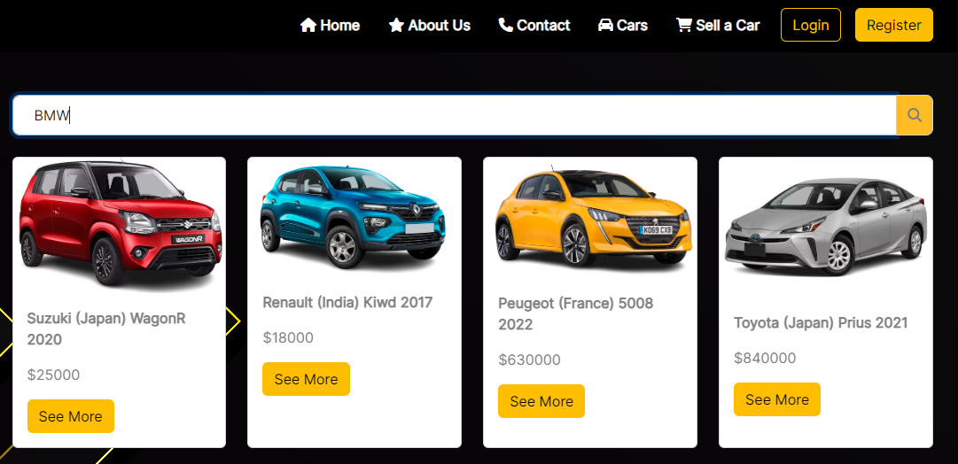**Evidance: Fig: TS002 – TC002 (1)**

Figure 30:Evidence: Fig: TS002 – TC002 (1)

**Evidance: Fig: TS002 – TC002 (2)**

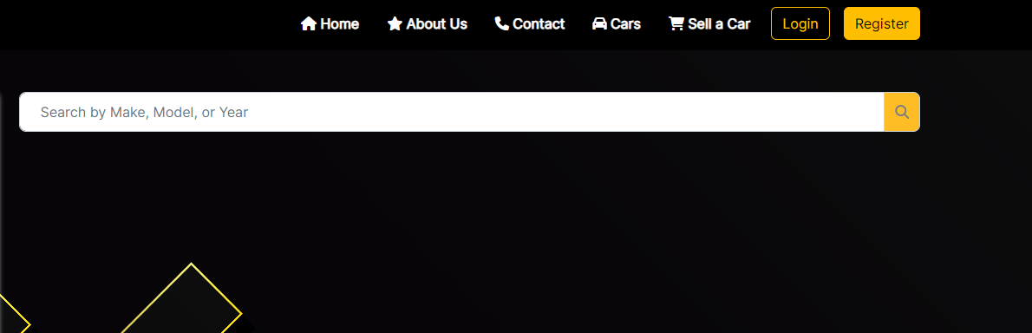

Figure 31:Evidence: Fig: TS002 – TC002 (2)

* **Login**

|  |  |
| --- | --- |
| Test Scenario | Login |
| TS003 |
| Test Cases | Login to ABC CARS PTE LTD Portal |
| TC001 | Validating data that is input into the login form |
| TC002 | Check that the login button loads the profile page when logged in. |
| TC003 | Check access website from the user with the role “USER” and user with role “ADMIN” |

|  |  |  |  |  |  |  |  |
| --- | --- | --- | --- | --- | --- | --- | --- |
| Test Scenario ID | Test Case ID | | Test Priority | Pre-conditions | Expected Result | Actual Result | Final Result |
| TS003 | TC001 | | High | ABC Cars Sale Portal Website hosted on a server | When trying to login in after inputting an incorrect password, an error message is displayed | As expected | Pass |
| Test Data | | Username = chathu@77  Password = “567834565” (correct password = 12345678) | | | | | |
| Evidance | | Fig: TS003 – TC001 | | | | | |

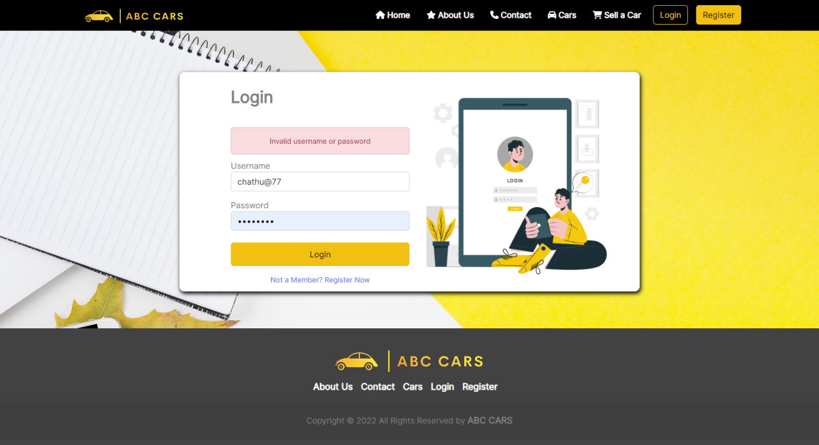**Evidance: Fig: TS003 – TC001**

Figure 32: Evidence: Fig: TS003 -TC001

|  |  |  |  |  |  |  |  |
| --- | --- | --- | --- | --- | --- | --- | --- |
| Test Scenario ID | Test Case ID | | Test Priority | Pre-conditions | Expected Result | Actual Result | Final Result |
| TS003 | TC002 | | High | ABC Cars Sale Portal Website hosted on a server | After entering the details correctly and clicking the login button, the user will be logged in to the profile page | As expected | Pass |
| Test Data | | Username = chathu@77  Password = 12345678 | | | | | |
| Evidance | | Fig: TS003 – TC002 (1)  Fig: TS003 – TC002 (2) | | | | | |

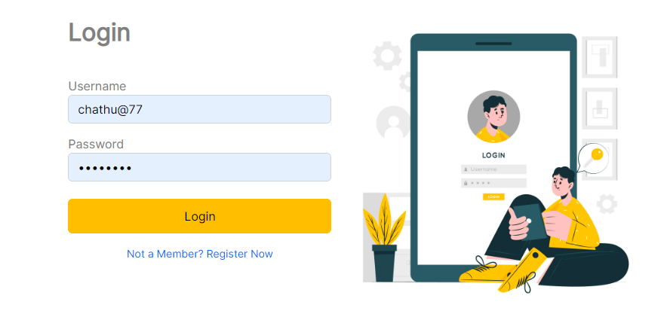**Evidance: Fig: TS003 – TC002 (1)**

Figure 33:Fig: TS003 – TC002 (1)

**Evidance: Fig: TS003 – TC002 (2)**

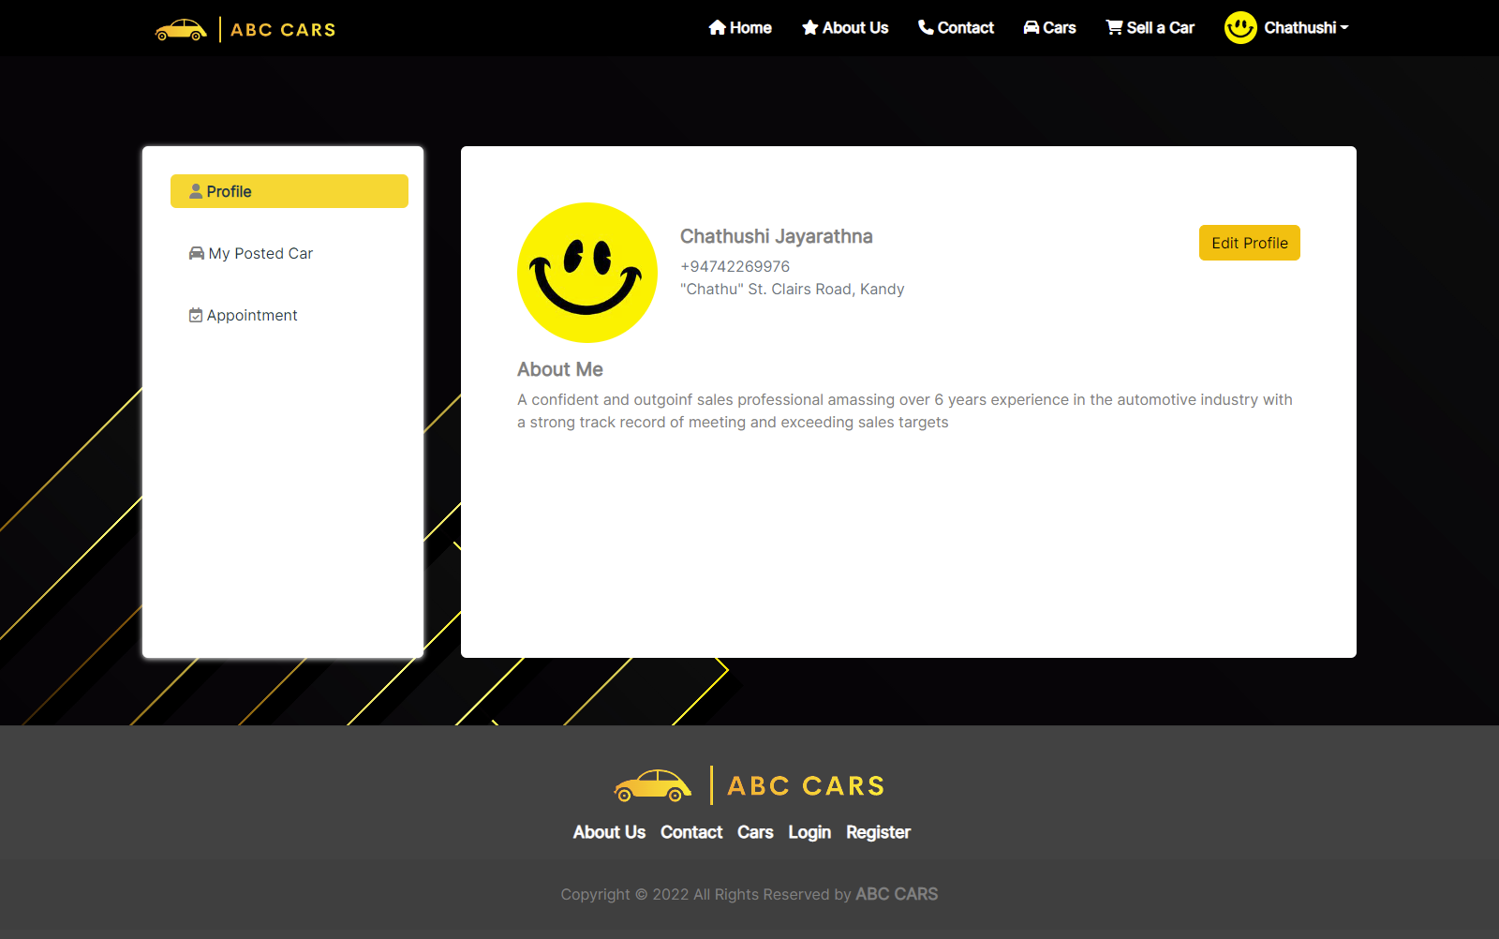

Figure 34:Fig: TS003 – TC002 (2)

|  |  |  |  |  |  |  |  |
| --- | --- | --- | --- | --- | --- | --- | --- |
| Test Scenario ID | Test Case ID | | Test Priority | Pre-conditions | Expected Result | Actual Result | Final Result |
| TS003 | TC003 | | High | ABC Cars Sale Portal Website hosted on a server | “user” role has access to publish car, place vehicle bid, appoint test drive,  “ADMIN” role has get right of entry to to admin dashboard and website car income control | As expected | Pass |
| Test Data | | Username = admin123  Password = admin123 | | | | | |
| Username = user123  Password = user123 | | | | | |
| Evidence | | Fig: TS003 – TC003 (1) – Post car (User)  Fig: TS003 – TC003 (2) – Car Bid (User)  Fig: TS003 – TC003 (3) – Test Drive Appointments (User)  Fig: TS003 – TC003 (4) – Admin Dashboard  Fig: TS003 – TC003 (5) – Car Mangement | | | | | |

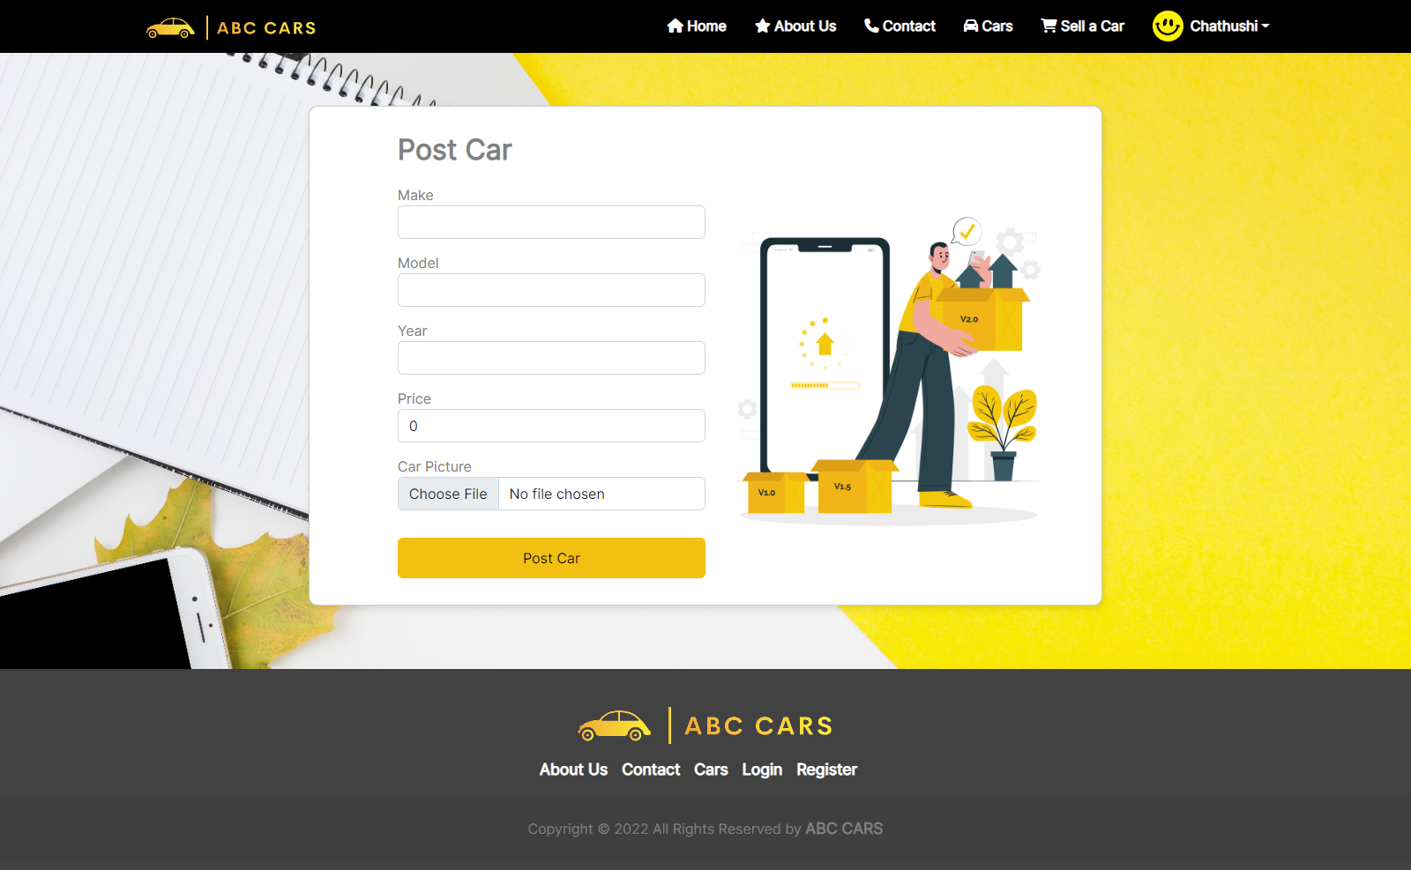**Evidance: Fig: TS003 – TC003 (1) – Post car (User)**

Figure 35:Fig: TS003 – TC003 (1) – Post car (User)

**Evidence: Fig: TS003 – TC003 (2) – Car Bid (User)**

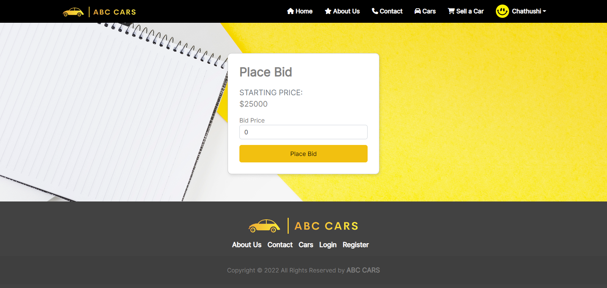

Figure 36:Evidence: Fig: TS003 – TC003 (2) – Car Bid (User)

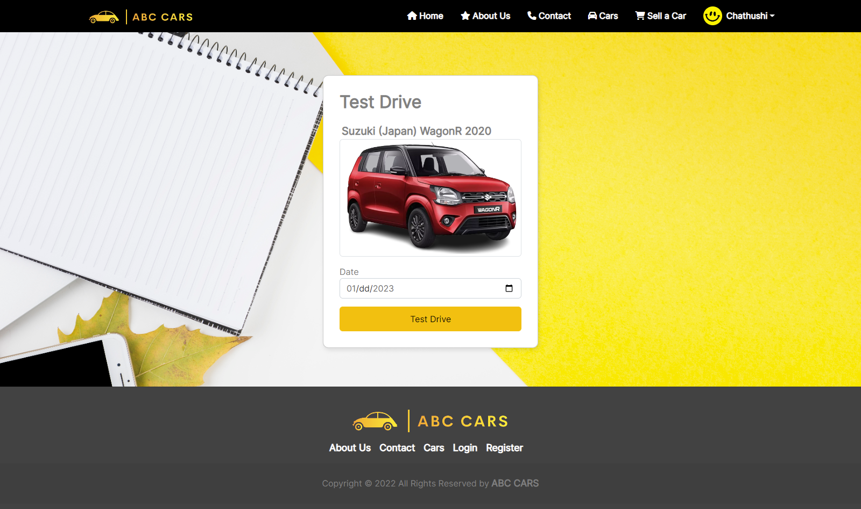**Fig: TS003 – TC003 (3) – Test Drive Appointments (User)**

Figure 37:Fig: TS003 – TC003 (3) – Test Drive Appointments (User)

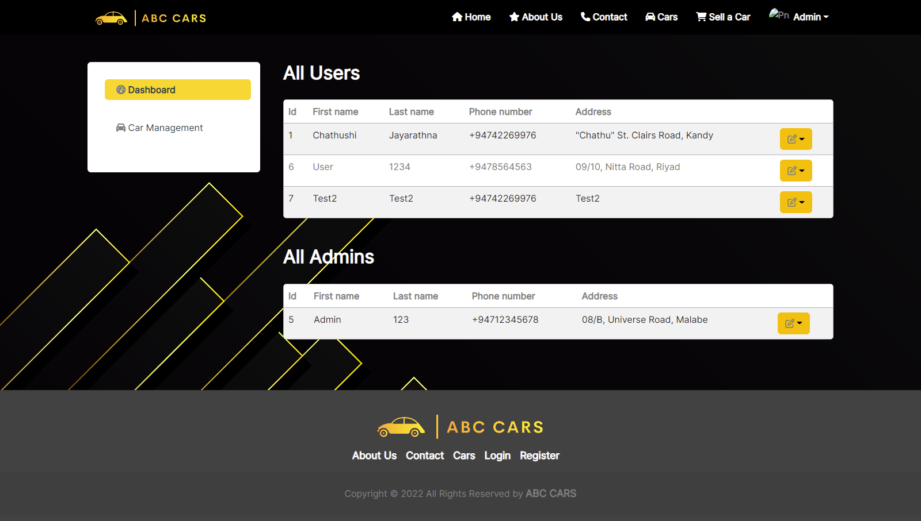**Fig: TS003 – TC003 (4) – Admin Dashboard**

Figure 38:Fig: TS003 – TC003 (4) – Admin Dashboard

**Fig: TS003 – TC003 (5) – Car Mangement**

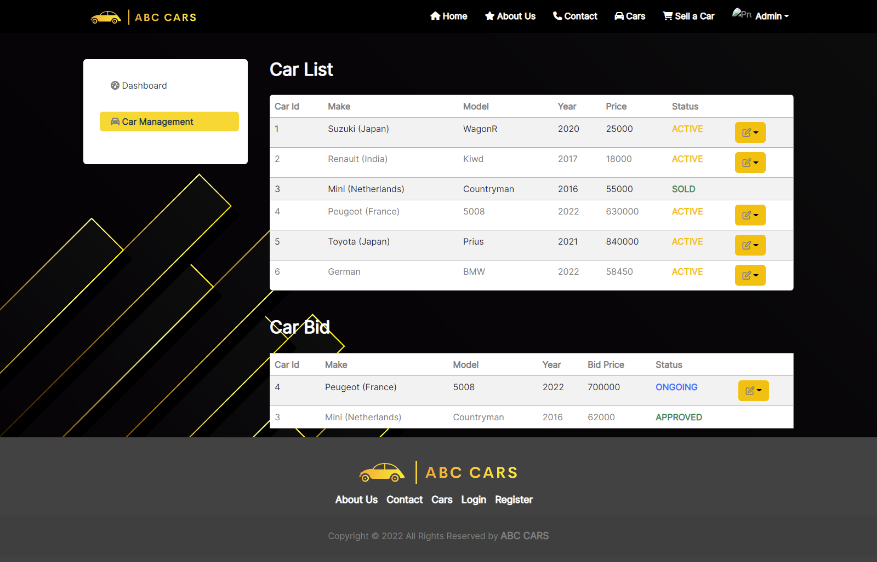

Figure 39:Fig: TS003 – TC003 (5) – Car Mangement

* **View and Post Car**

|  |  |
| --- | --- |
| Test Scenario | View Car |
| TS004 |
| Test Cases | View Car in ABC CARS PTE LTD Portal |
| TC001 | After the user clicking see more button on car details it should load a car details page |
| TC002 | After the car details posted, those details should be added to the database |

|  |  |  |  |  |  |  |  |
| --- | --- | --- | --- | --- | --- | --- | --- |
| Test Scenario ID | Test Case ID | | Test Priority | Pre-conditions | Expected Result | Actual Result | Final Result |
| TS004 | TC001 | | High | ABC Cars Sale Portal Website hosted on a server | After the user clicking see more button on car details it should load a car details page | As expected | Pass |
| Test Data | | Click on see more button | | | | | |
| Evidence | | Fig: TS004 – TC001 (1)  Fig: TS004 – TC001 (2) | | | | | |

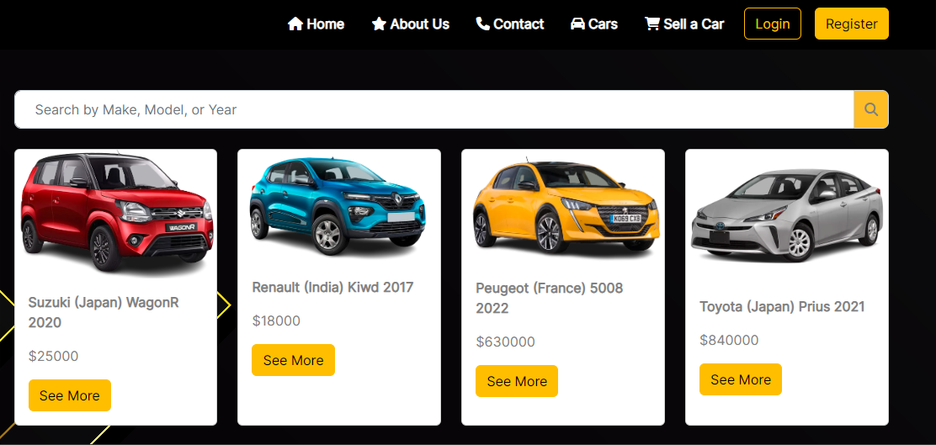**Evidance: Fig: TS004 – TC001 (1)**

Figure 40:Evidence: Fig: TS004 – TC001

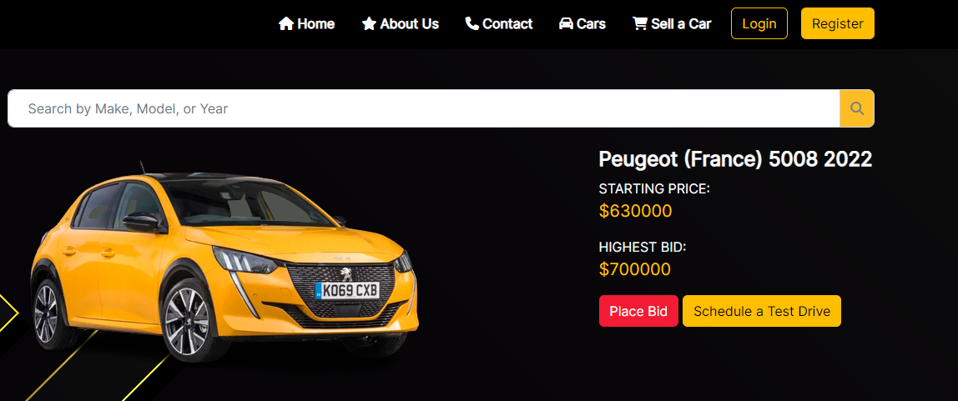**Evidance: Fig: TS004 – TC001 (1)**

Figure 41:Evidence: Fig: TS004 – TC001 (1)

|  |  |  |  |  |  |  |  |
| --- | --- | --- | --- | --- | --- | --- | --- |
| Test Scenario ID | Test Case ID | | Test Priority | Pre-conditions | Expected Result | Actual Result | Final Result |
| TS004 | TC002 | | Medium | ABC Cars Sale Portal Website hosted on a server | After the car details posted, those details should be added to the database | As expected | Pass |
| Test Data | | Make: German  Model: BMW  Year: 2022  Price: $58450  Car picture: BMW.png | | | | | |
| Evidence | | Fig: TS004 – TC002 (1)  Fig: TS004 – TC002 (2)  Fig: TS004 – TC002 (3) | | | | | |

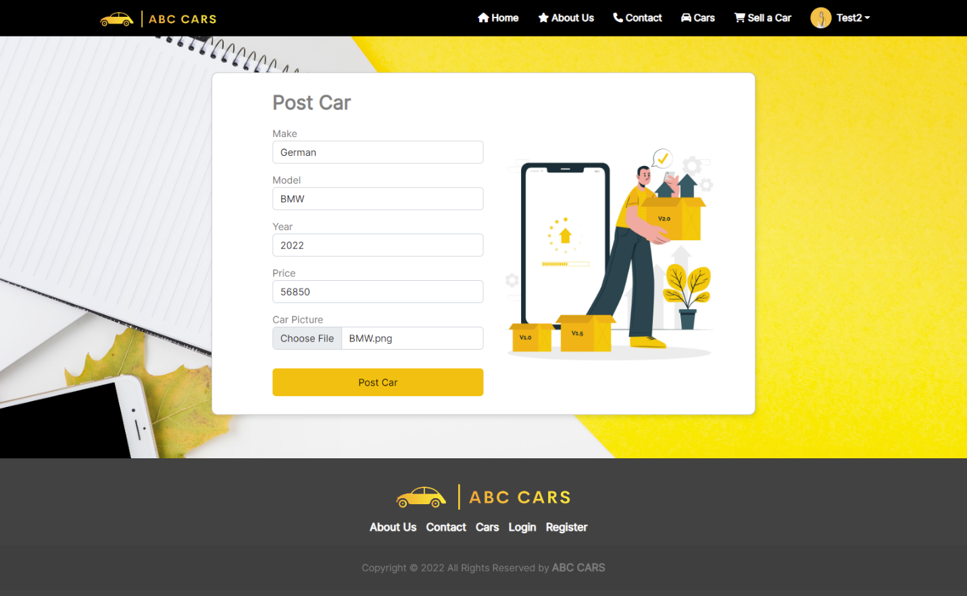**Evidance: Fig: TS004 – TC002(1) – Car Details post form**

Figure 42:Evidence: Fig: TS004 – TC002(1)

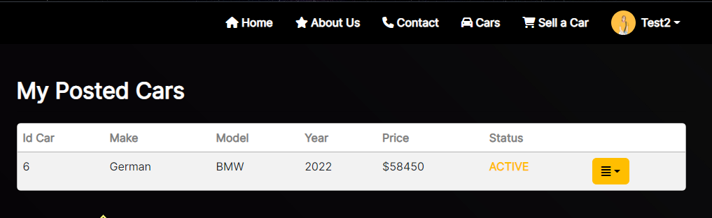**Evidance: Fig: TS004 – TC002(2) – Posted car Details**

Figure 43:Evidence: Fig: TS004 – TC002(2)

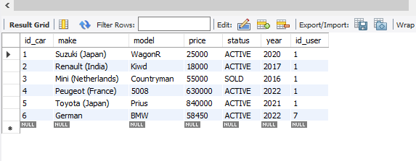**Evidance: Fig: TS004 – TC002(3)**

Figure 44:Evidence: Fig: TS004 – TC002(3)

* + 1. **Unit Testing**

|  |  |
| --- | --- |
| Test Scenario | To ensure registration |
| TS00 |
| Test Cases | Unit Testing |
| UT001 | Ensure that registration working correctly |
| UT002 | Ensure that login working correctly |
| UT003 | Ensure that the search car working correctly |
| UT004 | Ensure that the view car working correctly |
| UT005 | Ensure that post-care working correctly |

|  |  |  |  |  |  |  |  |
| --- | --- | --- | --- | --- | --- | --- | --- |
| Test Case ID | Test Case | Preconditions | Test Step | Test Data | Expected Results | Actual Results | Pass / Fail |
| TS005 | UT001 | The user should have the URL of the website and open the homepage of the abccars | * Type URL * Click “Sign up” on the website home page linked to the Landing page * Enter all the fields. * Click submit. | Username= chathu@77  Password = 12345678  Firstname = Chathushi  Lastname = Jayarathna  Phone number = +94742269976  Address = “Chathu” St. Clairs Road, Kandy  About = A confident and outgoing sales professional amassing over 6 years’ experience in the automotive industry with a strong track record of meeting and exceeding sales targets | The entered data should be added to the database and the thank you page should appear to the user after a successful registration | As expected, | Pass |
| TS005 | UT002 | The user should have the URL of the website and open the homepage of the abccars | * Type URL * Click “Login” on the website home page linked to the Landing page * Enter all the fields. * Click submit. | Username= chathu@77  Password = 12345678 | User Profile should be loaded | As expected, | Pass |
| TS005 | UT003 | The user should have the URL of the website and open the homepage of the ABC cars | * Type URL * Click “Cars” on the website home page linked to the landing Page * Search car by its model, make, or year * Click the search button | Model: **Peugeot**  **Make: France**  **Year: 2022** | Search cars details should be appeared | As expected, | Pass |

* + 1. **Functional Testing – Performance Testing**

|  |  |
| --- | --- |
| Test Scenario | Ensure that the user or admin can access the home page at the required time. |
| TS006 |
| Test Cases | Performance Testing |
| TC001 | Test cases Loading Time/ speed checking out |
| TC002 | Allocate the login web page to the index page at login load time. |
| TC003 | To look how long it takes for the user to come back to the home page and sign up and log in. |

|  |  |  |  |  |  |  |  |
| --- | --- | --- | --- | --- | --- | --- | --- |
| Test Scenario ID | Test Case ID | | Test Priority | Pre-conditions | Expected Result | Actual Result | Final Result |
| TS006 | TC001 | | Internet access required | Admin/User successful registration | After users/admins registered, the thank you page will be displayed. They can be returned by clicking the home button when needed | As expected | Pass |
| Test Data | | Register   * Username= chathu@77 * Password = 12345678 * Firstname = Chathushi * Lastname = Jayarathna * Phone number = +94742269976 * Address = “Chathu” St. Clairs Road, Kandy * About = Hi   Click Register button  It will appear registration thank u page  Click “home” button to return home page | | | | | |
| Evidence | | Fig: TS006 – TC001 (1)  Fig: TS006– TC001 (2)  Fig: Ts006 – TC001 (3) | | | | | |

**Evidence: Fig: TS006 – TC001 (1)**

Figure 45:Evidence: Fig: TS006 – TC001 (1)

Figure 46:Evidence: Fig: TS006 – TC001 (1)

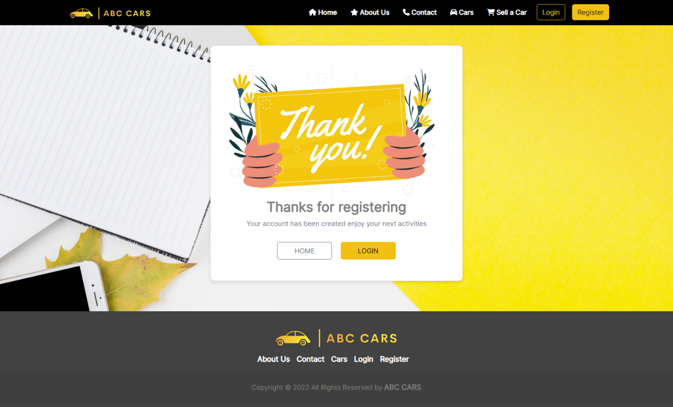**Evidence: Fig: TS006 – TC001 (2)**

Figure 47:Evidence: Fig: TS006 – TC001 (2)

**Evidence: Fig: TS006 – TC001 (3) – Home Page**

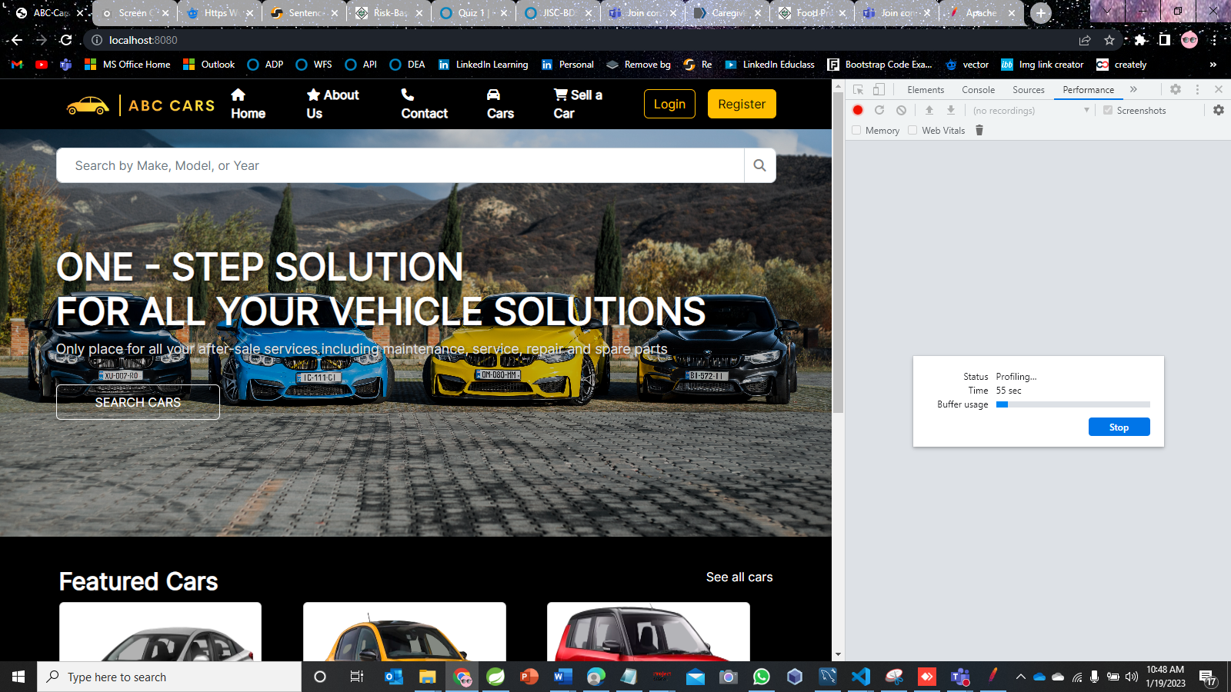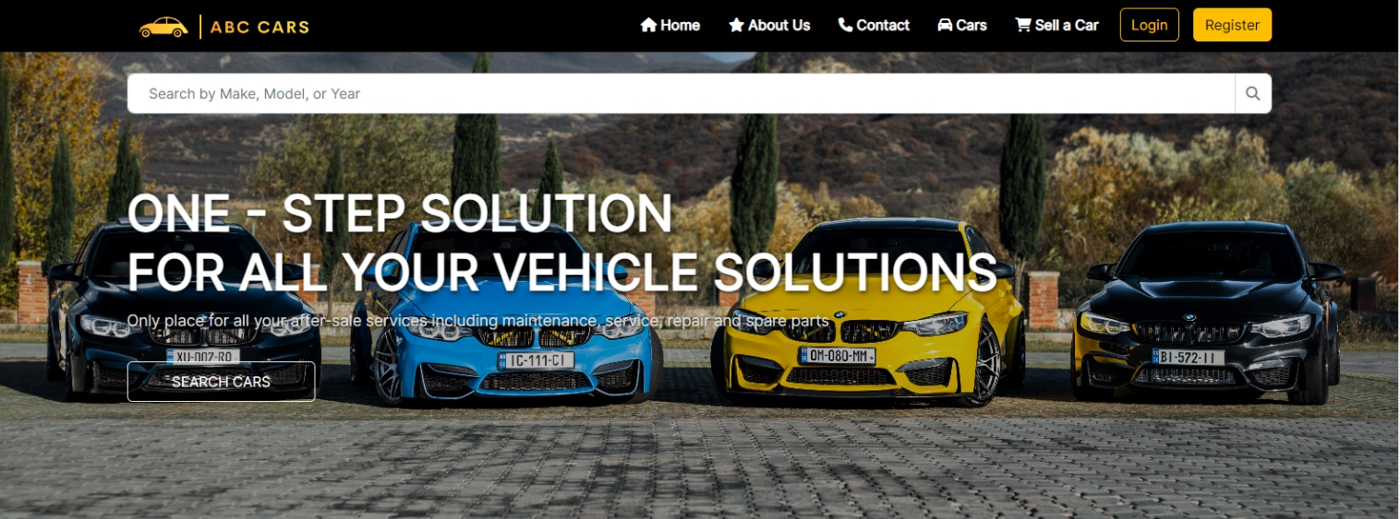**(**The results show that is took 55sec for the user to go from the login to the home page)

Figure 48:Evidence: Fig: TS006 – TC001 (3)

* + 1. **Functional Testing - Compatibility Testing**

|  |  |  |  |
| --- | --- | --- | --- |
| Requirements | Test Scenario ID | Test Scenario | Number of test cases |
| Compatibility Testing | CBT001 | Registration | 2 |
| CBT002 | Login | 2 |
| CBT003 | Add Car | 2 |
| CBT004 | Search car | 2 |

* **Registration**

|  |  |  |  |  |  |  |  |  |
| --- | --- | --- | --- | --- | --- | --- | --- | --- |
| Scenario ID | Test Case ID | Test Case | Preconditions | Test Step | Test Data | Expected Results | Actual Results | Pass / Fail |
| CBTS001 | CBT01 | Check the register user is working correctly. | ABC Cars Portal website has completed and uploaded on server | 1. Go to Google chrome type localhost:8080 | In Registration Page, input test data  Username= chathu@77  Password = 12345678  Firstname = Chathushi  Lastname = Jayarathna  Phone number = +94742269976  Address = “Chathu” St. Clairs Road, Kandy  About = Hi  Click Register button | 1. Loaded the Thank Page correctly. | As expected, | Pass |

**Evidance: Fig: CBTS001 – CBT01**



Figure 49:Evidance: Fig: CBTS001 – CBT01 - Google Chrome

Figure 50:Evidance: Fig: CBTS001 – CBT01 - Google Chrome

|  |  |  |  |  |  |  |  |  |
| --- | --- | --- | --- | --- | --- | --- | --- | --- |
| Scenario ID | Test Case ID | Test Case | Preconditions | Test Step | Test Data | Expected Results | Actual Results | Pass / Fail |
| CBTS001 | CBT02 | Check that registration page is working correctly on Mozilla Firefox. | ABC Cars Portal website has completed and uploaded on server | Go to MS Edge type localhost:8080 | In Registration Page, input test data  Username= cbt@11  Password = cbt@11  Firstname = CBT  Lastname = CBT  Phone number = +94123456789  Address = CBT  About = CBT  Click Register button | 1. Loaded the Thank you correctly. | As expected, | Pass |

**Evidance: Fig: CBTS001 – CBT02 – Microsoft Edge**

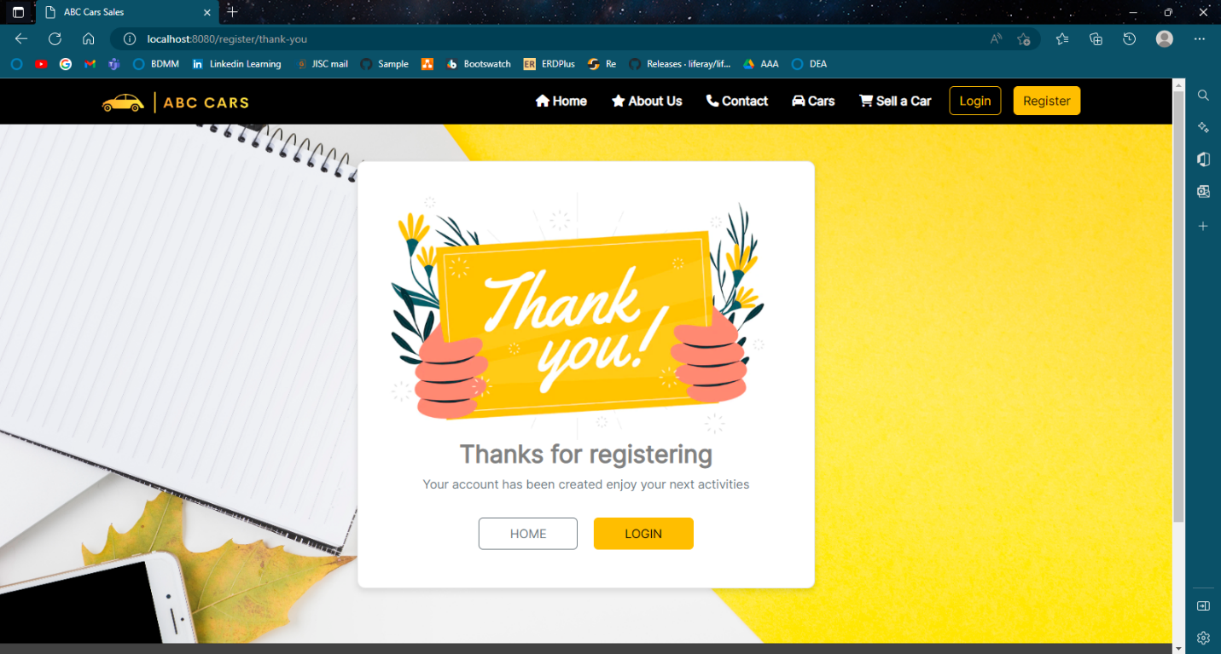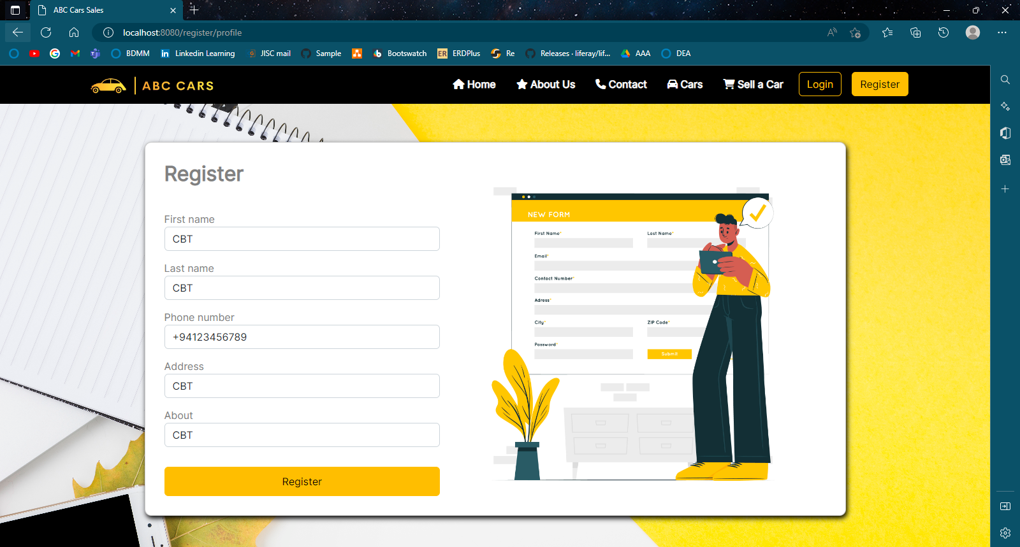

Figure 51:Evidance: Fig: CBTS001 – CBT01 – Microsoft Edge

Figure 52:Evidance: Fig: CBTS001 – CBT01 – Microsoft Edge

* **Login**

|  |  |  |  |  |  |  |  |  |
| --- | --- | --- | --- | --- | --- | --- | --- | --- |
| Scenario ID | Test Case ID | Test Case | Preconditions | Test Step | Test Data | Expected Results | Actual Results | Pass / Fail |
| CBTS002 | CBT01 | Check the login user is working correctly on Google Chrome. | ABC Cars Portal website has completed and uploaded on server | 1. Go to Google chrome type localhost:9091 | In Login page enter sample data  Username = chathu@77  Password = 12345678 | 1. Loaded the Login Page correctly. | As expected, | Pass |
| CBTS002 | CBT02 | Check that Login page is working correctly on Microsoft Edge. | ABC Cars Portal website has completed and uploaded on server | 1. Go to MS Edge type localhost:9091 | In Login page enter sample data  Username = chathu@77  Password=12345678 | 1. Loaded the registration page correctly. | As expected, | Pass |

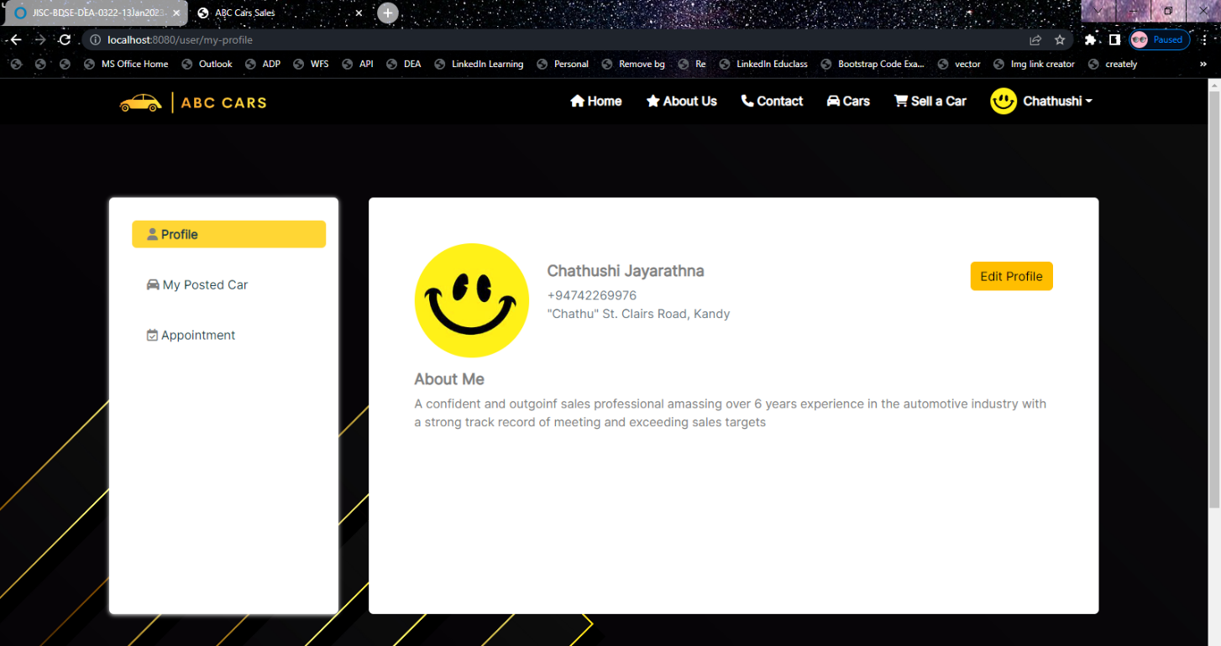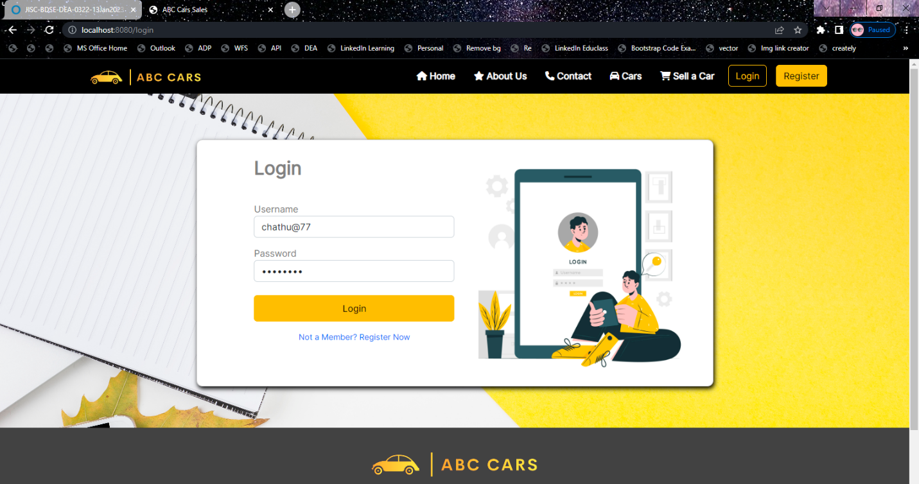**Evidance: Fig: CBTS002 – CBT01 – Google Chrome**

Figure 53:Evidance: Fig: CBTS002 – CBT01 – Google Chrome

Figure 54:Evidance: Fig: CBTS002 – CBT01 – Google Chrome

**Evidance: Fig: CBTS002 – CBT02 – Microsoft Edge**

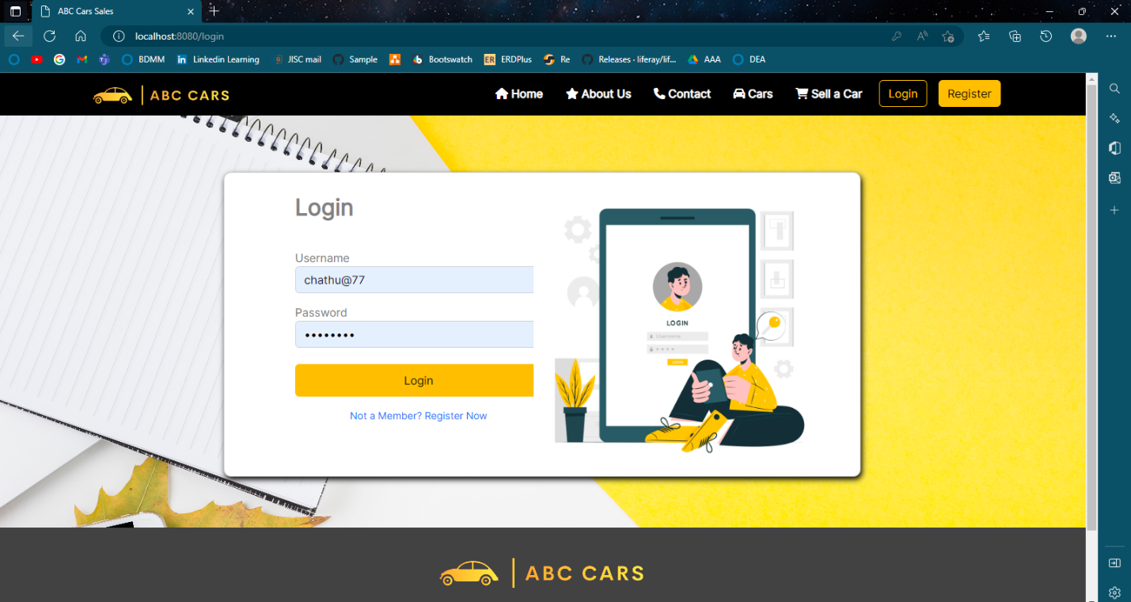

Figure 55:Evidance: Fig: CBTS002 – CBT01 – Microsoft Edge

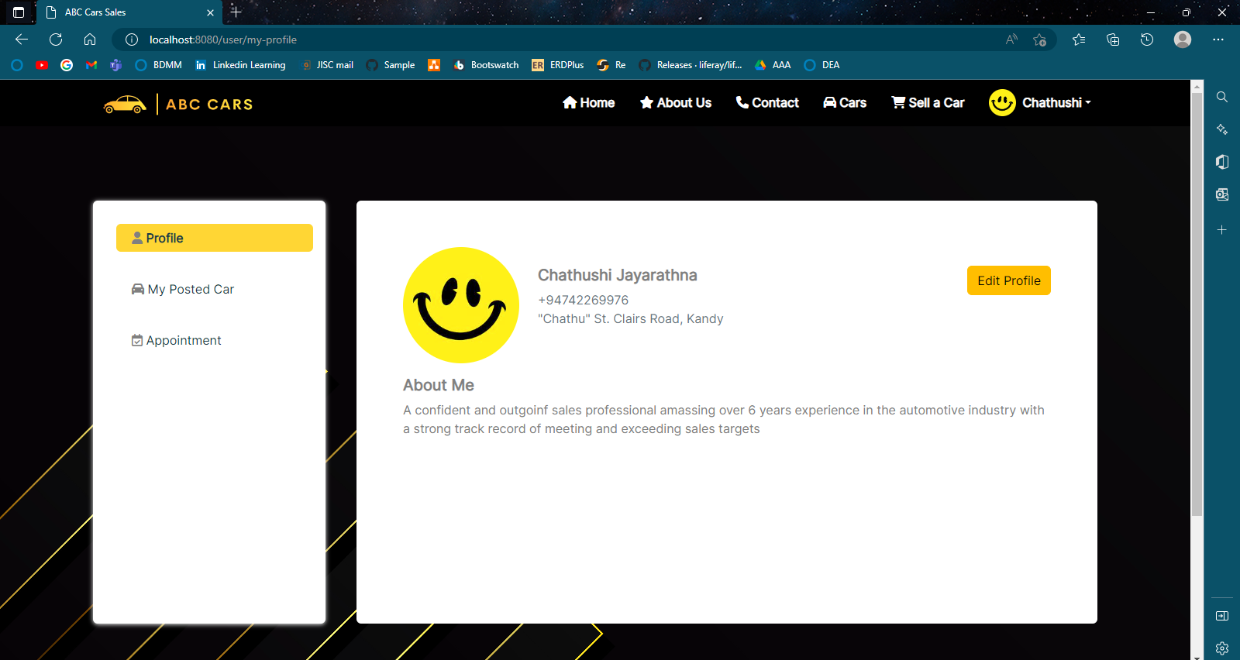

Figure 56:Evidance: Fig: CBTS002 – CBT01 – Microsoft Edge

* **Post Car**

|  |  |  |  |  |  |  |  |  |
| --- | --- | --- | --- | --- | --- | --- | --- | --- |
| Scenario ID | Test Case ID | Test Case | Preconditions | Test Step | Test Data | Expected Results | Actual Results | Pass / Fail |
| CBTS003 | CBT01 | Check the Add car is working correctly on Google Chrome. | ABC Cars Portal website has completed and uploaded on server | 1. Go to Google chrome type localhost:9091 | In the PostCar page enter sample data  Make = Suzuki (Japan)  Model = WagonR  Year = 2020  Price = $25000 | 1. Loaded the Add Car correctly. | As expected, | Pass |
| CBTS003 | CBT02 | Check that Add car is working correctly on Mozilla Firefox. | ABC Cars Portal website has completed and uploaded on server | 1. Go to MS Edge type localhost:9091 | In Post Car page enter sample data  Make = Suzuki (Japan)  Model = WagonR  Year = 2020  Price = $25000 | 1. Loaded the Add Car page correctly. | As expected, | Pass |

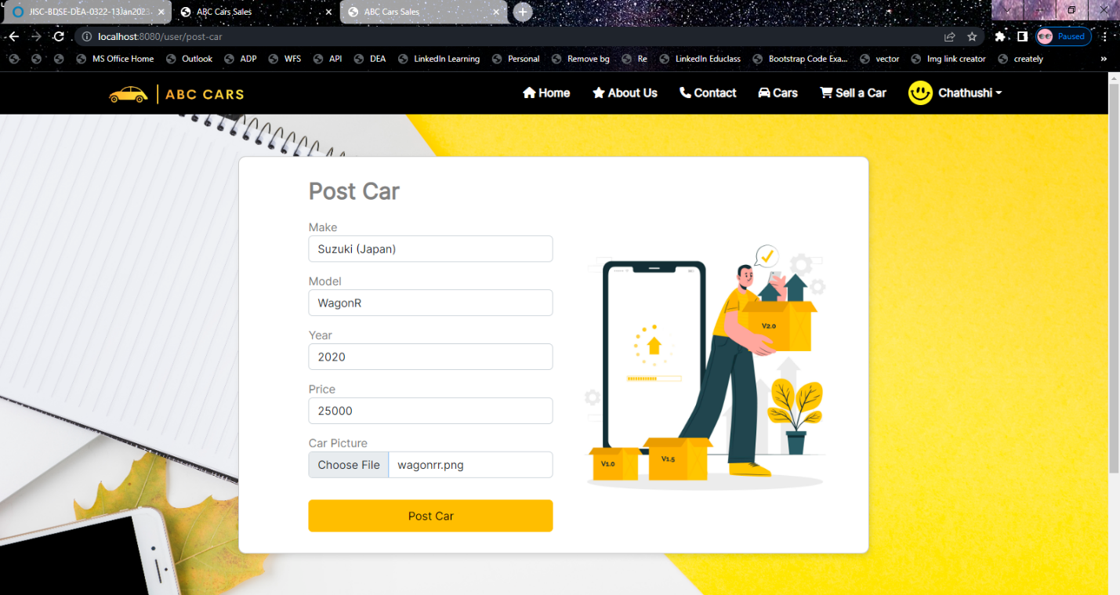**Evidance: Fig: CBTS003 - CBT01 – Google Chrome**

Figure 57:Evidance: Fig: CBTS003 – CBT01 – Google Chrome

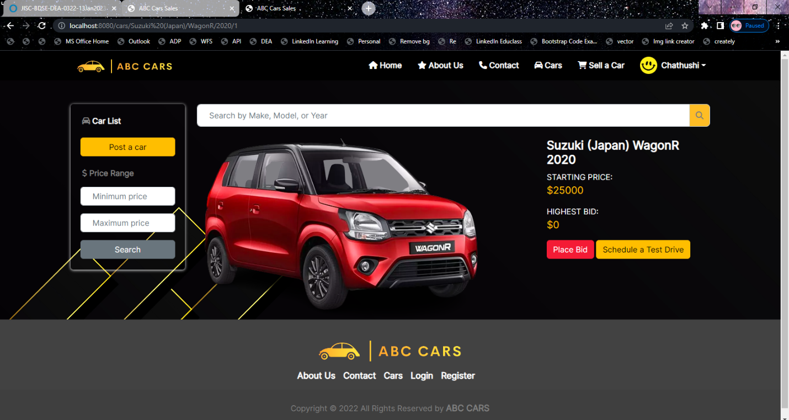

Figure 58:Evidance: Fig: CBTS003 – CBT01 – Google Chrome

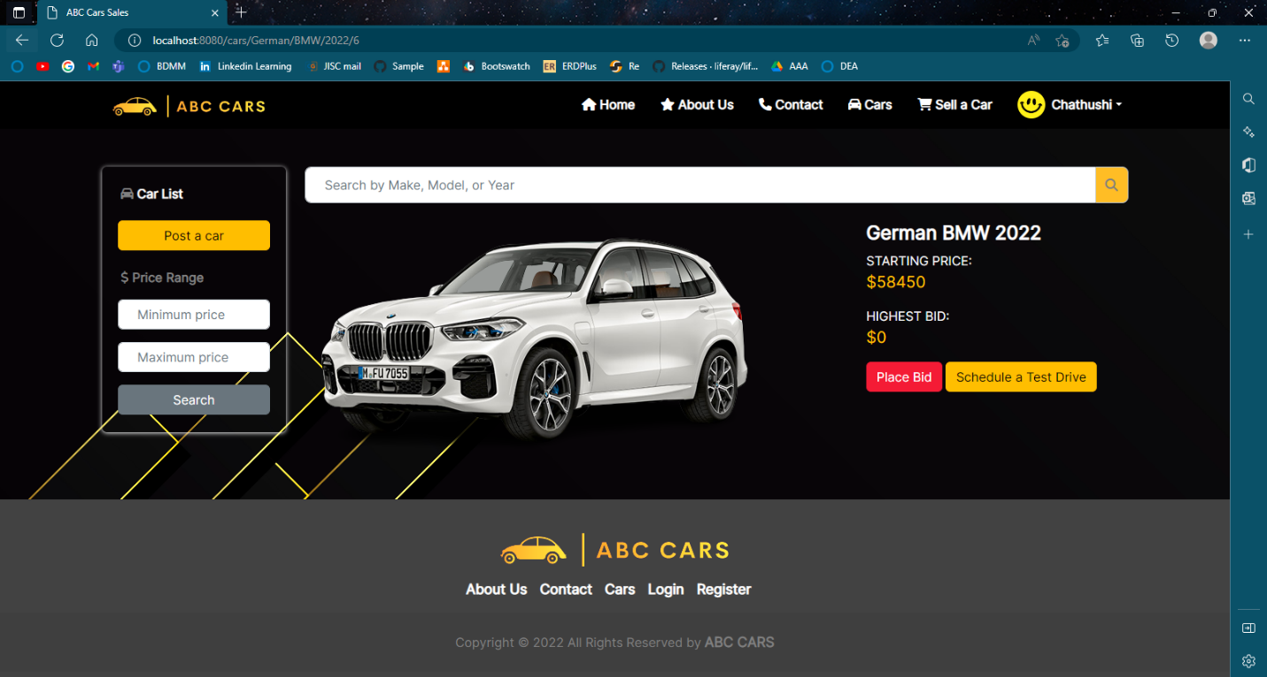**Evidance: Fig: CBTS003 - CBT02 – Microsoft Edge**

Figure 59:Evidance: Fig: CBTS003 - CBT02 – Microsoft Edge

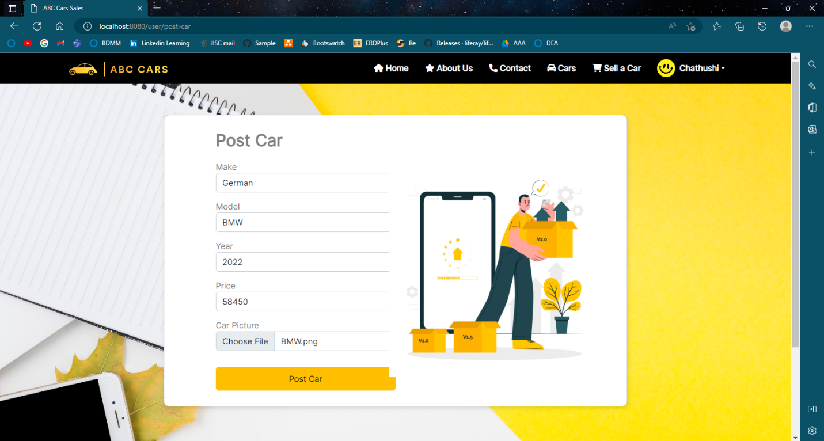

Figure 60:Evidance: Fig: CBTS003 - CBT02 – Microsoft Edge

* **Search Car**

|  |  |  |  |  |  |  |  |  |
| --- | --- | --- | --- | --- | --- | --- | --- | --- |
| Scenario ID | Test Case ID | Test Case | Preconditions | Test Step | Test Data | Expected Results | Actual Results | Pass / Fail |
| CBTS004 | CBT01 | Check the View car is working correctly on Google Chrome. | ABC Cars Portal website has been completed and uploaded to the server | 1. Go to Google chrome type localhost:8080 | In the nav bar Click the cars link to see the car details. | Loaded the View car page correctly. | As expected, | Pass |
| CBTS004 | CBT02 | Check that View car is working correctly on Mozilla Firefox. | ABC Cars Portal website has been completed and uploaded on the server | 1. Go to MS Edge type localhost:8080 | In the nav bar Click the cars link to see the car details. | Loaded the View car page correctly. | As expected, | Pass |

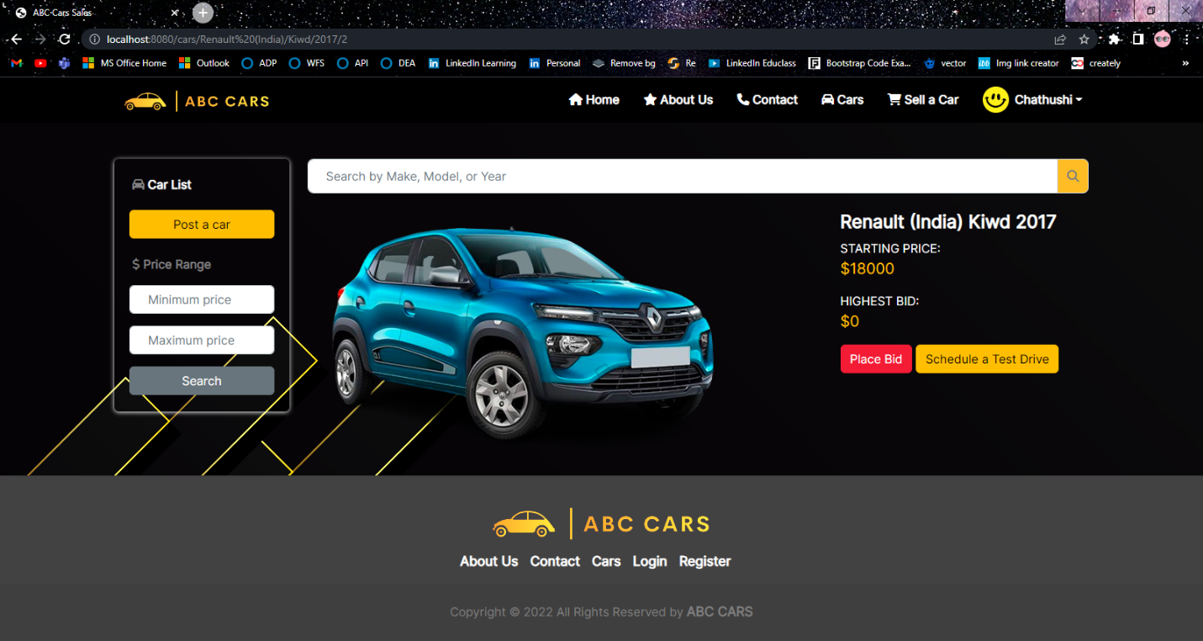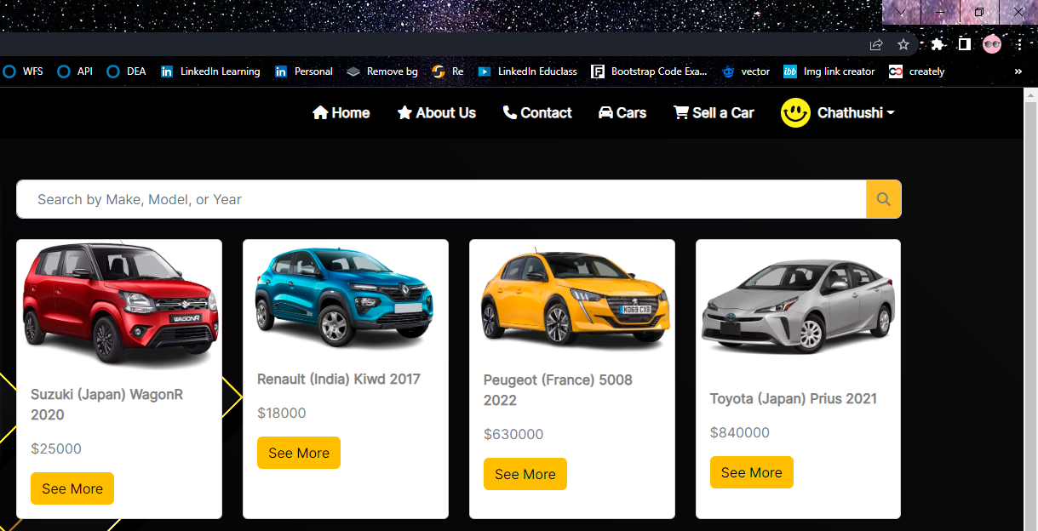**Evidence: Fig: CBTS004 – CBT01 – Google Chrome**

Figure 61:Evidence: Fig: CBTS004 – CBT01 – Google Chrome

Figure 62:Evidence: Fig: CBTS004 – CBT01 – Google Chrome

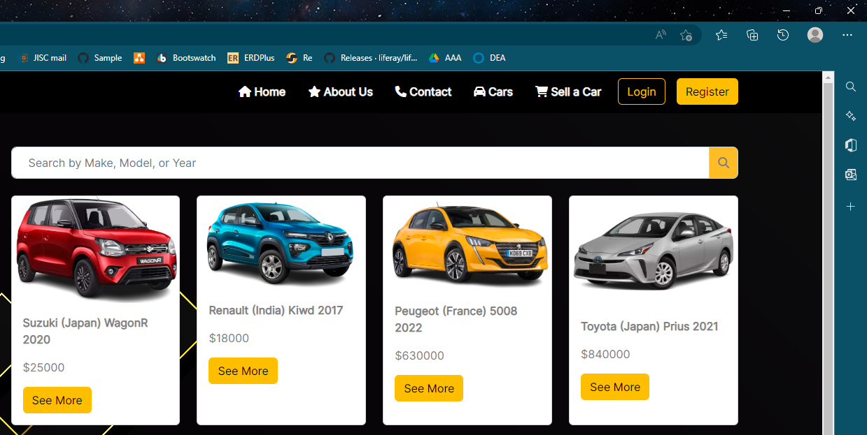**Evidence: Fig: CBTS004 – CBT02 – Microsoft Edge**

Figure 63:Evidence: Fig: CBTS004 – CBT02 – Microsoft Edge

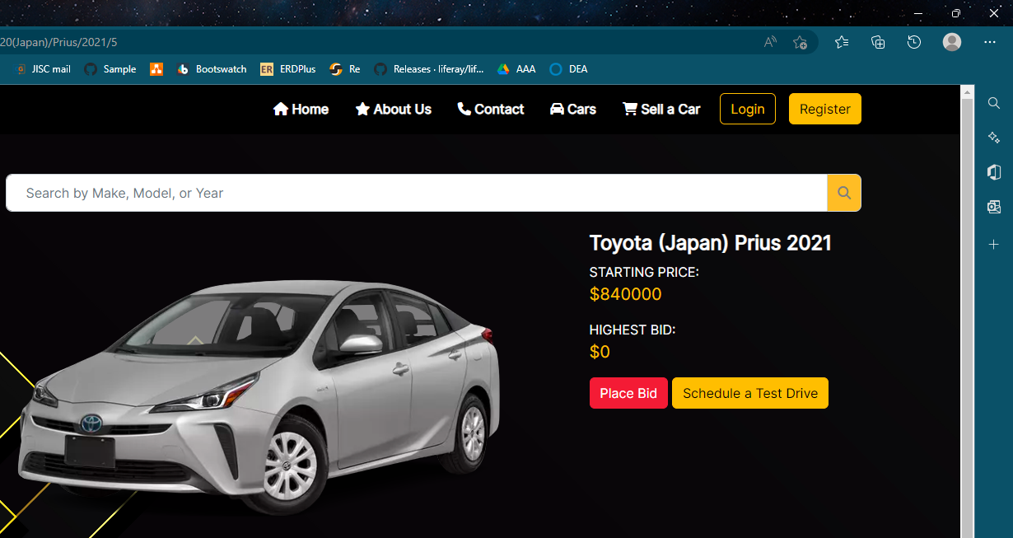

Figure 64:Evidence: Fig: CBTS004 – CBT02 – Microsoft Edge

* + 1. **Usability Testing**
* **Registration Page**

|  |  |
| --- | --- |
| Test Scenario | Registration Page. |
| TS007 |
| Test Cases | Registration Page in ABC CARS PTE LTD Portal |
| TC001 | The ABC Car portal meet with GUI and User-friendly interface design. |

|  |  |  |  |  |  |  |
| --- | --- | --- | --- | --- | --- | --- |
| Test Scenario ID | Test Case ID | Test Priority | Pre-condition | Expected Result | Actual Result | Pass/  Fail |
| TS007 | TC001 | Low | ABC Cars Portal website has been completed and uploaded on the server | The ABC Car portal meet with GUI and User-friendly interface design. | as expected, | Pass |
| Test Step & Test data | Navigation – Logo, Navigation, Register button, Login Button  Body – Register Form, Register Background, Register Form Image | | | | | |
| Evidence | Fig: TS007 – TC001 | | | | | |

**Evidence: Fig: TS008 – TC001**

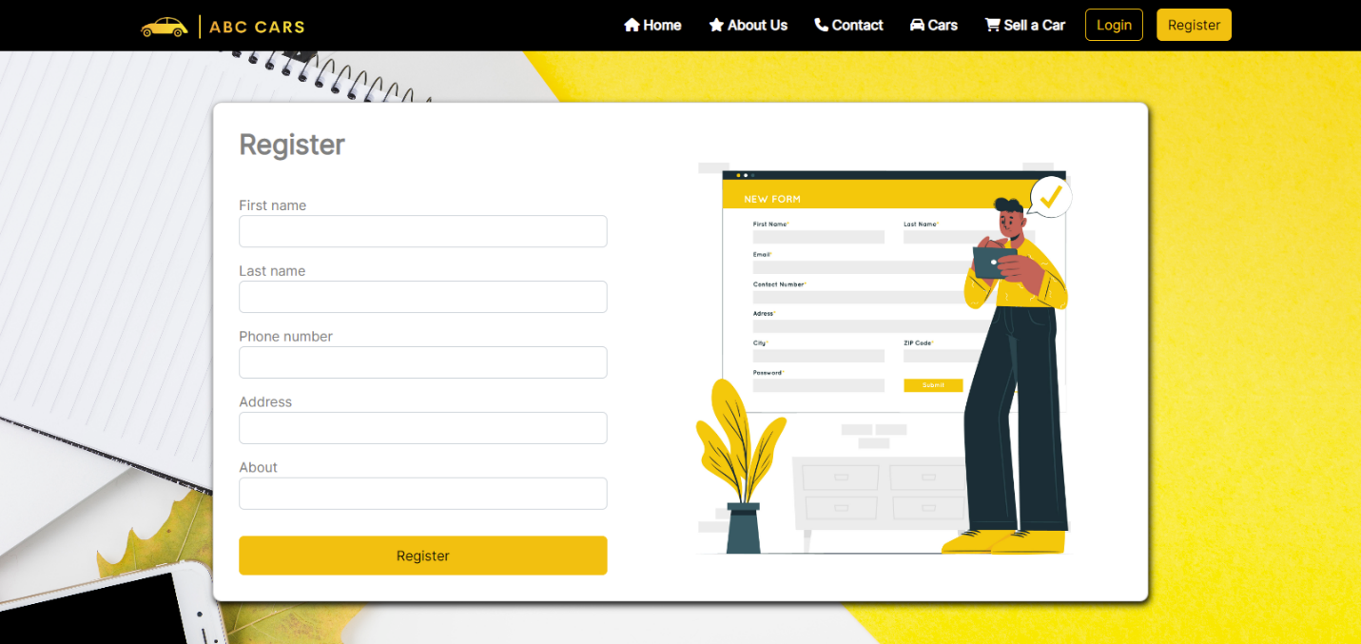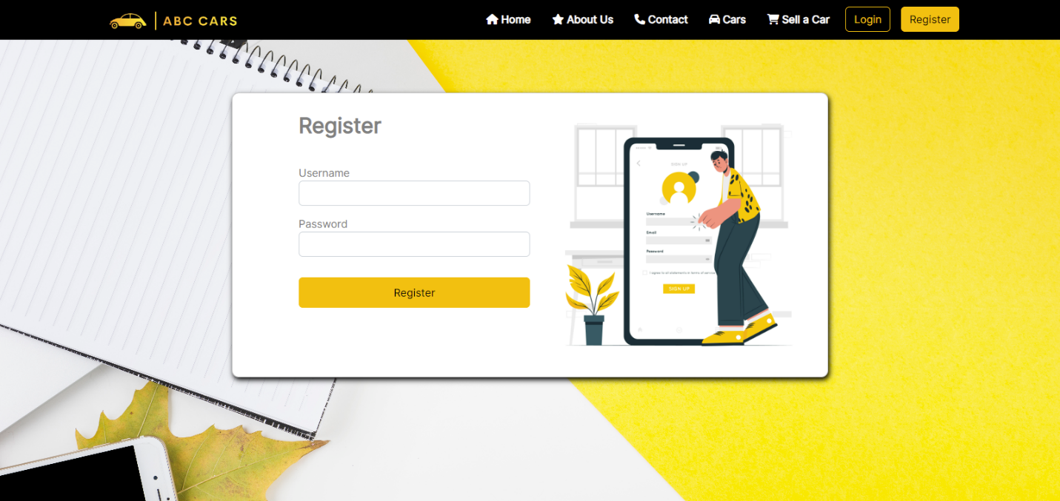

Figure 65:Evidence: Fig: TS008 – TC001

Figure 66:Evidence: Fig: TS008 – TC001

* **Login Page**

|  |  |
| --- | --- |
| Test Scenario | Login Page. |
| TS008 |
| Test Cases | Login Page in ABC CARS PTE LTD Portal |
| TC001 | The ABC Car portal meet with GUI and User-friendly interface design. |

|  |  |  |  |  |  |  |  |
| --- | --- | --- | --- | --- | --- | --- | --- |
| Test Scenario ID | Test Case ID | | Test Priority | Pre-condition | Expected Result | Actual Result | Pass/  Fail |
| TS008 | TC001 | | Low | ABC Cars Portal website has been completed and uploaded to the server | The ABC Car portal meets with GUI and aUser-friendly interface design. | As expected, | Pass |
| Test Step & Test data | Navigation – Logo, Navigation, Register button, Login Button  Body – Login Form, Image, Background Image  Footer – Logo, Page links & Copyright | | | | | | |
| Evidence | | Fig: TS007 – TC001 | | | | | |

**Evidence: Fig: TS008 – TC001**

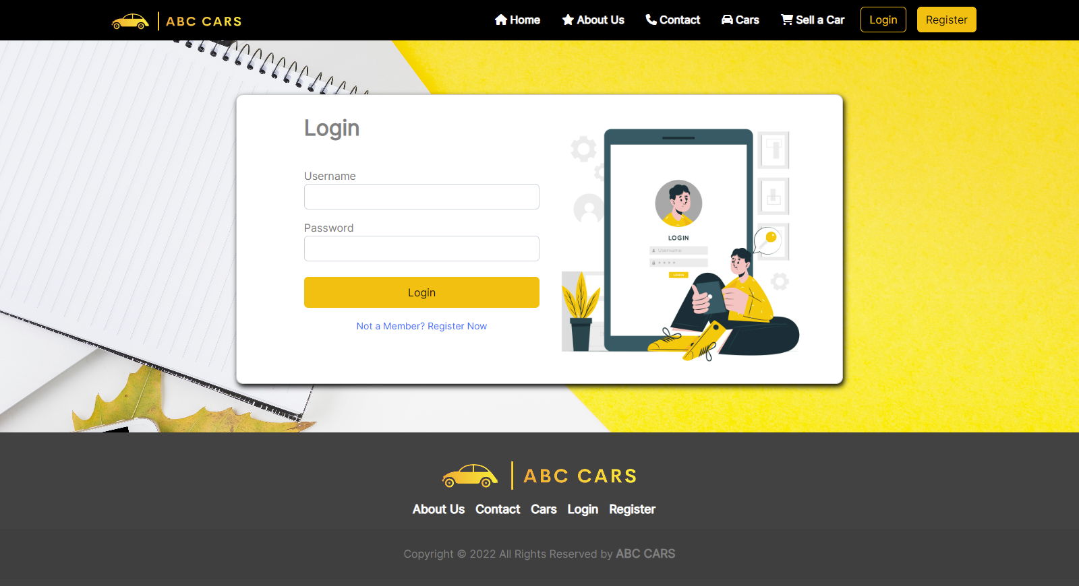

Figure 67:Evidence: Fig: TS008 – TC001

* **Car List Page**

|  |  |
| --- | --- |
| Test Scenario | List Car Page. |
| TS009 |
| Test Cases | List Car Page in ABC CARS PTE LTD Portal |
| TC001 | The ABC Car portal meets with GUI and User-friendly interface design. |

|  |  |  |  |  |  |  |
| --- | --- | --- | --- | --- | --- | --- |
| Test Scenario ID | Test Case ID | Test Priority | Pre-condition | Expected Result | Actual Result | Pass/  Fail |
| TS009 | TC001 | Low | ABC Cars Portal website has been completed and uploaded to server | The ABC Car portal meets with GUI and a User-friendly interface design. | As expected, | Pass |
| Test Step & Test data | Navigation – Logo, Navigation, Brand name  Body – Header, Search bar, Car list  Footer – Logo, Page links & Copyright | | | | | |
| Evidence | Fig: TS009 – TC001 | | | | | |

**Evidence: Fig: TS009 – TC001**

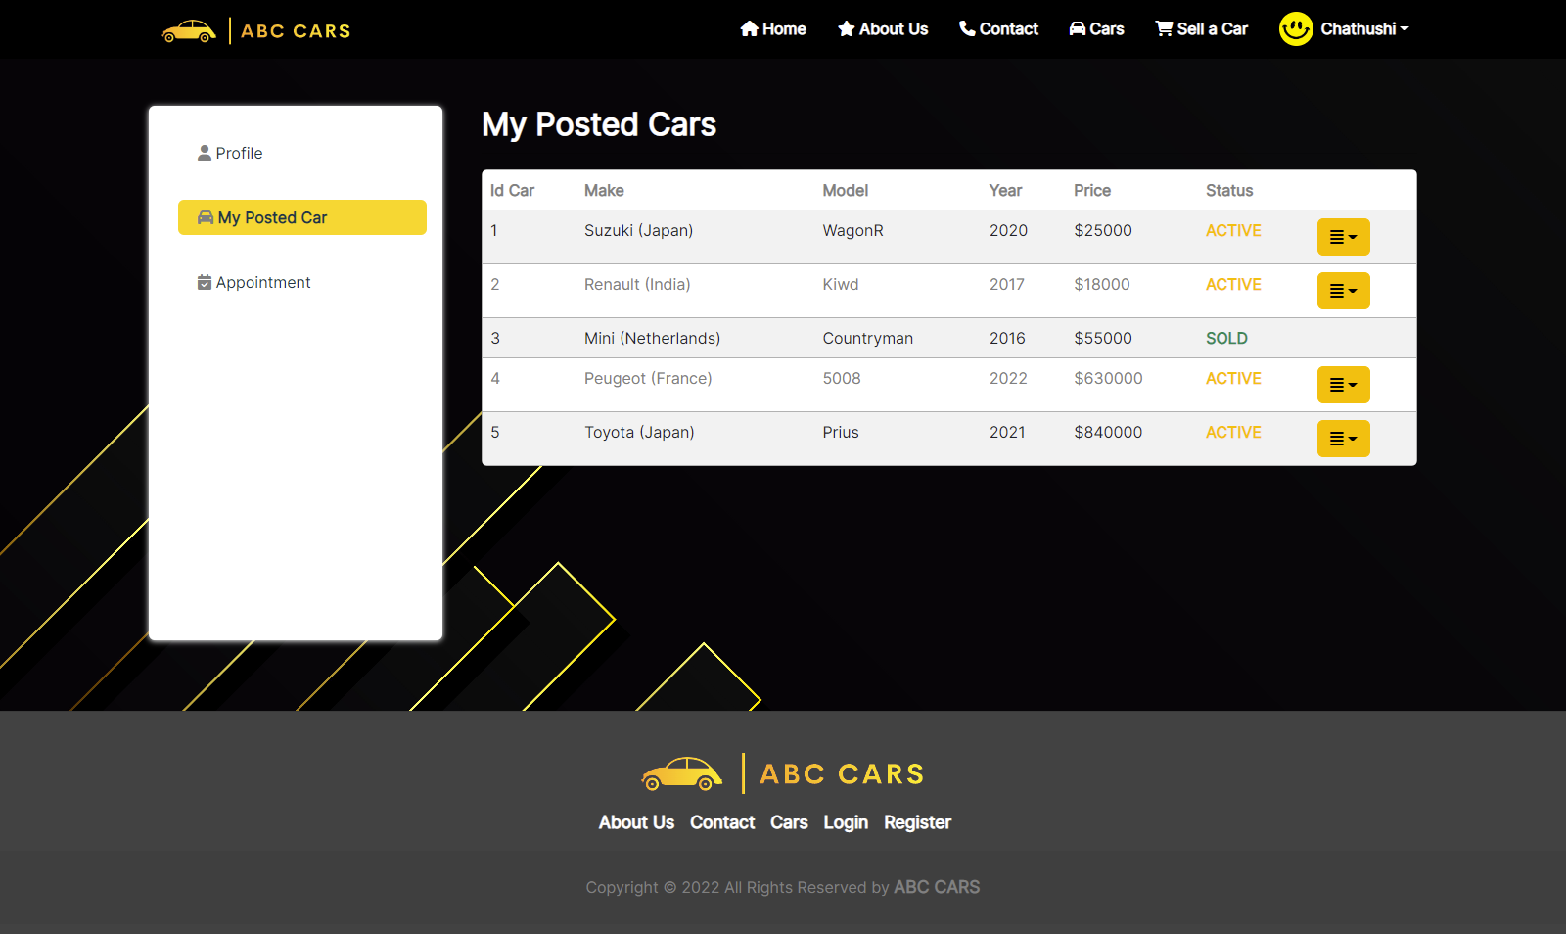

Figure 68:Evidence: Fig: TS009-TC001

|  |  |
| --- | --- |
| Test Scenario | View Car Page. |
| TS010 |
| Test Cases | View Car Page in ABC CARS PTE LTD Portal |
| TC001 | The ABC Car portal meet with GUI and User-friendly interface design. |

|  |  |  |  |  |  |  |
| --- | --- | --- | --- | --- | --- | --- |
| Test Scenario ID | Test Case ID | Test Priority | Pre-condition | Expected Result | Actual Result | Pass/  Fail |
| TS010 | TC001 | Low | ABC Cars Portal website has been completed and uploaded on server | The ABC Car portal meet with GUI and meets-friendly interface design. | As Expected, | Pass |
| Test Step & Test data | Navigation – Logo, Navigation, Brand name  Body – Header, Car Information, Car bidding option, Bidding details  Footer – Logo, Page links & Copyright | | | | | |
| Evidence | Fig: TS010 – TC001 | | | | | |

* **View Car Page**

**Evidence: Fig: TS010 – TC001**

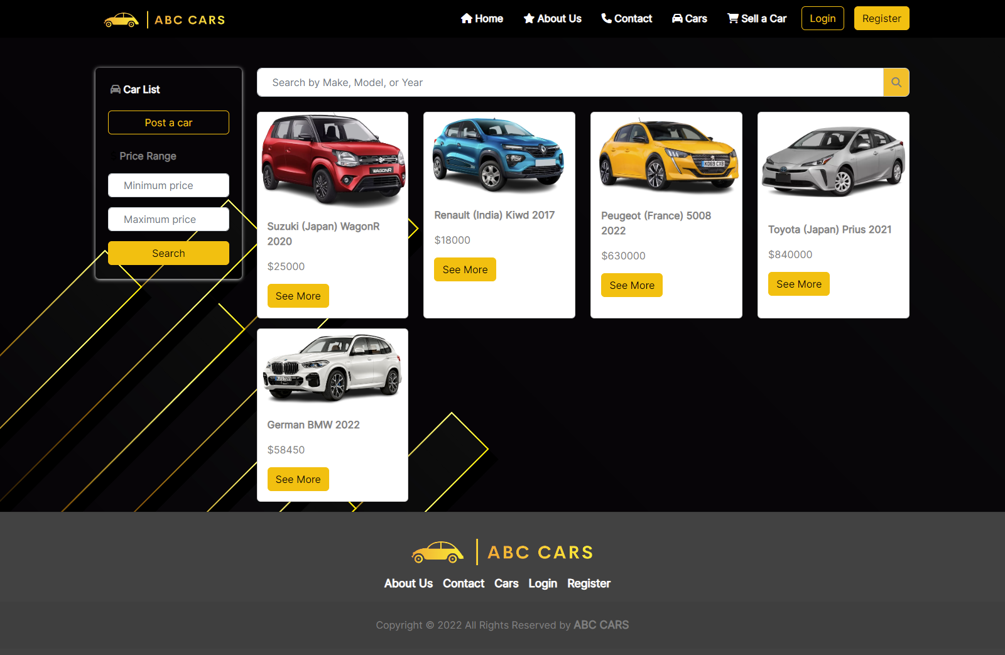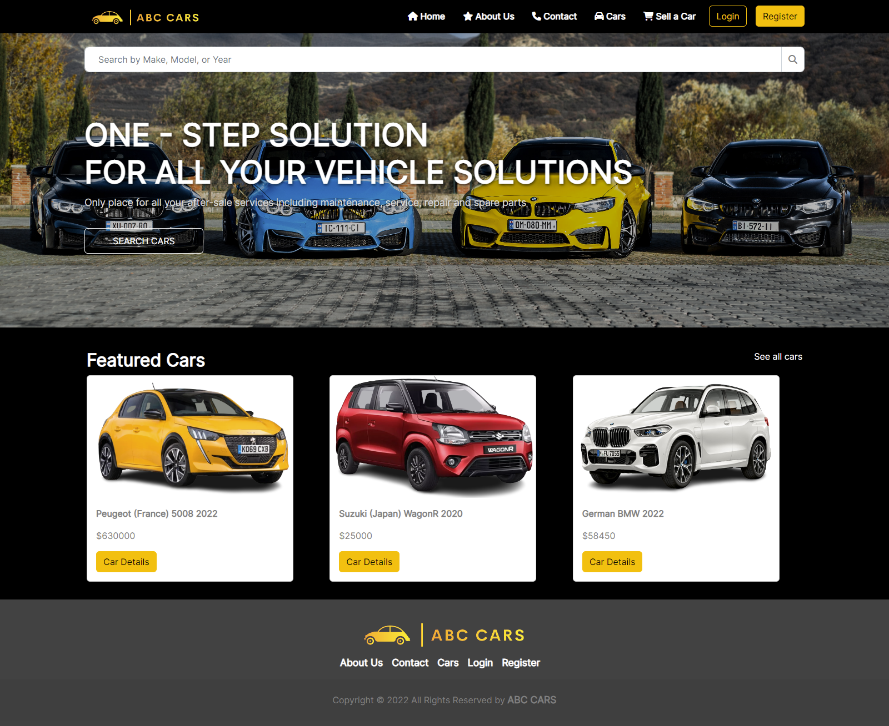

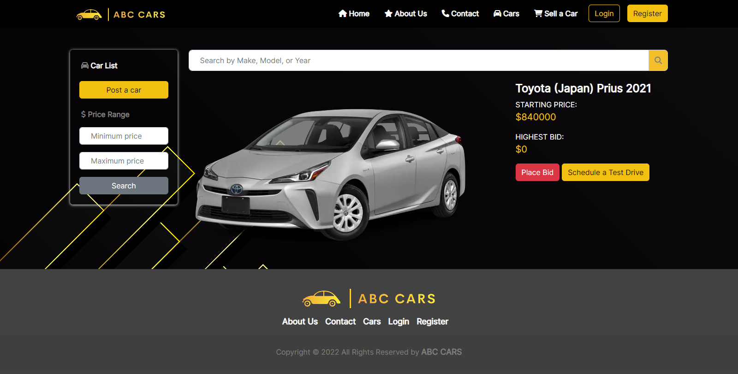

Figure 69:Evidence: Fig: TS010 – TC001

* **Post Car**

|  |  |
| --- | --- |
| Test Scenario | Post Car Page. |
| TS011 |
| Test Cases | Post Car Page in ABC CARS PTE LTD Portal |
| TC001 | The ABC Car portal meet with GUI and User-friendly interface design. |

|  |  |  |  |  |  |  |
| --- | --- | --- | --- | --- | --- | --- |
| Test Scenario ID | Test Case ID | Test Priority | Pre-condition | Expected Result | Actual Result | Pass/  Fail |
| TS011 | TC001 | Low | ABC Cars Portal website has been completed and uploaded to the server | The ABC Car portal meets with GUI and a User-friendly interface design. | As expected, | Pass |
| Test Step & Test data | Navigation – Logo, Navigation, Brand name  Body – Header, Add car form  Footer – Copyright name. | | | | | |
| Evidence | **Fig:TS011 – TC001** | | | | | |

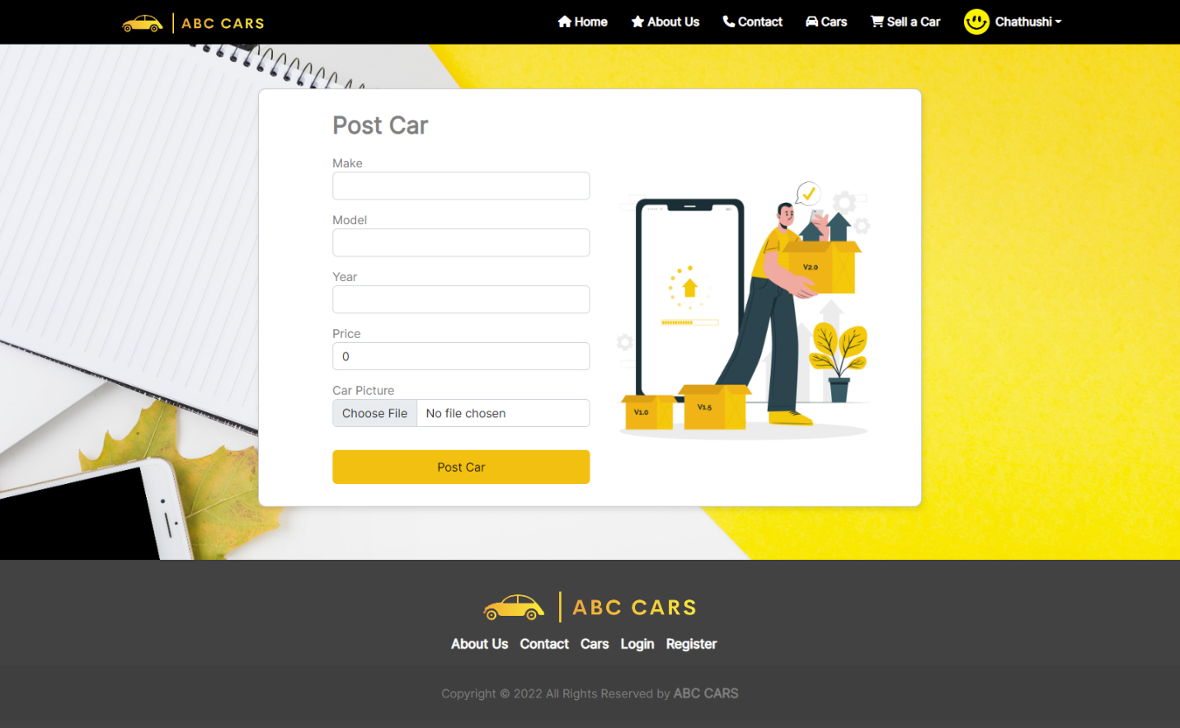**Evidence: Fig:TS011 – TC001**

Figure 70:Evidence: Fig:TS011 – TC001

* + 1. **Portability Testing**
* **Home Page – Phone Mode**

|  |  |
| --- | --- |
| Test Scenario | Home Page. |
| TS012 |
| Test Cases | Post Car Page in ABC CARS PTE LTD Portal |
| TC001 | Check ABC Car portal is working on Phone |

|  |  |  |  |  |  |  |
| --- | --- | --- | --- | --- | --- | --- |
| Test Scenario ID | Test Case ID | Test Priority | Pre-condition | Expected Result | Actual Result | Pass/  Fail |
| TS012 | TC001 | Low | ABC Cars Portal website has completed and uploaded on server | The ABC Car portal is working on phone correctly. | Result is come out  as expected, | Pass |
| Test Step & Test data | Load ABC Car Portal on browser and go to inspect option and change the device into phone mode. | | | | | |
| Evidence | Fig:TS012 – TC001 | | | | | |

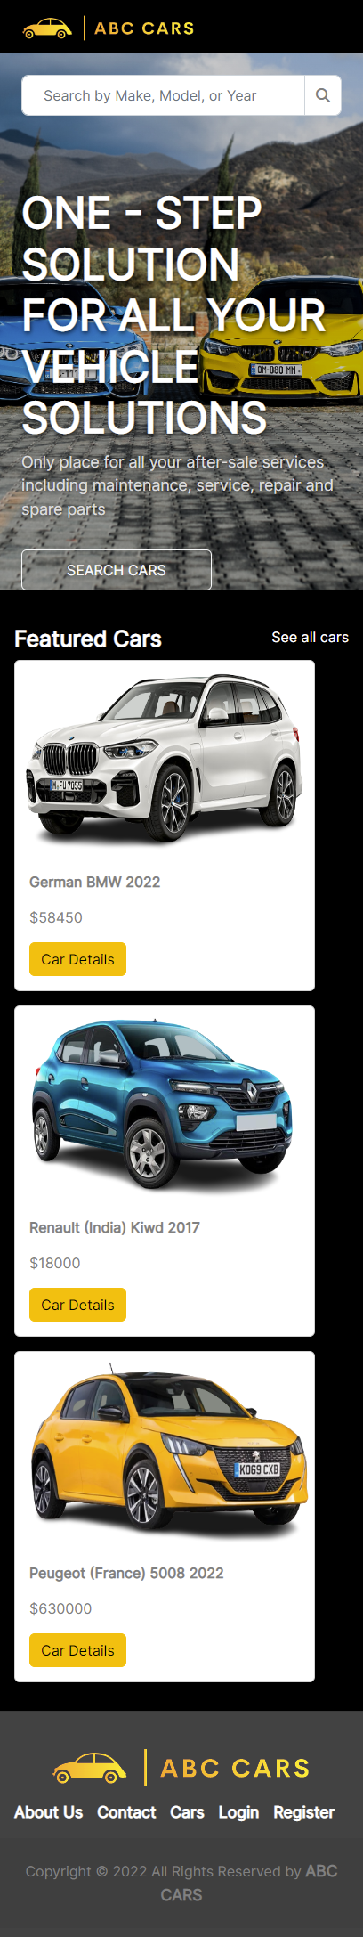**Evidence: Fig:TS012 – TC001 – Phone Mode**

Figure 71:Evidence: Fig:TS012 – TC001 – Phone Mode

* **Home page – Tablet Mode**

|  |  |
| --- | --- |
| Test Scenario | Home Page. |
| TS013 |
| Test Cases | Post Car Page in ABC CARS PTE LTD Portal |
| TC001 | Check ABC Car portal is working on Tablet |

|  |  |  |  |  |  |  |
| --- | --- | --- | --- | --- | --- | --- |
| Test Scenario ID | Test Case ID | Test Priority | Pre-condition | Expected Result | Actual Result | Pass/  Fail |
| TS013 | TC001 | Low | ABC Cars Portal website has been completed and uploaded to the server | The ABC Car portal is working on the tablet correctly. | As expected, | Pass |
| Test Step & Test data | Load ABC Car Portal on the browser and go to inspect option and change the device into tablet mode. | | | | | |
| Evidence | Fig:TS013– TC001 | | | | | |

**Evidence: Fig: TS013 – TC001 – Tablet Mode**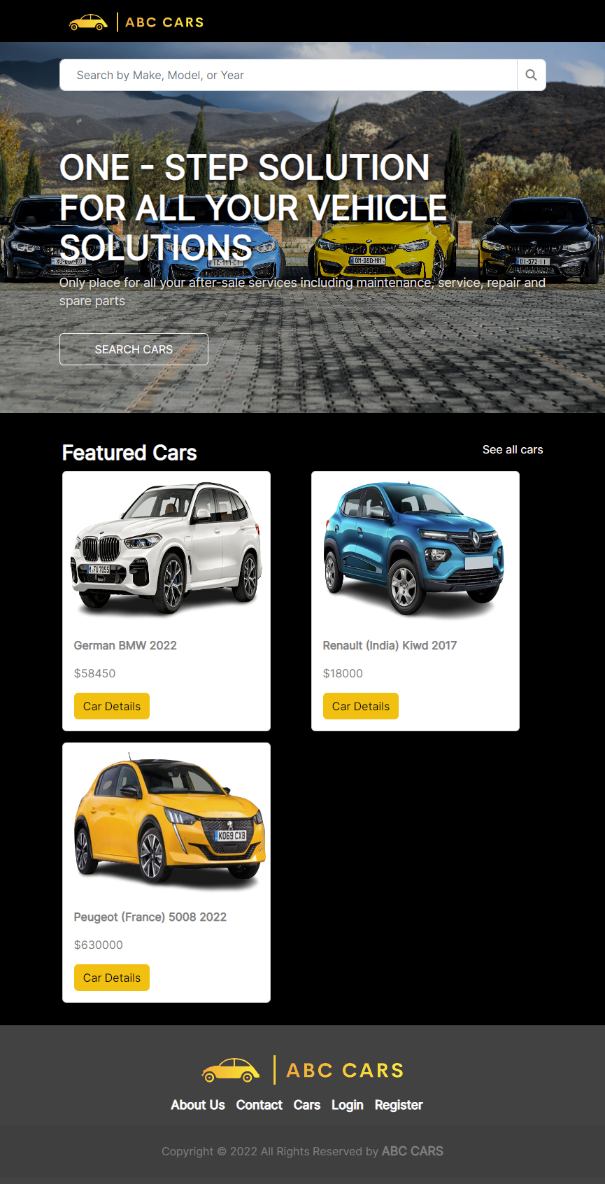

Figure 72:Evidence: Fig: TS013 – TC001 – Tablet Mode

* **Home page – Laptop Mode**

|  |  |
| --- | --- |
| Test Scenario | Home Page. |
| TS014 |
| Test Cases | Post Car Page in ABC CARS PTE LTD Portal |
| TC001 | Check ABC Car portal is working on Laptop |

|  |  |  |  |  |  |  |
| --- | --- | --- | --- | --- | --- | --- |
| Test Scenario ID | Test Case ID | Test Priority | Pre-condition | Expected Result | Actual Result | Pass/  Fail |
| TS014 | TC001 | Low | ABC Cars Portal website has been completed and uploaded to the server | The ABC Car portal is working on the laptop correctly. | As expected, | Pass |
| Test Step & Test data | Load ABC Car Portal on the browser and go to inspect option and change the device into laptop mode. | | | | | |
| Evidence | Fig:TS014 – TC001 | | | | | |

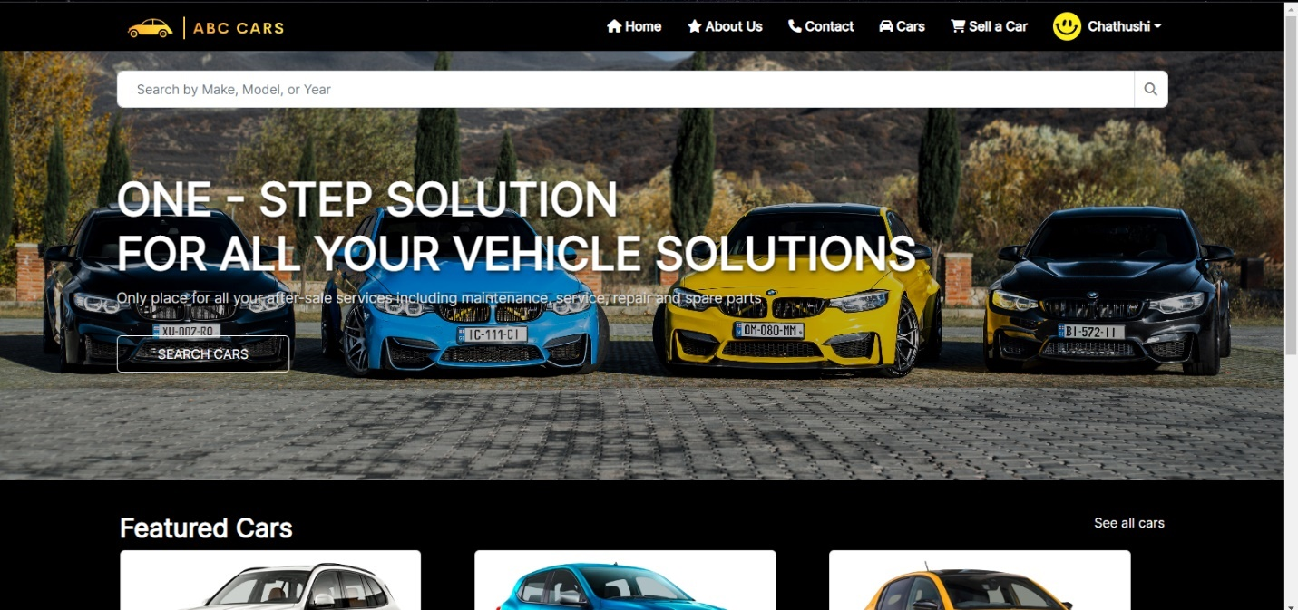**Evidence: Fig: TS014 – TC001 – Laptop Mode**

Figure 73:Evidence: Fig: TS014 – TC001 – Laptop Mode

* + 1. **Security Testing**

|  |  |
| --- | --- |
| Test Scenario | Authentication. |
| TS015 |
| Test Cases | Check login in ABC CARS PTE LTD Portal |
| TC001 | Check login with correct login information. |
| TC002 | Check login with wrong login information. |

|  |  |  |  |  |  |  |
| --- | --- | --- | --- | --- | --- | --- |
| Test Scenario ID | Test Case ID | Test Priority | Pre-condition | Expected Result | Actual Result | Pass/  Fail |
| TS015 | TC001 | Medium | ABC Cars Portal website has been completed and uploaded on the server | After entering the correct password and username user will redirect to a User profile page | As expected, | Pass |
| Test Step & Test data | In Login Page, input test data   * + - * Username- chathu@77 * Password: 12345678   Click Login button | | | | | |
| Evidence | Fig: TS015 – TC001 | | | | | |
| Test Scenario ID | Test Case ID | Test Priority | Pre-condition | Expected Result | Actual Result | Pass/  Fail |
| TS015 | TC002 | Medium | ABC Cars Portal website has been completed and uploaded on the server | After entering the wrong password user can see the error message to enter the correct password or username. | As expected, | Pass |
| Test Step & Test data | In Login Page, input test data   * + - * Username- chathu@77 * Password: 1234 (correct password = 12345678)   3. Click Login button | | | | | |
| Evidence | Fig: TS015 – TC002 | | | | | |

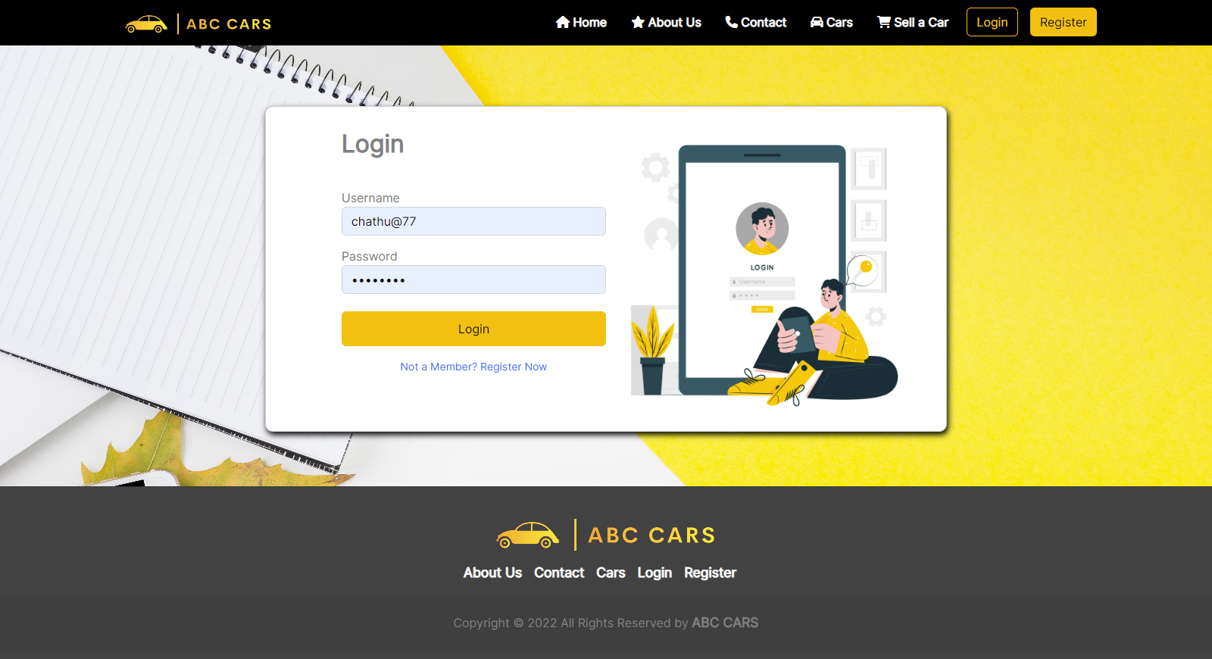**Evidence: Fig: TS015 – TC001**

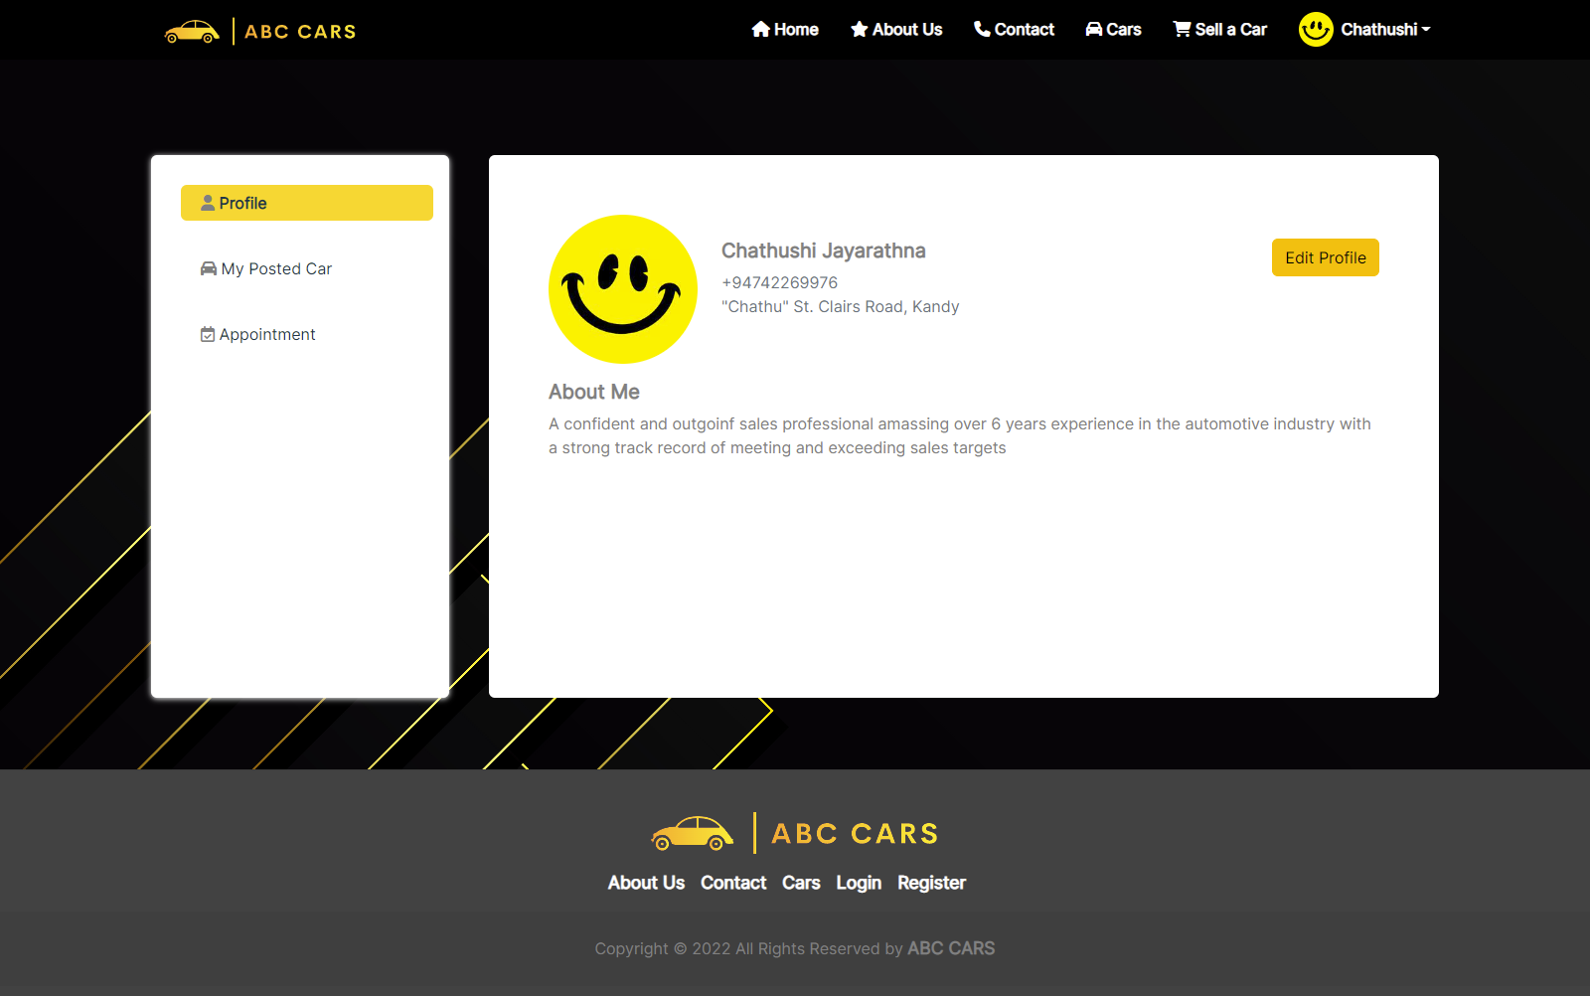

Figure 74:Evidence: Fig: TS015 – TC002

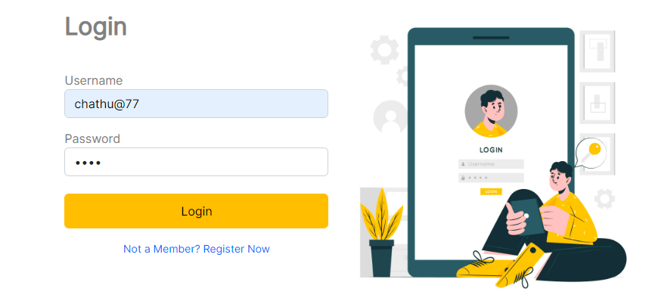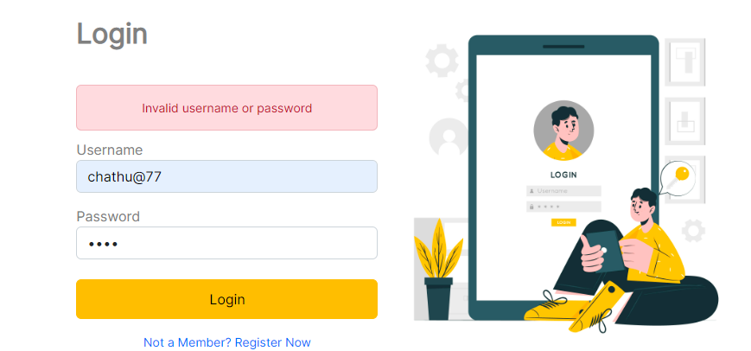**Evidence: Fig: TS015 – TC002**

* 1. **Provide a detailed log of test results**

|  |  |
| --- | --- |
| Reported By: | Chathushi Jayarathna |
| Report Date: | 19/01/2023 |
|  |  |
| Tested By: | Chathushi Jayarathna |
| Tested Date: | 12/01/2023 |
| Testing Name/ Test Scenario ID | **Functional testing: UAT Testing** (TS001 / TS002 / TS003 / TS004) |
| Total Number of Test Cases | 11 |
| No. of Pass: | 10 |
| No. of Failures: | 1 |
| Elapsed Time: | 1 Hour 30min |
|  |  |
| Tested By: | Chathushi Jayarathna |
| Tested Date: | 12/01/2023 |
| Testing Name/ Test Scenario ID | **Functional testing: Unit Testing** (TS006 ) |
| Total Number of Test Cases | 5 |
| No. of Pass: | 5 |
| No. of Failures: | 0 |
| Elapsed Time: | 2 hours 45 min |
|  |  |
| Tested By: | Chathushi Jayarathna |
| Tested Date: | 12/01/2023 |
| Testing Name/ Test Scenario ID | **Performance Testing** (TS006) |
| Total Number of Test Cases | 3 |
| No. of Pass: | 3 |
| No. of Failures: | 0 |
| Elapsed Time: | 30 min |
|  |  |
| Tested By: | Chathushi Jayarathna |
| Tested Date: | 12/01/2022 |
| Testing Name/ Test Scenario ID | **Compatibility Testing** (CBTS001, CBTS002, CBTS003, CBTS004) |
| Total Number of Test Cases | 8 |
| No. of Pass: | 8 |
| No. of Failures: | 0 |
| Elapsed Time: | 1 hours 30min |
|  |  |
| Tested By: | Chathushi Jayarathna |
| Tested Date: | 12/01/2023 |
| Testing Name/ Test Scenario ID | **Usability Testing** (TS009, TS010, TS011, TS012) |
| Total Number of Test Cases | 4 |
| No. of Pass: | 4 |
| No. of Failures: | 0 |
| Elapsed Time: | 45min |
|  |  |
| Tested By: | Chathushi Jayarathna |
| Tested Date: | 13/01/2023 |
| Testing Name/ Test Scenario ID | **Security Testing**/ TS012 |
| Total Number of Test Cases | 2 |
| No. of Pass: | 2 |
| No. of Failures: | 0 |
| Elapsed Time: | 1 hour |
|  |  |
| Tested By: | Chathushi Jayarathna |
| Tested Date: | 28/7/2022 |
| Testing Name/ Test Scenario ID | **Portability Testing** (TS013, TS014, TS015) |
| Total Number of Test Cases | 3 |
| No. of Pass: | 3 |
| No. of Failures: | 0 |
| Elapsed Time: | 30 Min |
| SUMMARY LOG STATUS | |
| Total Number of Test Cases | 36 |
| Total Number of Pass | 35 |
| Total Number of Failures | 1 |
| Pass % | 97.2% |
| Total Elapsed Time | 7 hours 10min |

* 1. **Modify the risk-based test procedure with the reasons**
* Identify Risk upon Log Fail Result
* Identify Impacts upon it.
* Modify RBT test plan along with Prioritization
* Create RBT test plan with test scenario, test cases, and prioritization
* Modify if the code is needed
* Execute test cases
* Create a test log report again (like above)

Including no longer found car while searching vehicle with keyword or price range

**Before**

Figure 75:Before Fix - Interface

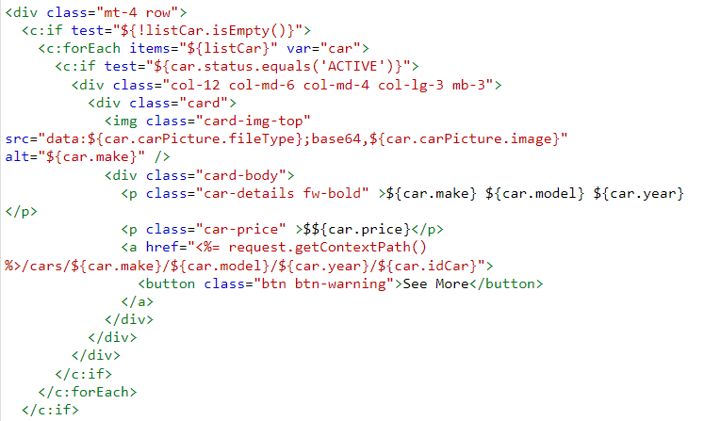

Figure 76:Before Fix - Source Code

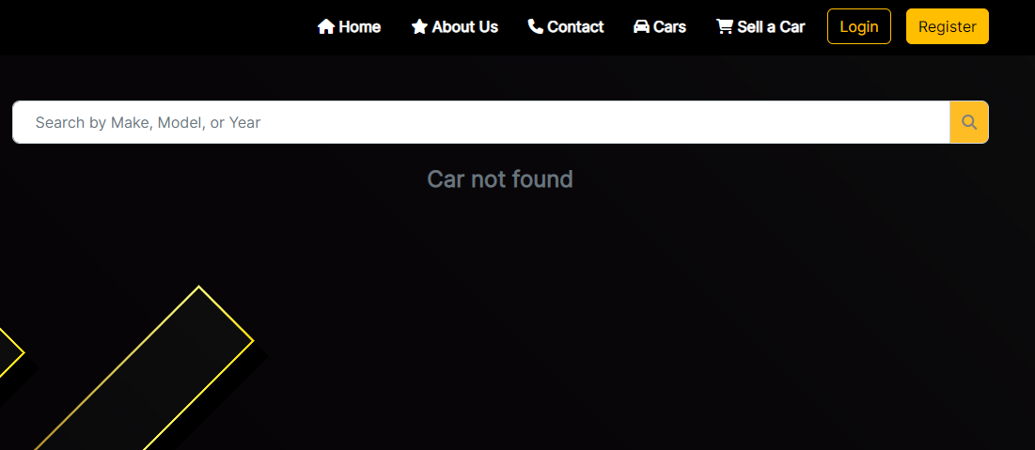**After**

Figure 77:After Fixed - Interface

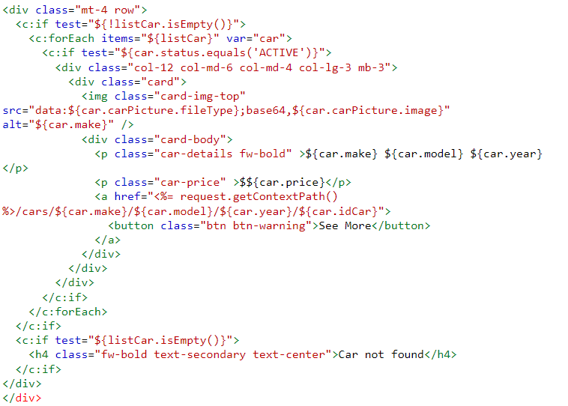

Figure 78:After Fixed - Source Code

**Log result After Modification**

|  |  |
| --- | --- |
| Project ID/ Project Name: | Used Car Sale Portal Project |
|  |  |
| Reported By: | **Chathushi Jayarathna** |
| Report Date: | **19/01/2023** |
|  |  |
| Tested By: | **Chathushi Jayarathna** |
| Tested Date: | **19/01/2023** |
| Testing Name/ Test Scenario ID | **UAT Testing** |
| Total Number of Test Cases | **1** |
| No. of Pass: | **1** |
| No. of Failures: | **0** |
| Elapsed Time: | **00:15:00** |

**Task 7**

1. **Evaluation of Testing strategy**
   1. **Evaluate the effectiveness of the RBT strategy and assess the security testing cycles.**

Evaluating the effectiveness of the RBT method and evaluating security testing cycles is considered a characteristic of importance and possibility or impact of failure. A testing technique that prioritizes exams of functions and functions based on the chance of failure and importance to the commercial enterprise. Evaluate the effectiveness of the approach and don't forget Spring Boot security. Here too every person can get admission to anybody's websites whilst protection isn't always blanketed. They may be hacked. There comes the need for a method. Threat-based total testing applies the ideas of chance management to testing sports. The grant pursuits to create and gift a framework that enables a clear dialogue of risks between testers, builders, and other stakeholders. Hazard-based checking out is important for car portals. That's wherein Spring Boot security comes in accessible. In trendy, Spring security objectives to offer an extraordinarily customizable way of imposing authentication, authorization, and protection in opposition to commonplace assaults. It's far vital for car portals to be like this. An instance of non-purposeful testing within the SDLC is safety testing. Authentication, authorization, and square injection are crucial in protection testing. As well as heading off safety issues in packages. It encompasses the complete software lifestyles cycle from requirements analysis, design, implementation, and verification in addition to renovation. Safety is a nonfunctional testing method. Spring security is the number one choice for imposing utility-degree safety in spring packages. Unit testing within the design segment is carried out for white containers, integration testing uses black field testing, and machine testing is all implemented by using the safety device, the auto portal venture will join all code elements thru comfy config. From there the functionality of all pages is determined. Admin's tasks and person's obligations are indexed one after the other.

* 1. **Evaluate the testing strategies and compare it’s pro and cons**

|  |  |
| --- | --- |
| Using RBT |  |
| Pro | **Cons** |
| Saving cost | More time required |
| Increases focus on customers. | Unidentified risks may be involved. |
| Improves software quality. | Risks can be assessed as very low. |
| Tests are more structured. | Risk assessment is based on highly subjective criteria. |
| Analyse risks and establish a priority hierarchy of software modules. |  |
| Plan, design and execute priority test modules. |  |

* 1. **Assess the importance and environment suitability and examine the test heuristics are identified with proper justification**

|  |  |
| --- | --- |
| Environment | The Importance of Environment Suitability and How It Supports RBT Test Strategy |
| STS IDE | All applications use to develop and use. taken into consideration whole regression assessments. suitable insurance makes use of causal scenarios and examines diverse relevant user roles overlaying give up-to-end paths. |
| MySQL Database | SQL is used to manage and share data in a relational database management system and users can perform operations inclusive of inserting, deleting, pick on the database. SQL programming is broadly used to create, save and manage records within the database. |
| Window 11 | there may be a windows operating device. Windows 11 is an acquainted, easy-to-use bundle with stronger capabilities available. Presents continuous security protections and remains connected across devices to convey preferred apps and documents anytime, everywhere. |
| Java Version 11 | JDK is a development environment for constructing programs and additives the usage of the Java programming language. The JDK is beneficial for growing and trying out applications written inside the Java programming language and running on the Java platform. |
| ABC Cars Portal | Need to have ready software. This is my car portal application. It needs to coding and running a test plan. |
| Test Plan | The test plan is used for all tests. risk-primarily based testing emphasizes thorough testing of capabilities that without delay have an effect on customers, directly improve business performance, reduce the probability of negative evaluations, and usually decrease the impact of each recognized risk. |
| Documentation | Documentation is essential for quality control and process control |
| Devices | A device is a unit of physical hardware or equipment that gives one or greater computing functions inside a computer system. A pc can offer input, be given output, or each. A device can be any electronic component with a few computing functionalities that helps the installation of firmware or third-party software program. |
| Browsers | The main web browser used is Google Chrome. Microsoft Edge |

**Task 8**

1. **Screen capture of developed pages.**

* 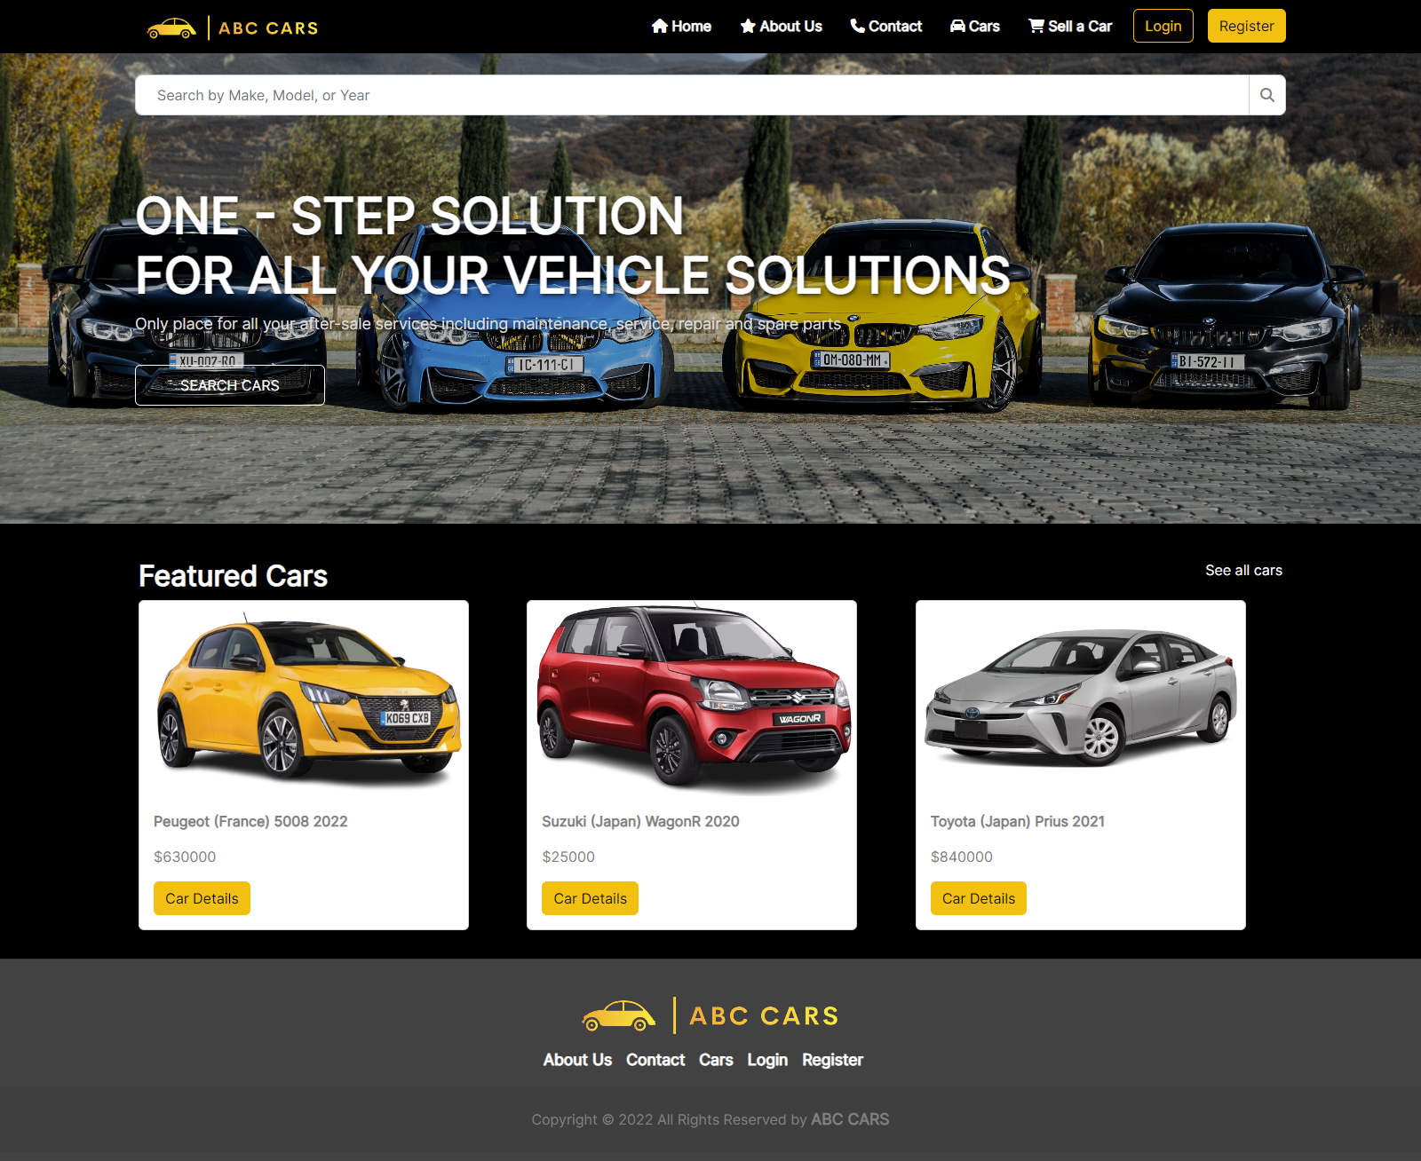**Home Page**

Figure 79:Screenshot of Home Page

* **About Us Page**

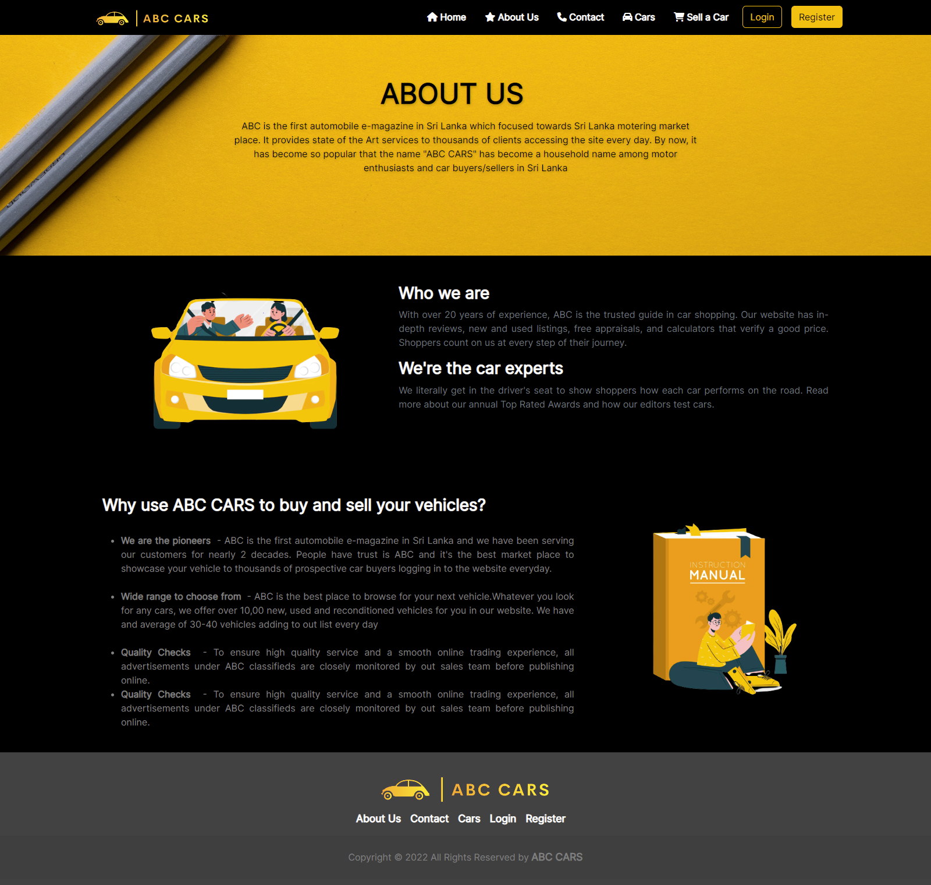

Figure 80:Screenshot of About Us Page

* **Contact Us Page**

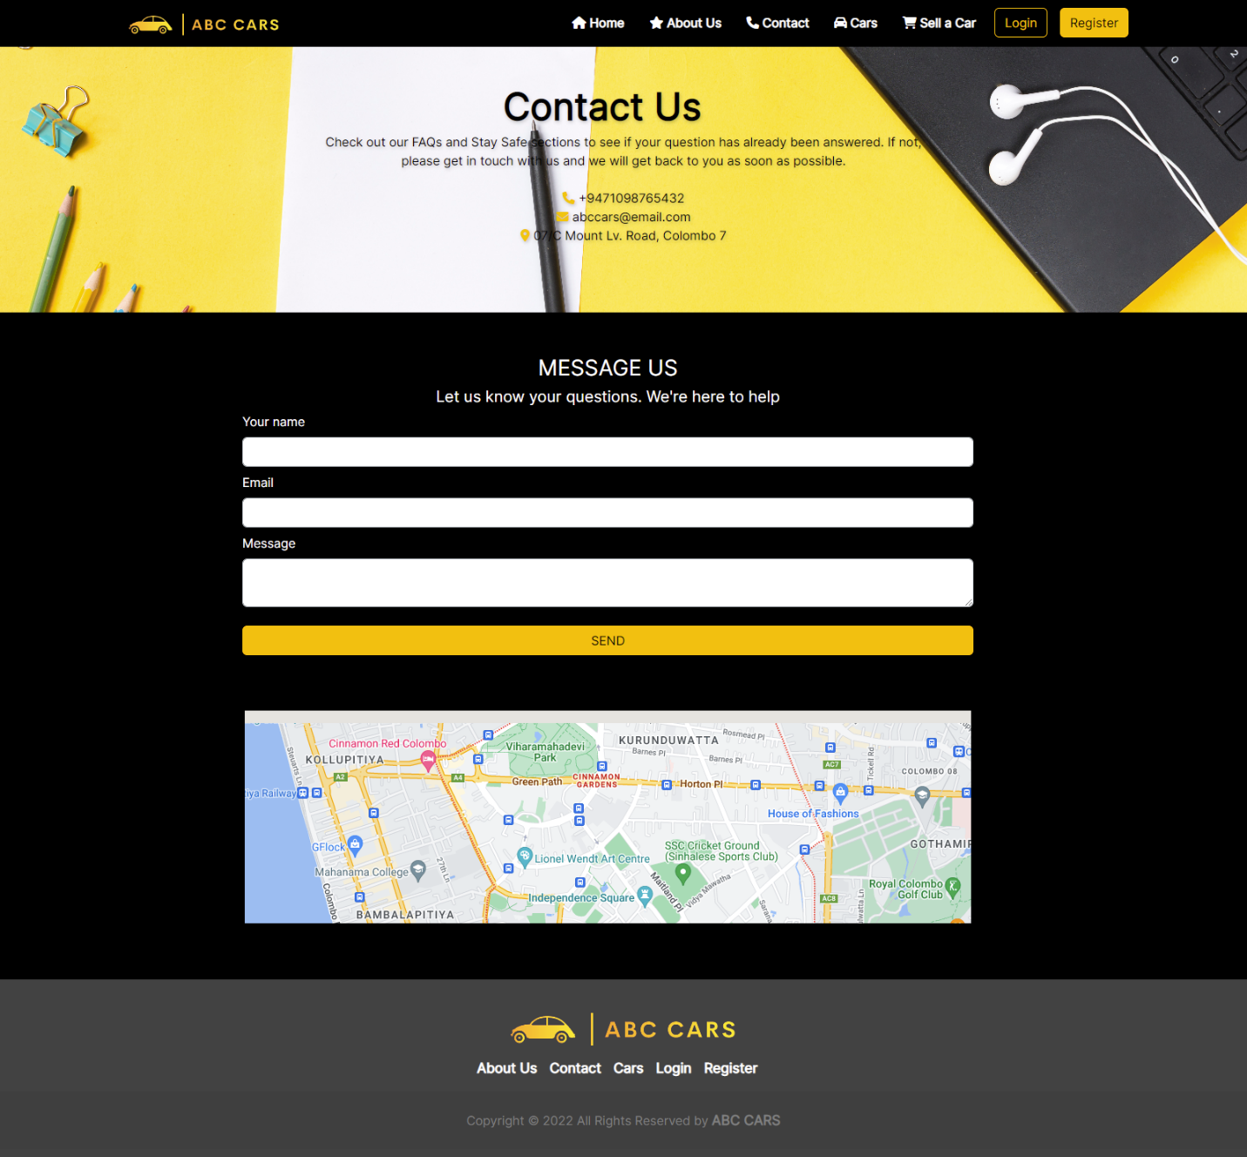

Figure 81:Screenshot of Contact Us Page

* **Login Page**

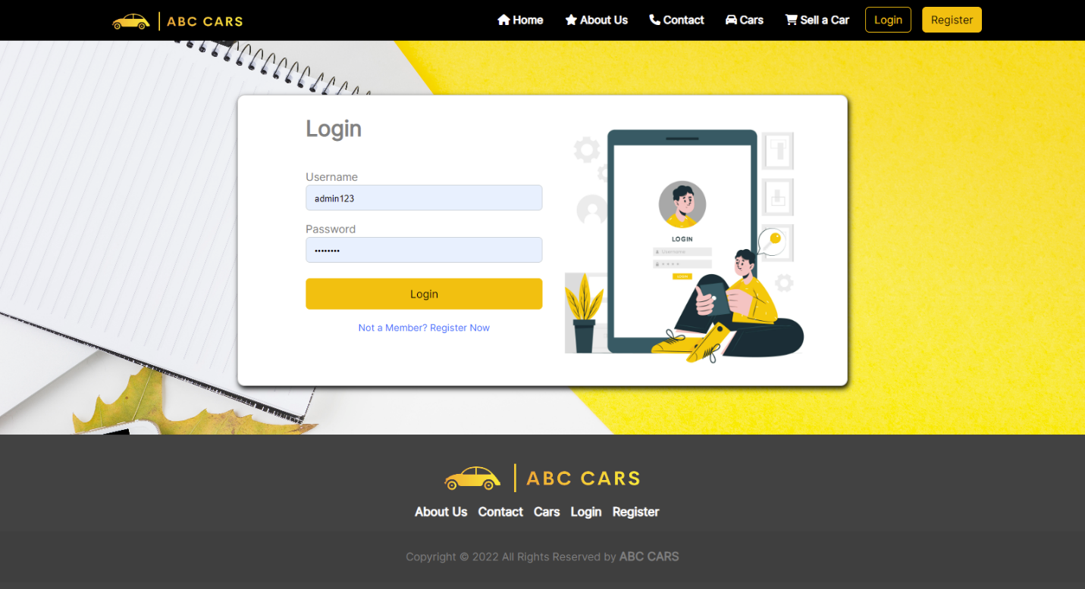

Figure 82:Screenshot of Login Page

* **Registration Page**

Figure 83:Screenshot of Register Account Page

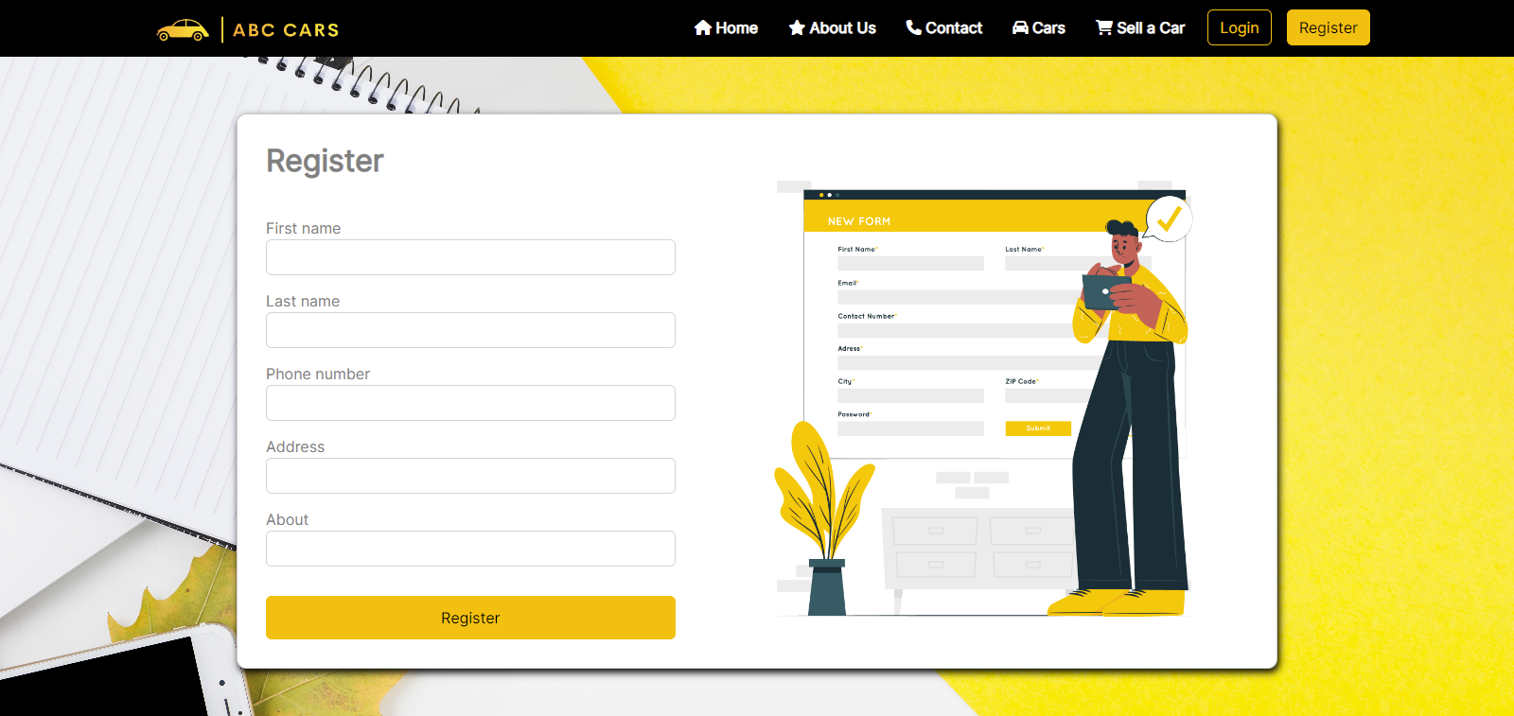

Figure 84:Screenshot of register Profile Page

* 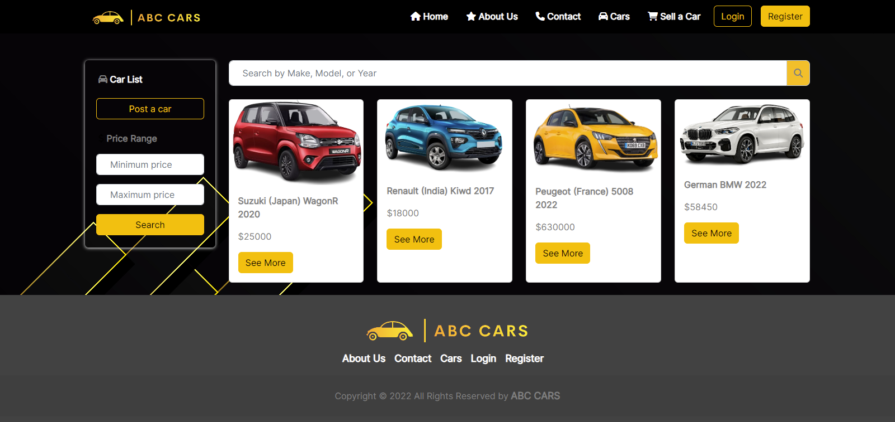**Car List View Page**

Figure 85: Screenshot of Car View Page

* **Car Details View Page**

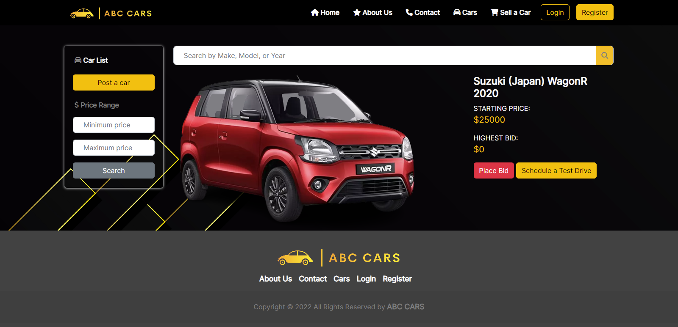

Figure 86:Screenshot of car details view page

**USER**

* 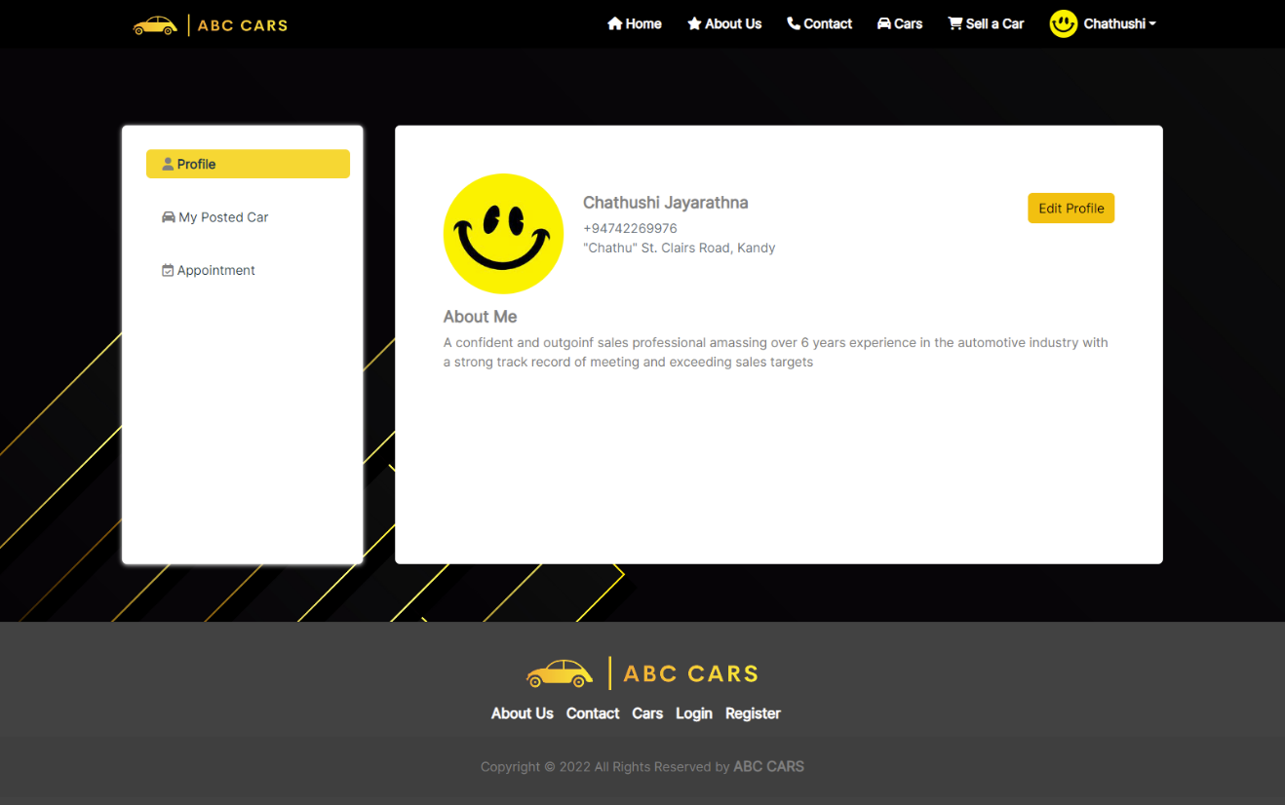**User Profile**

Figure 87:Screenshot of User Profile

* 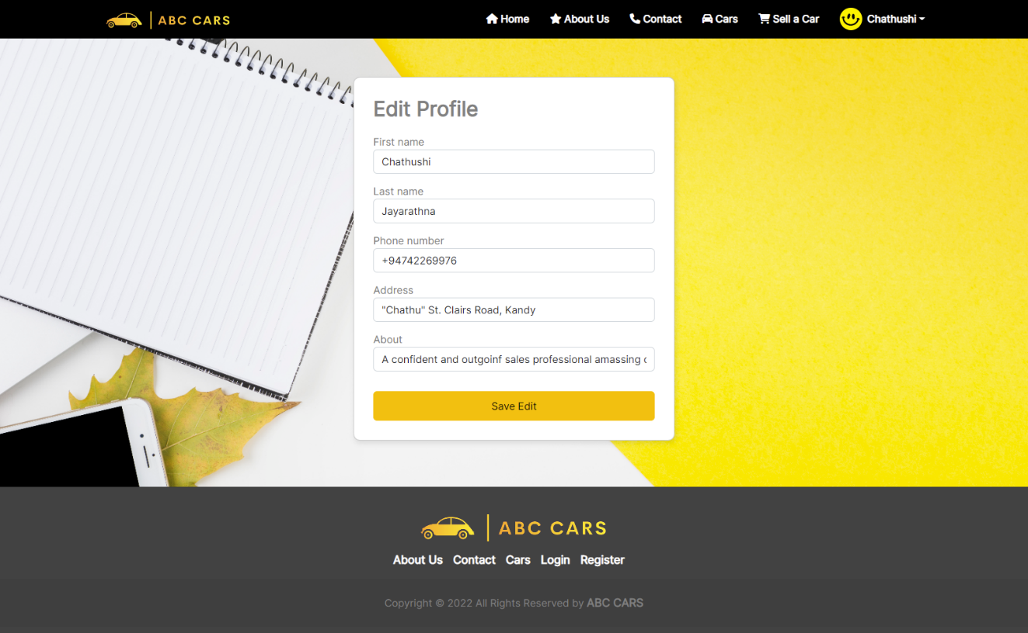**User Edit Profile**
* 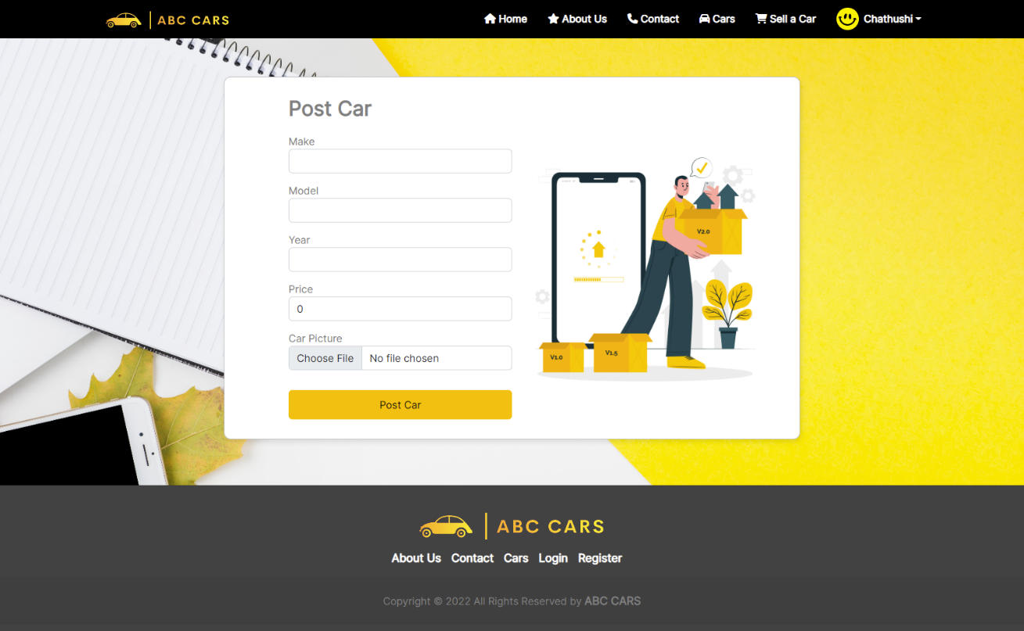**User Post Car Page**

Figure 88:Screenshot of Post Car Page

Figure 89:Screenshot of User Edit Profile

* 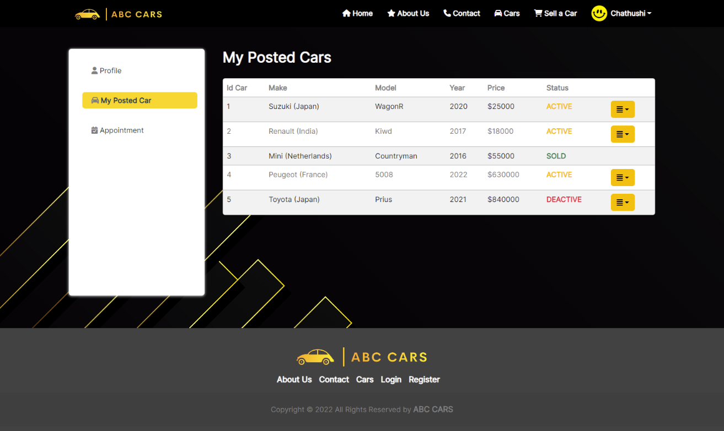**User Posted Car List Page**

Figure 90:User Posted Car List Page

* 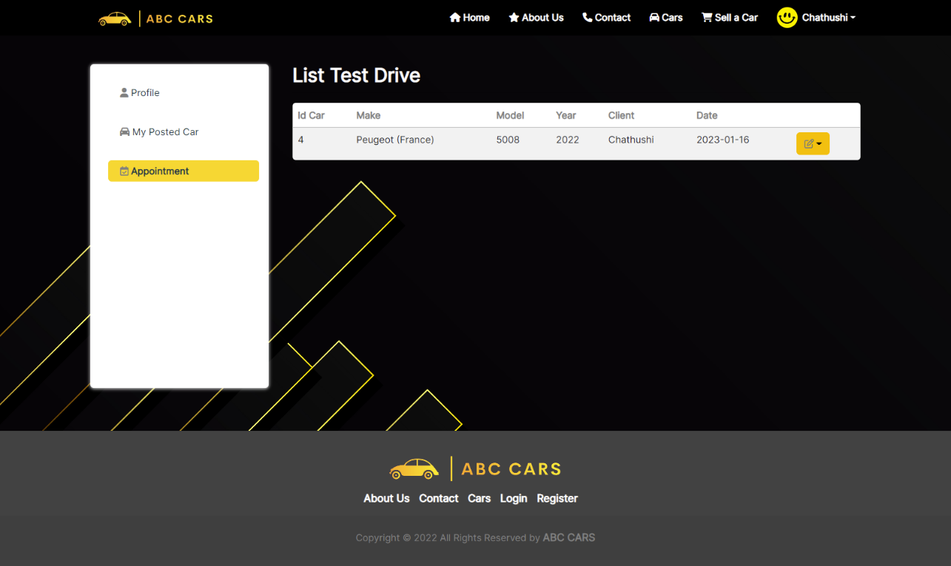**User List Test Drive Car Page**

Figure 91:Screenshot of User Test Drive Car Page

* 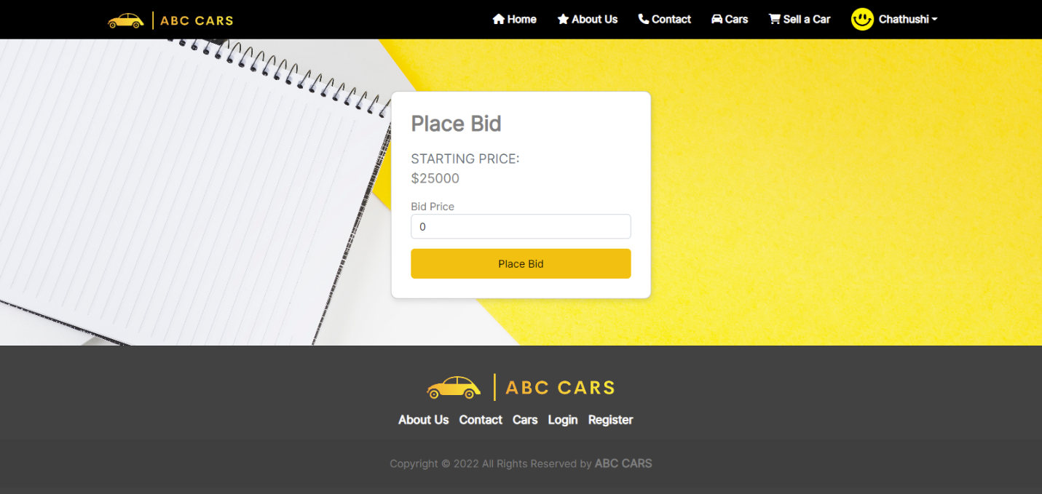**Car Bidding Page**

Figure 92:Screenshot of Car Bidding Page

* 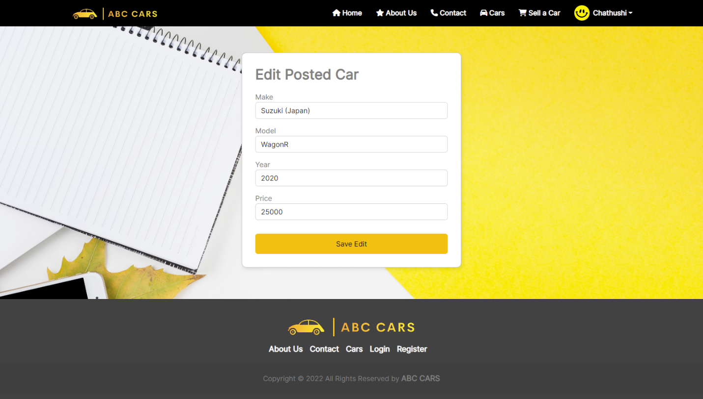**Edit Posted Car Details**

Figure 93:Screenshot of Edit Posted Car Details

**ADMIN**

Figure 94:Screenshot of Admin Dashboard

* 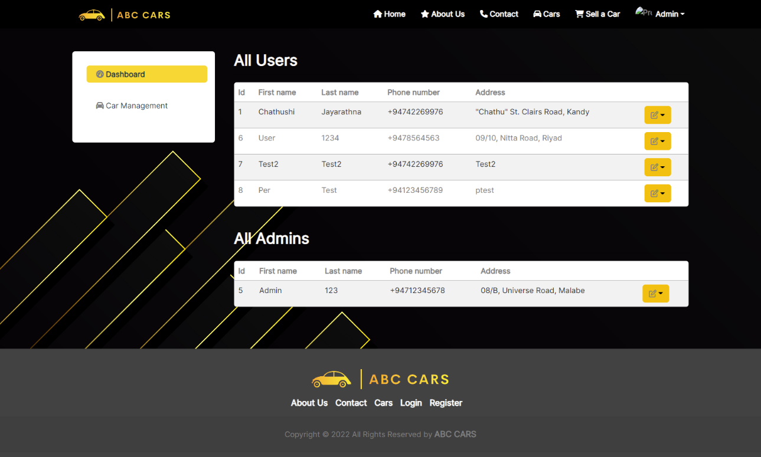**Admin Dashboard**

Figure 95:Screenshot of Admin Dashboard

* 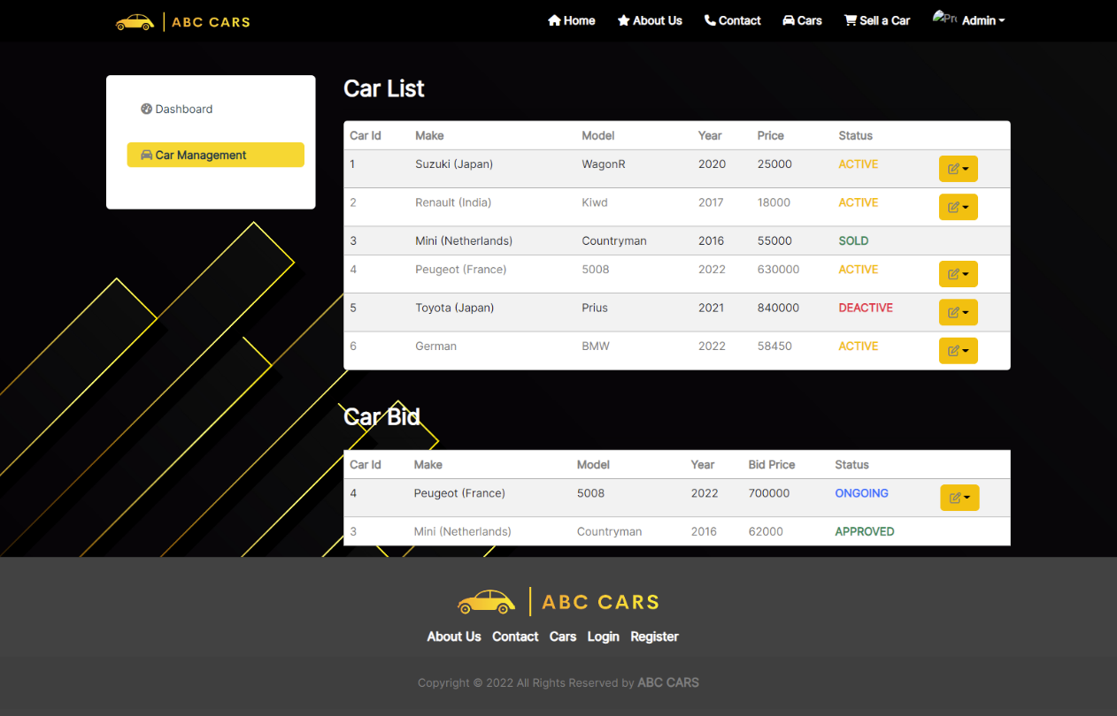**Admin Car Management Page**

Figure 96:Screenshot of Car Mangement Page

* 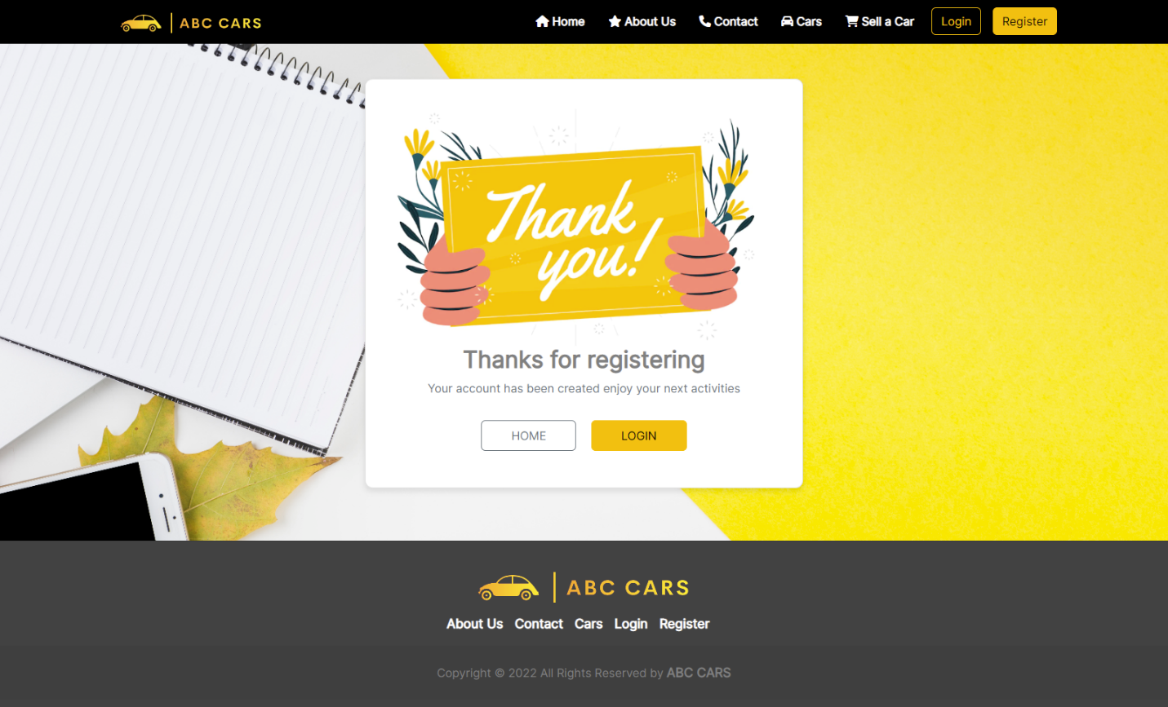**Registration Thank You Page**

Figure 97:Screenshot of Registration Thank You Page

**References**

[**www.youtube.com**](http://www.youtube.com)

[**www.google.com**](http://www.google.com)

[**www.w3school.com**](http://www.w3school.com)

[**www.stackoverflow.com**](http://www.stackoverflow.com)

[**www.guru99.com**](http://www.guru99.com)

[**www.softwaretestinghelp.com**](http://www.softwaretestinghelp.com)